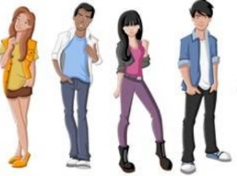
What Are My Peers Like? by _______________________________

Statistical Question:
________________________________________________________

Data:

Rearrange your data IN ORDER:

Find each value below. Show your work!
Mean?
Median?
Mode?
Range?

Create a dot plot:

Statistical Question:
________________________________________________________

Data:

Rearrange your data IN ORDER:

Find each value below. Show your work!
Mean?
Median?
Mode?
Range?

Create a dot plot:

Statistical Question:
________________________________________________________

Data:

Rearrange your data IN ORDER:

Find each value below. Show your work!
Mean?
Median?
Mode?
Range?

Create a dot plot:

Statistical Question:
________________________________________________________

Data:

Rearrange your data IN ORDER:

Find each value below. Show your work!
Mean?
Median?
Mode?
Range?

Create a dot plot:

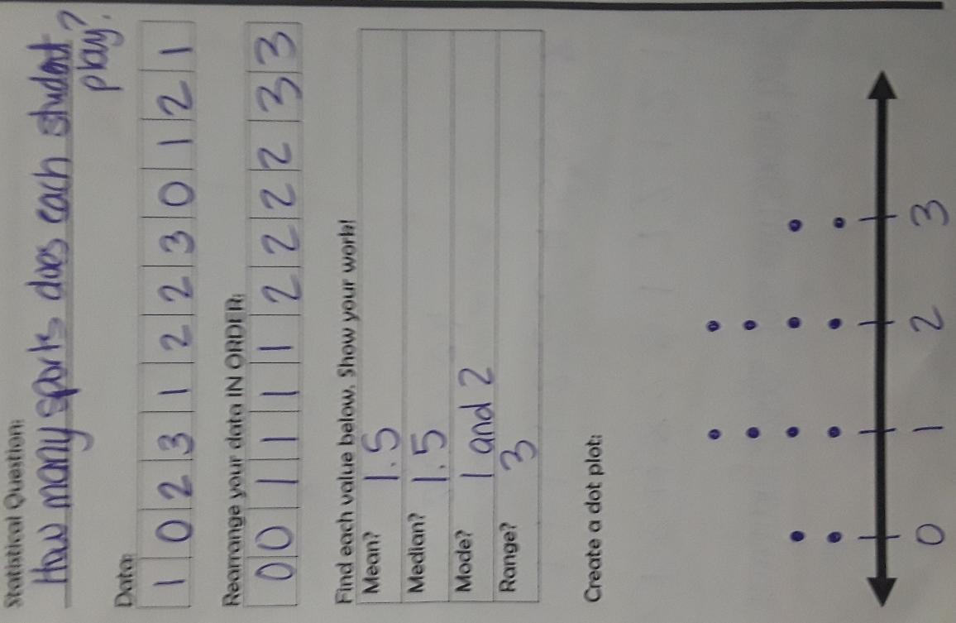
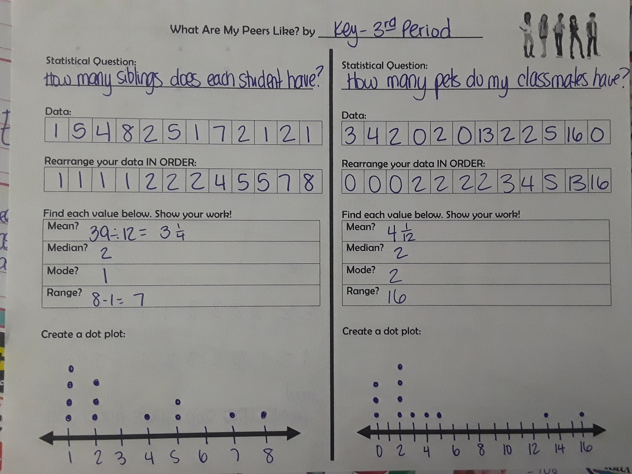
3rd Period Data & Key

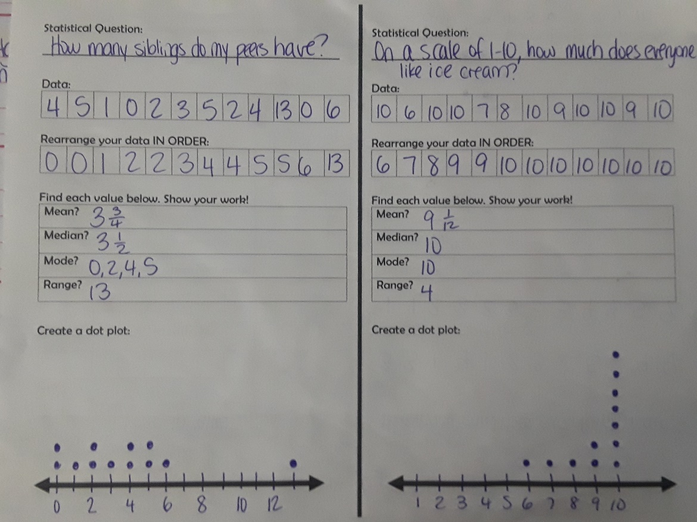
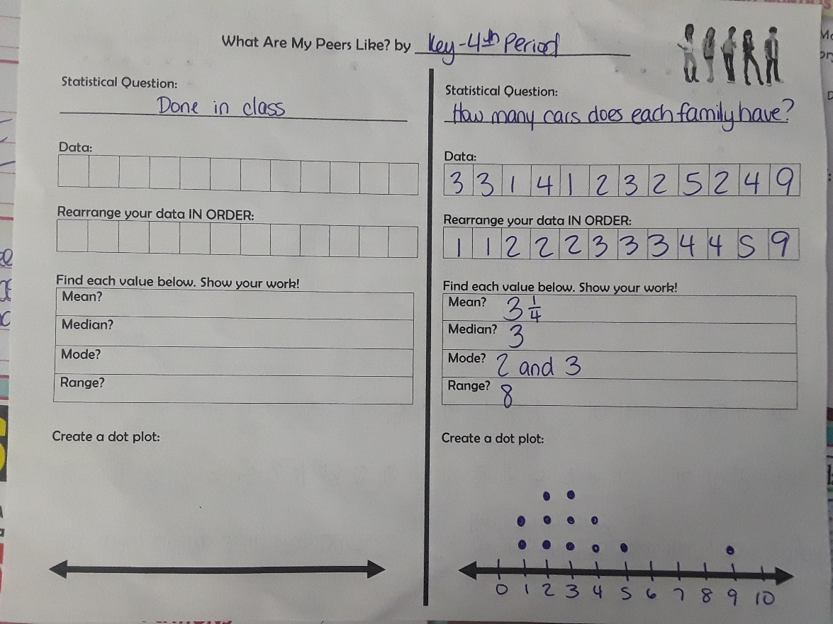
4th Period Data & Key

