**Unit 9 Prerequisite Skills Review** Name: ______________________________

**Simplifying Expressions:**

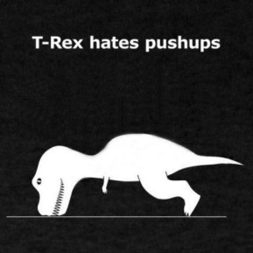1) Circle ALL of the following expressions that are equivalent to 24y + 88. **SHOW ALL WORK BELOW**.

a. 4(6y + 22) b. 8(3y + 88) c. 4(6y + 88) d. 24(y + 88)

e. 2(44 + 12y) f. 6y + 18 + 88 g. 112y h. 88 + 24y

2) Simplify 6x² + 15x² + 4y² - 6x² 3) Simplify 7xy³ + 13x³y - x³y + 23x³y

4) Simplify 15(x² + 4x) + 3(2x² + 5x) 5) Simplify 13(2xy² + 3y) + (2xy² + 5xy²)

**Rational Numbers Review**

6) Fill in the table with at least 3 examples and non-examples of each:

|  |  |  |
| --- | --- | --- |
|  | Examples | Non-examples |
| Whole Numbers |  |  |
| Integers |  |  |
| Rational Numbers |  |  |

7) 8 + (-19) + 14 8) -41 – (-8) 9) -6 • -4 • -2 10) -18 ÷ -4

11) -19 + 11 + 8 12) 52 – 98 13) 2.5 • (-4) 14) 

**Writing the Expressions and/or Equations:**

15) -3 more than twice a number ______________________________________

16) 6 less than four times a number is 19 ________________________________

17) the sum of 16 and half of x equals 4 __________________________________

**Solving Equations:**

**SHOW ALL WORK!!**

18) x – 9 = -11 19) y + -4.5 = -13 20) -1.2m = -6

+ 9 + 9

x = -2

*-2 - 9 = -11*

*-2 + (-9)= -11*

21)  = -25 22) n - (-2.3) = 2 23) b + (-3) = 

**Two-Step Equations:**

Using any method (substitution or inverse operations), determine the value of each variable:

24) -4x + 5 = 17 a. -3 b. 3 c. -5 d. 12

25) 3b - 8 = -2 a. 24 b. -2 c. 2 d. -3.3

26) 2x - 6 = 14 a. 4 b. -4 c. 10 d. 20

|  |  |  |  |
| --- | --- | --- | --- |
|  | Graph on a Number Line: | Possible Solutions | Non-solutions |
| 27) x > -11 |  |  |  |
| 28) z < ½ |  |  |  |

**Inequalities:** Graph each inequality on a number line, and list 3 possible solutions AND 3 non-solutions.