Math 6 - Unit 7: Rational Explorations Name:
Study Guide
Class Period: 1 2 3 4 Date:

- What is the difference between finding the opposite of a number and finding its absolute value?

- Which coordinate stays the same when you are reflecting a point over the x-axis?

- Evaluate:
3a) |-9| 3b) |11| 3c) -|-23| 3d) |0|
- Write the numbers in order from least to greatest?
4a) 2, -5, -17, |-9|, 7, 0
4b) |-11|, -7, -83, |-89|, 3, -1
- Mark each of the numbers below as an integer (I) or not (N)?
5a) 4 _____ 5b) 0 _____ 5c) $-\frac{3}{4}$ _____ 5d) -10 _____ 5d) 4.5 _____

6) The table below shows today’s temperature for 5 cities. Which statement is TRUE? ____________
City | Richmond | Knoxville | Atlanta | NYC | Boston
Temperature (⁰Celsius) | -22 | -11 | -20 | -19 | -13

a) Knoxville is colder than Richmond. c) Boston is colder than Knoxville.
b) Atlanta is the coldest city. d) Richmond is the warmest city.
7) Fill in each with <, >, or = to make a true statement.
9a) |−14| -14 > 9b) 8 −36 > 9c) 0 −30 <
9d) −4 4 > 9e) |-8| 8 > 9f) 0 |-57| <
Use the number line for questions 14-15.
A
B
C
D
E
8) Which point is represented by -5? ____________

9) Which integer represents the opposite of Point E in the number line? ____________

10) What is the opposite of -56? ____________
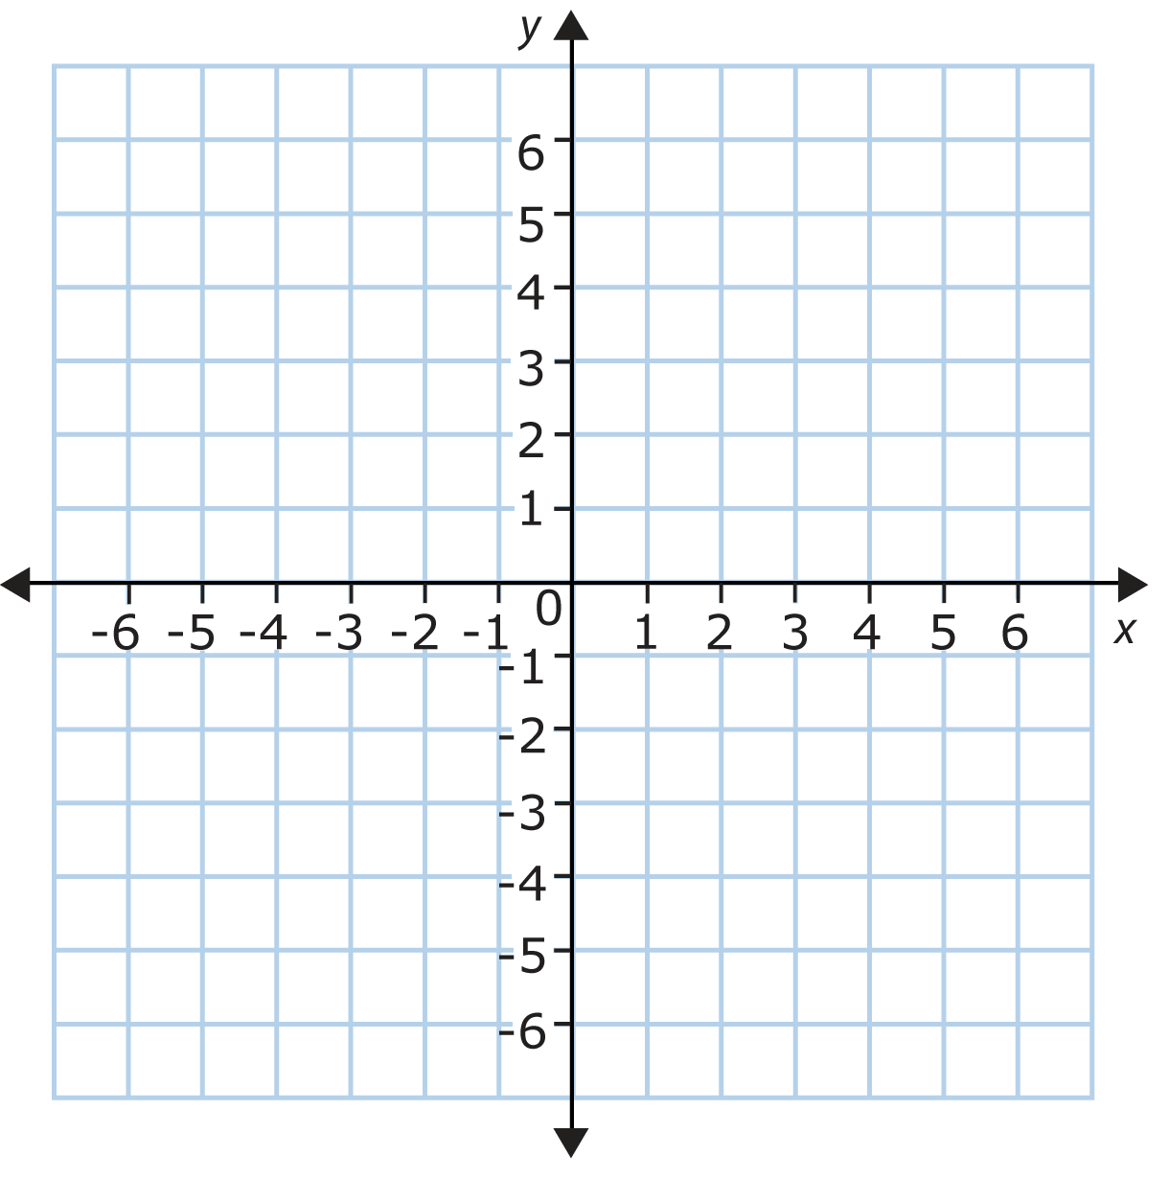
Use the map to answer questions 10-13. Each unit represents one block.
Stadium
Gas Station
City Hall
Art Museum
Hospital
Police Station
Cemetery
Animal Shelter

11) Which ordered pair represents the location
of the Hospital?.

12) How many blocks apart are the police station
and the city hall?

13) Which building is located in quadrant III?

14) Which building is located 4 blocks south of the origin?

- Write an integer to represent, “Ben added 10 songs to his iPod?” ____________

- Write an integer to represent, “Lizzie went diving 50 feet underwater?” ____________

17) According to the data in the table, which student’s test score changed the
most between Test 1 and Test 2? ____________
Student | Test 1 Score | Test 2 Score | Change from Test 1 to Test 2
Monserrat | 100 | 97 | -3
Samya | 88 | 95 | 7
Kathleen | 92 | 89 | -3
Samuel | 90 | 75 | -15

18) Tariq’s bank account shows a $0 balance. Estephanie’s bank account shows a
-$43 balance. Reece’s bank account shows a $24 balance. Which friend’s bank
account has a greater absolute value? ____________
19) If you reflect the point (-3, -2) across the y-axis, what would be the coordinates
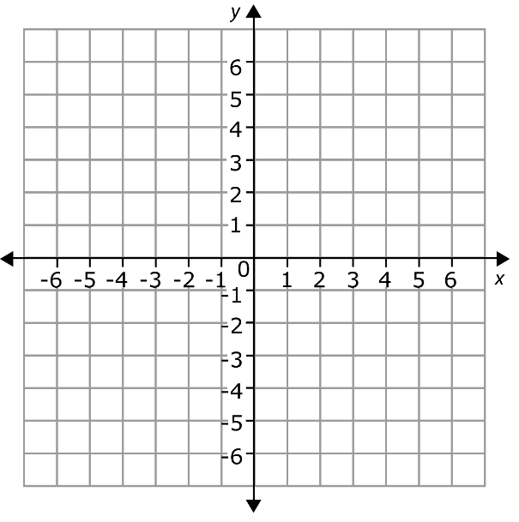
of the reflected point? (HINT: You may use the coordinate plane below to help you!) ____________
B
A
C
D
Use the coordinate plane for questions 22-35.

20) Which point is located at (-4,3)? ____________
21) What are the coordinates of point B? ____________
22) Which point is located in Quadrant IV? ____________
23) Which statement is true for points B and A?
a) B and A are reflections across the x-axis
b) B and A are reflections across the y-axis
c) B and A are reflected across both axes
d) B and A are not reflections

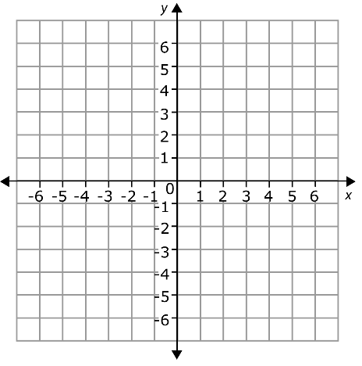
Use the coordinate plane for questions 26-28.
A
B
24) What is the distance between Point A and Point D?
25) What is the perimeter of rectangle ABCD?
D
C
26) What is the area of rectangle ABCD?

27) Put the rational numbers in order from least to greatest? 3, 0, -7, $-\frac{3}{7}$
28) The ordered pairs (2, -7), (-4, -7), and (2, 3) are three vertices of a rectangle.
Which ordered pair is the 4th vertex? Use the coordinate plane below to find the 4th vertex and then find the perimeter and area for the rectangle.

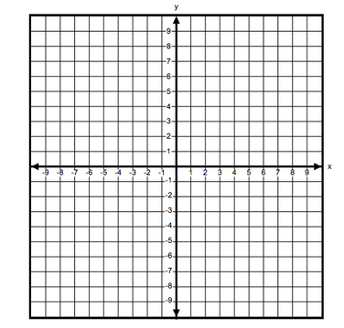
29) What are the coordinates of the 4th ordered pair? ____________

30) Area: ____________

31) Perimeter: ____________

