Math 6 - Unit 6: Statistics Name:
Unit 6 Study Guide
Class Period: 1 2 3 4 Date:

Use the following data to answer problems 1-4.
At the last five basketball games, Simone scored the following points: 12, 15, 9, 11, 8.

- What is the mean number of points Simone scored?

- What is the median number of points Simone scored?

- What is the mode of Simone’s scores?

- What is the range of Simone’s scores?

Use the histogram below to answer questions 5-8.
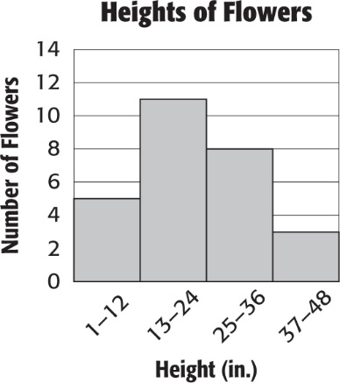
5) How many flowers were less than 25 inches in height?

6) How many flowers are in the 25-36 in. interval?

7) How many flowers were at least 13 inches tall?

8) Which interval had the fewest number of flowers?

For questions 9-13 indicate whether the question IS statistical (S) or NOT statistical (NOT).

9) How many times has each of my classmates been to the beach?

10) How many kids does Mrs. Katz teach?

11) How many pairs of pants does each of my family members own?

12) How many ice cream shops are in each town in Georgia?

13) How many songs are on Katherine’s iPod?
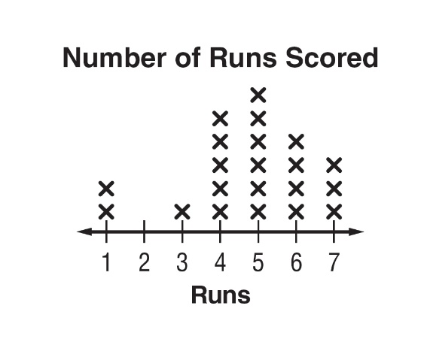
Use the dot plot to answer problems 14 - 16:
14) What is the mode of the data?
15) What is the range of the number of runs scored?

16) What is the mean number of runs scored?

17) Which measure of center is MOST affected by an outlier?
Use the box plot to answer questions 18 – 21.
Number of Shoes sold per Day
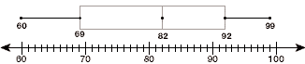
18) What percent of data is GREATER THAN 69 (the lower quartile)?

19) What is the median of the data in the box plot?

20) What is the IQR of the data in the box plot?
21) Which set of data could be used to create the box plot?

a. 60, 61, 61, 69, 79, 80, 99 b. 60, 61, 61, 82, 83, 90, 99

c. 60, 61, 61, 82, 79, 80, 100 d. 0, 61, 61, 82, 79, 80, 99

22) How many total people were surveyed in the dot plot below?
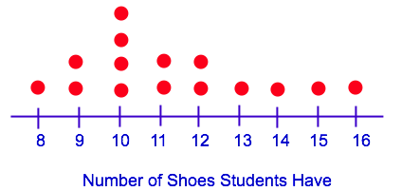

Use the box plot to answer questions 23-24.
Number of Baskets Made for Each Player on the Team

23) What is the interquartile range (IQR) in the box plot?

24) What percent of participants scored more than 6 baskets?
25) The 5-Number Summary of a box plot is shown below.
What is the interquartile range (IQR) for this set of data?
Minimum: 7 Lower Quartile (Q₁): 9 Median: 18 Upper Quartile (Q₃): 26 Maximum: 58

Use the histogram to the right to answer questions 26-27.
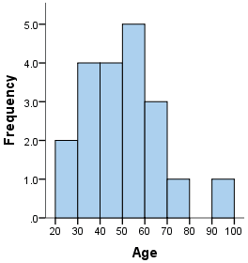
26) The histogram to the right shows the ages of the adults who went
to see Black Panther.
Which statement about the histogram is TRUE?

- Most ages fall within the 60-70 interval.
- Most ages fall within the 20-30 interval.
- No person fell within the 80-90 age interval.
- No person fell within the 50-60 age interval.
27) How many more people who went to see Black Panther are in their 40s than in their 70s?

Constructed Response

28) The data below represents the number of students missing a pencil in all the classes on 6B.

10, 5, 6, 5, 11, 10, 2, 2, 3, 8, 16, 2, 10, 3, 8, 2

- Make a box plot of the data.

- Find one measure of spread. Clearly identify which measure of spread you are finding.
- Find one measure of center. Clearly identify which measure of center you are finding.
- Circle one of the choices below to describe the shape of the box plot.

  - skewed left b. skewed right c. symmetrical

