**Math 6 - Unit 5: Area & Volume** Name:

*End of Unit Test Study Guide*

Class Period: 1 2 3 4 Date:

1) How could you determine the surface area of a triangular prism?

2) Is painting your house a real world example of surface area or volume?

3) What shape is formed by folding the following nets?

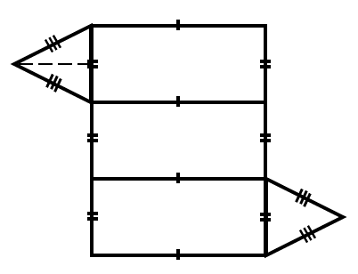 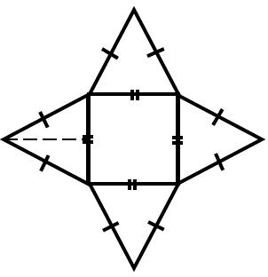 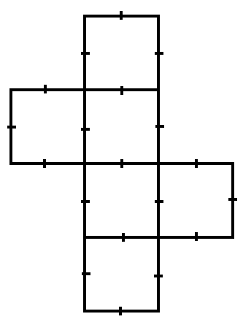 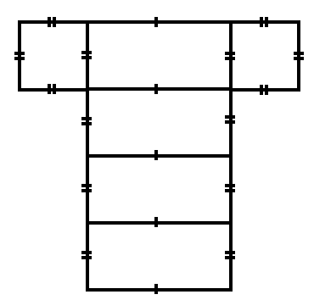

|  |  |
| --- | --- |
| 4) $$\frac{1}{6}in$$ | **Volume of the Cube:** |
| Image result for shaded part of a square area5) | **Area:** |
| 6)  1cm  1cm  3 cm  8 cm | **Area:** |
| http://sohcahtoa.org.uk/pages/images/composite-areas-l-shape-01.png7)  13m  4m  5m  11m | **Area:** |
| Image result for PARALLELOGRAM AREA8)  5 cm  19 cm  10 cm | **Area:** |
| 9) A box is covered with wrapping paper with no overlap. The net of the box is shown below.  How many square inches of wrapping paper is needed to cover the surface area of the box? | **Surface Area:**  6 in.  6 in.  2 in. |
| 10) What is the area of the shaded frame?  7 ft  6 ft  5 ft | **Area:** |
| http://moodle2.rockyview.ab.ca/pluginfile.php/63354/mod_book/chapter/23816/m10_3_m4/images/m4/m10_3_m4_034_opt.jpeg11)  **6 cm**  **22 cm**  **10 cm** | **Area:** |
| 12)  40 m  18 m  10 m | **Surface Area:** |
| 13) A fish tank is shown below. How many cubic inches of water can fit inside the tank?  **4 ½ in.**  **10 in.**  **12 in.** | **Volume:** |
| http://www.mathvillage.info/sites/default/files/VolSA/volume_set1/vol_files/image007.png14)  **5 cm**  **4 cm**  **6 cm**  13m  5m | **Total Square cm needed to wrap the outside of the box:**  **Surface Area:** |
| Image result for surface area of a triangular prism15) | **Surface Area:** |

15) How much paper is needed to wrap a cube with a side length of 10 cm?

16) Draw 2 different nets that could be folded to make a cube.

17) A rectangular pool is 10 feet long, 14 ½ feet wide, and 6 feet deep. How many cubic feet of water can it hold?

18) Give a real world example of something that relates to volume.

19) If carpet costs $5 per square yard, how much would it cost to carpet a rectangular room that is 4.5 yards wide and 15 yards long?

20) How many 2 in cubes can fit inside an 8 in cube?

2 in

8 in