Math 6 - Unit 4 Study Guide Name:

Class Period: 1 2 3 4 Date:

PART I: Direct Variation
- Circle each graph that shows a direct variation:
- B. C. D. E. F.
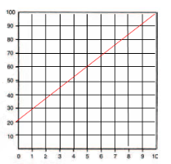
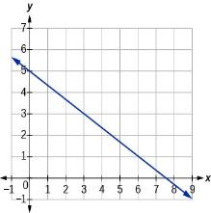
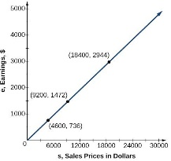
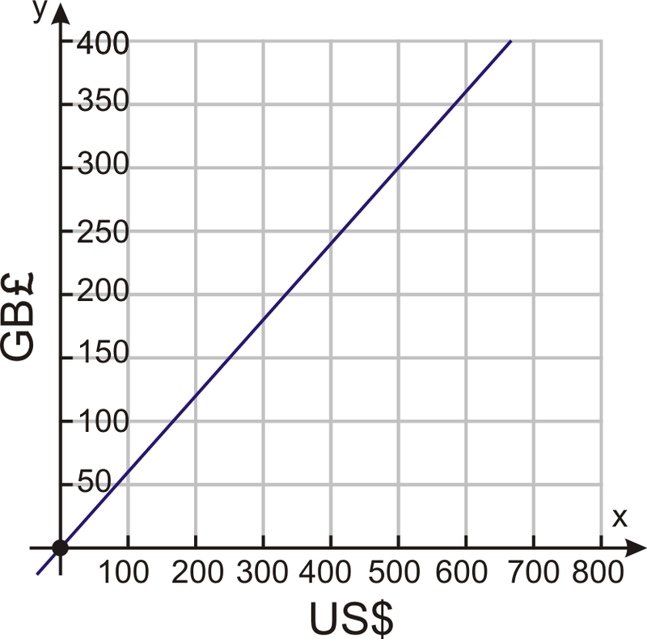
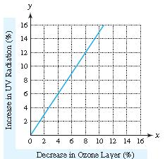

- Write a direct variation equation that matches the data in the table. ___________________________
x | 0 | 2 | 3 | 8
y | 0 | 18 | 27 | 72

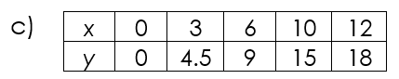
- Circle the table that satisfies the direct variation equation,
a) | x 0 1 3 5 10  y 1.5 2.5 3.5 5.5 11.5 | b) | x 0 2 3 4 10  y 0 3 4 6.5 18
Why did you make that choice?______________________________________________________________

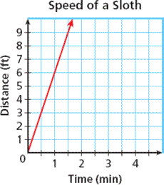
4. Write a direct variation equation to represent the data in the graph below. _____________________

5. Claire sold 15 boxes of cookies (x) and made a total of $60 (y), as shown in the data table.
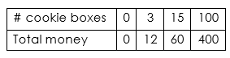
- Write a direct variation equation that represents this situation, where k = the cost per box of cookies.

- What does the dependent variable represent?

- What does the independent variable represent?

PART II: Inequalities
- Using the inequality 16 < a, name 3 possible solutions for x:___________ and 3 non-solutions:________

- Honor Roll students must have grades over 79. Inequality: ____________

- At least 180 6th graders made Honor Roll. Inequality: _________________

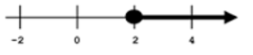
- Write the inequality AND a word problem to match this graph:

Inequality:______________

Word Problem:________________________________________________________________________________

PART III: Equations
- When solving an equation, you must first perform the ___________________ operation on ____________ sides of

the equation. Once you have a solution, __________________ it back into the equation to check your answer.

- Write 2 different equations that have a solution of 48. ___________________and____________________

Write an equation for each word problem on #s 12-15, and solve. SHOW ALL STEPS!
- Your math teacher graded x papers last quarter. She split those evenly over 9 weeks, and graded 500 each week. Write an equation and solve for x, the total number of papers graded. | - Michael’s phone could hold x gigabytes of data. He has already used 11.75, and has 4.25 left. Write an equation and solve for x, the total gigabytes on his phone.
- The drama club has 16 weeks to rehearse for their play. They need to practice a total of 80 hours. Write an equation and solve for x, the number of hours they need to practice each week. | - McKenzie had x dollars. She got $25 more over the holidays, and she earned $14.90 doing chores. Her total is now $54.83. Write an equation and solve for x, the amount she started with.

