Unit 3
Expressions
Exponents
Order of Operations
Evaluating Algebraic Expressions
Translating Words to Math
Identifying Parts of Expressions
Evaluating Formulas
Algebraic Properties
Simplifying Expressions
Identifying Equivalent Expressions

Name:
Math Teacher:

Unit 3 Calendar
11/4 | 11/5 | 11/6 | 11/7 | 11/8
Unit 3 Pre-Test  MSG set up  Exponents  HW: IXL D.2 | No School  Election Day | Wildcat Lab  HW: IXL O.3 | Exponents/  Order of Operations  HW: IXL O.6 | Order of Operations  Quiz #1 (Order of Operations)
IXL Week of 11/4: D.2, O.3, O.6
11/11 | 11/12 | 11/13 | 11/14 | 11/15
Evaluating Expressions  HW: IXL Y.4 & Y.5 | Evaluating Expressions Using Formulas  HW: IXL Y.6 | Translating Words to Math  HW: IXL Y.1 | Translating Words to Math  HW: Y.3 | Quiz #2  (Evaluating Expressions and Translating)
IXL Week of 11/11: Y.4, Y.5, Y.6, Y.1, Y.3
11/18 | 11/19 | 11/20 | 11/21 | 11/22
Combining Like Terms  HW: IXL Y.7 | Wildcat Lab  HW: IXL Y.15 | Combining Like Terms  HW: IXL Y.9 | Putting it all together  HW: IXL Y.10 | Quiz #3  (Combining Like Terms)
IXL Week of 11/18: Y.7, Y.15, Y.9, Y.10
11/25 | 11/26 | 11/27 | 11/28 | 11/29
Thanksgiving Break
12/2 | 12/3 | 12/4 | 12/5 | 12/6
Distributive Property  HW: IXL Y.11, Y.16 | Distributive Property  HW: IXL Y.12 | Unit 3  Review Stations  HW: Study Guide | Unit 3  Mini Post Test/  Review Stations  HW: Study Guide | Unit 3  End of Unit Test
IXL Week of 12/2: Y.11, Y.16, Y.12

Unit 3: Expressions
Standards, Checklist and Concept Map
Georgia Standards of Excellence (GSE):
MGSE6.EE.1: Write and evaluate numerical expressions involving whole-number exponents.
MGSE6.EE.2: Write, read, and evaluate expressions in which letters stand for numbers.
MGSE6.EE.2a: Write expressions that record operations with numbers and with letters standing for numbers. For example, express the calculation “Subtract y from 5” as 5-y.
MGSE6.EE.2b : Identify parts of an expression using mathematical terms (sum, term, product, factor, quotient, coefficient); view one or more parts of an expression as a single entity. For example, describe the expression 2(8 + 7) as a product of two factors; view (8 + 7) as both a single entity and a sum of two terms.
MGSE6.EE.2c : Evaluate expressions at specific values of their variables. Include expressions that arise from formulas used in real-world problems. Perform arithmetic operations, including those involving whole-number exponents, in the conventional order when there are no parentheses to specify a particular order (Order of Operations). For example, use the formulas V = s³ and A = 6s² to find the volume and surface area of a cube with sides of length s = ½.
MGSE6.EE.3 : Apply the properties of operations to generate equivalent expressions. For example, apply the distributive property to the expression 3(2 + x) to produce the equivalent expression 6 + 3x; apply the distributive property to the expression 24x + 18y to produce the equivalent expression 6(4x + 3y); apply the properties of operations to y + y + y to produce the equivalent expression 3y.
MGSE6.EE.4 : Identify when two expressions are equivalent (i.e., when the two expressions name the same number regardless of which value is substituted into them). For example, the expressions y + y + y and 3y are equivalent because they name the same number regardless of which number y stands for.

What Will I Need to Learn??
________ I can evaluate expressions, including with variables and exponents
________ I can translate words to expressions
________ I can identify parts of expressions
________ I can substitute to evaluate formulas
________ I can apply the Order of Operations
________ I can use the distributive property
________ I can identify equivalent expressions

Unit 3 Circle Map: Make a Circle Map of important vocab and topics from the standards listed above.
Unit 3 IXL Tracking Log
 | Required Skills
 | Skill | Your Score
Week of 11/4 | D.2 (Evaluate Exponents)
 | O.3 (Evaluate Numerical Expressions Involving Whole Numbers)
 | O.6 (Evaluate Numerical Expression Involving Decimals)
Week of 11/11 | Y.4 (Evaluate Variable Expressions with Whole Numbers)
 | Y.5 (Evaluate Multi-Variable Expressions)
 | Y.6 (Evaluate Variable Expressions with Decimals and Fractions)
 | Y.1 (Write Variable Expressions – One Operation)
 | Y.3 (Write Variable Expressions – Word Problems)
Week of 11/18 | Y.7 (Identify Terms & Coefficients)
 | Y.15 (Add and Subtract Like Terms)
 | Y.9 (Properties of Addition)
 | Y.10 (Properties of Multiplication)
Week of 12/2 | Y.11 (Multiply Using the Distributive Property)
 | Y.16 (Identify Equivalent Expressions I)
 | Y.12 (Factor Using the Distributive Property)

Unit 3 - Vocabulary
Term | Definition
Algebraic expression | A group of variable(s), operation(s), and/or number(s) that represents a quantity. Expressions do not contain equal signs.
Coefficient | A number which multiplies a variable
Constant | A quantity that has a fixed value that doesn’t change, such as a number.
Exponent | Shows how many times to multiply the base number by itself
Like terms | Terms whose variables (and exponents) are the same
Order of operations | A specific order in which operations must be performed in order to get the correct solution to a problem
Term | One part of an algebraic expression that may be a number, a variable, or a product of both
Variable | A symbol, usually a letter, that represents a number
Associative property of addition | This property states that no matter how numbers are grouped, their sum will always be the same
Associative property of multiplication | This property states that no matter how numbers are grouped, their product will always be the same
Commutative property of addition | This property states that numbers may be added together in any order, and the sum will always be the same
Commutative property of multiplication | This property states that numbers may be multiplied together in any order, and the product will always be the same
Distributive property | Multiplying a number is the same as multiplying its addends by the number, then adding the products
Unit 3 – Vocabulary – You Try
Term | Definition
Algebraic expression | A group of variable(s), operation(s), and/or number(s) that represents a quantity. Expressions do not contain equal signs.
Coefficient | A number which multiplies a variable
Constant | A quantity that has a fixed value that doesn’t change, such as a number.
Exponent | Shows how many times to multiply the base number by itself
Like terms | Terms whose variables (and exponents) are the same
Order of operations | A specific order in which operations must be performed in order to get the correct solution to a problem
Term | One part of an algebraic expression that may be a number, a variable, or a product of both
Variable | A symbol, usually a letter, that represents a number
Associative property of addition | This property states that no matter how numbers are grouped, their sum will always be the same
Associative property of multiplication | This property states that no matter how numbers are grouped, their product will always be the same
Commutative property of addition | This property states that numbers may be added together in any order, and the sum will always be the same
Commutative property of multiplication | This property states that numbers may be multiplied together in any order, and the product will always be the same
Distributive property | Multiplying a number is the same as multiplying its addends by the number, then adding the products
Math 6 – Unit 3: Expressions Review
- Identify each part of the expression. Write “n/a” if the part is not in the expression: 9(3x² + 4)
a) coefficient: b) constant:
c) variable: d) exponent:
e) quotient: f) product:
g) factors: h) sum:
i) difference:
- What does it mean when a number is squared or cubed? Give an example of each.

- Evaluate the expression. Show EACH step. 10² – (14 – 2 +7)

- Write using exponents AND solve? 5 • 5 • 5 • 5 =

- If m=5, evaluate the expression: 4m² + 6m

- Apply the distributive property to write an equivalent expression to 9(y – 3).

- Combine like terms to simplify this expression:
8x³ + 4x² + 12x³ - x²

- The cost of renting a moving truck is $39.99 plus an additional $0.50 for each mile driven. Write an expression to represent the cost of renting the truck for m miles.

- Give an example of each of the properties below:
a) commutative property:
b) distributive property:
c) associative property:
- Write an expression for the product of 6 and c.
- Write an expression for 22 less than y.

- Which expression is not equivalent to the others?
- 3(4 + 2) b) 3(4) x 3(2) c) 3(4) + 3(2) d) 12 + 6

- The formula A=lw can be used to find the area of a rectangle. Ms. Julien is mowing a rectangular lawn that is 9.5 yards long and 6 yards wide. What is the area of the lawn?

- The formula for surface area of a cube is SA = 6s². Find the surface area of a cube whose side length (s) is 12 cm.

- The expression 12n + 75 can be used to find the total price for n students to take a field trip to the science museum. Evaluate the expression 12n + 75 if there are 25 students attending the field trip. (n = 25).

- Write a phrase for the expression $\frac{n}{7}$.

- Which expression represents the phrase, “eight less than the product of six and b?

a) | 8 – 6b | b) | 6 – b + 8 | c) | 6b – 8 | d) | 6b x 8

- Evaluate 10 squared.
- When you combine like terms, you mu8st look for terms with the same variable AND exponent. Choose the expression that is equivalent to 4m + 4m² – m + 6m² + 2m²
a) | 15m² | b) | 17m² | c) | 12m² + 3m | d) | 10m² – 3m
- Silly Sally has a friend named Cuckoo for Cocoapuffs. He also does not understand how to apply the order of operations, and has made a mistake in the problem below. Find the mistake and explain in THREE COMPLETE SENTENCES what the mistake is and what should have been done. Then write what the correct answer really is.
125 – 15 • 2³ + 5
125 – 15 • 6 + 5
125 – 90 + 5
- 5
40
Exponents
An __________ tells how many times to multiply a base times itself.
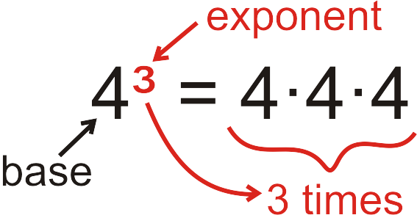
You read 4³ as 4 to the 3rd power or 4 cubed or 4 to the third power.
You read 5² as 5 squared or 5 to the second power.
If a base is being raised to the zero power, it will always be equal to one.
When evaluating an exponent REMEMBER, an exponent only works on what it touches!
Example:
2 + 3³ = 2 + 9 = 11 (2 + 3)³ = 5³ = 125
You Try:
Evaluate:
1) 2⁴ 2) 5 + 7² 3) (5 + 7)²
4) 10 - 3² 5) (10 – 3)² 6) 2 - 2⁰
Exponents Practice
Example:
Exponential Form | Expanded Form | Standard Form
2⁵ | 2 • 2 • 2 • 2 • 2 | 32
y⁴ | y • y • y • y | Depends on value of y
9² | 9 • 9 | 81
10⁰ |  | 1
3⁶ | 3 • 3 • 3 • 3 • 3 • 3 | 729

You Try: Fill in the blanks below to complete the chart.
Exponential Form | Expanded Form | Standard Form
6³
 | 10 • 10 • 10
4²
 | x • x • x • x • x • x
90²

FUN FACT: Any number raised to the __ power always equals __.
Let’s explore why:
Exponential Form | Expanded Form | Standard Form
2⁴
2³
2²
2¹
2⁰

Exponents Practice

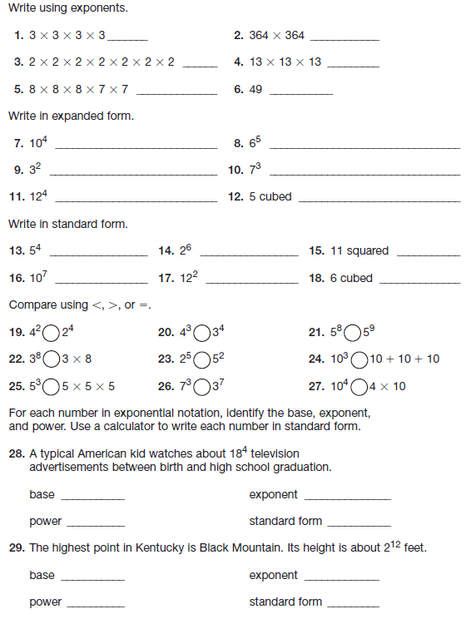

Order of Operations
When computing a problem that has more than one operation, the “Order of Operations” lists the order in which to work the problem to ensure that no matter who solves the problem, the answer will always be the same. Having this set of rules prevents us from getting multiple answers to the same problem!
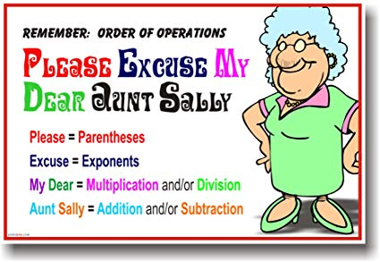
MULTIPLICATION and DIVISION are a group and they are worked from left to right.
ADDITION and SUBTRACTION are a group and they are worked from left to right.
When solving problems using the Order of Operations, your problems will look like a triangle (or a Dorito!) You must show all of your work as you complete each step!
Examples:
8 + 14 ÷ 7 x 3 – 5 6 – (5-3) + 10 42 – (8 – 6) x 2²
8 + 2 x 3 -5 6 – 2 + 10 42 – 2 x 2²
8 + 6 – 5 4 + 10 42 – 2 x 4
14 – 5 14 42 - 8
9 34
You Try:
1) 2 • 2 + 3² 2) 3 + (6 – 5)³ 3) (2 + 4)² ÷ 2
4) 42 ÷ (3² – 3) 5) 23 • (3 + 4) ÷ 2 6) 2 + 4² – (3 +2)
7) 4² ÷ 8 8) (3 -1) + 6 x 3 9) 90 ÷ 9 – 5 + 8

Expressions
An _____________________ is a mathematical statement that contains numbers and operations.
An _____________________ is an expression that contains at least one variable, along with operations and/or numbers.
Expressions | Algebraic Expressions | Non-Examples of Expressions
48 ÷ 12 | 48 ÷ y | y (this is a variable)
5² | x² | 25 (this is a constant)
13 + 9 | 13 + t • 3 | + (this is an operation)

Parts of Expressions
$$2x^{3}+4x-7$$
coefficients: 2 and 4 constant: 7
variable: x exponent: 3
quotient: none product: 2x3 and 4x
factors: 2, x, and 4 sum: 2x³ + 4x
difference: 4x – 7 terms: 2x³, 4x, 7
Example:
5x + 14 This example has two terms, 5x and 14
5x is the product of 5 and x
2(8 + 7) This example has three constants (2, 8 and 7)
There is a product (2 • (8 + 7))
There is a sum (8 + 7)
There are two factors (2 and 8+7)
You Try:
Use the expression below to identify the parts.
$$7y^{2}+\frac{4x}{5}-3$$
a) coefficient: b) constant:
c) variable: d) exponent:
e) quotient: f) product:
g) factors: h) sum:
i) difference: j) terms:
Evaluating Expressions
To evaluate, or solve an algebraic expression, you substitute a number in place of the variable(s) and then find the value.
Note: When a number and letter are written side by side with no operation indicated, then it can be assumed you will multiply them together.
3x = 3 times whatever x is. 4p = 4 times whatever p is
6u + 4 = the sum of the product of 6 and whatever u is and 4
Examples:
Evaluate the following algebraic expressions when a = 10, b = 3, and c = 5.
b + 18 (given expression) 4a ÷ c (given expression) b² (given expression)
3 + 18 (substitute 3 in for b) 4 • 10 ÷ 5 (substitute) 3² (substitute)
21 (solution) 40 ÷ 5 = 8 (solution) 9 (solution)
You Try:
Substitute to evaluate the following algebraic expressions when x = 2, y = 25 and z = 8. Show all of your work!
1) 3z | 2) y – z + x | 3) y^{x}
4) z ÷ x | 5) x + y + z | 6) 9 – x
7) 100 – 10x – 10z | 8) 14 ÷ x + 2y | 9) w⁰
10) xyz | 11) z(x + y) | 12) x + x • y
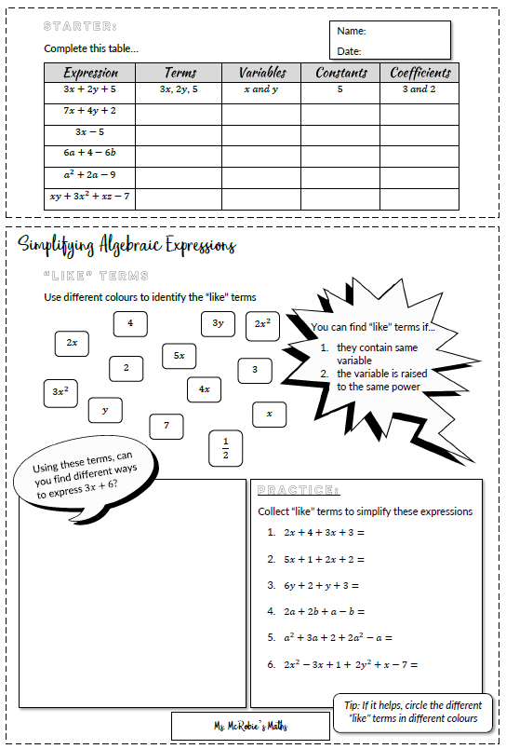
Evaluating Expressions Extra Practice
Use substitution to evaluate each expression for the given value of the variable. Show your work!
1) $9y – 3$(for y = 11) | 2) $7m$ (for m = 5) | 3) $d^{2}-2d$ (for d = 9)
4) $6q+39$ (for q=10) | 5) $6v$ (for v = 3) | 6) $j^{3}+11$ (for j = 8)
7) $2k^{2}+5k+2$  (for k = 11) | 8) $\frac{n}{3}+n$ (for n = 27) | 9) $a÷3$ (for a = 42)
10) $4\left(11+p\right)+13$  (for p = 89) | 11) $h^{3}-2$ (for h = 7) | 12) $14z-1$  (for z = 9)
Evaluating Expressions Extra Practice
Use substitution to evaluate each expression for the given value of the variable. Show your work!
13) $15e+37$  (for e = 5) | 14) $19r$ (for r = 8) | 15) $x^{2}+2x+4+x$  (for x = 10)
16) $7(4+h)$  (for h=21) | 17) $13+w$  (for w = 26) | 18) $b-15$  (for b = 15)
19) $\frac{y}{12}+y$  (for y = 72) | 20) $3b^{2}+5b$  (for b = 2) | 21) $8e+22$  (for e = 42)
22) $2x^{2}-11x+6$  (for x = 12) | 23) $p^{3}-4p$  (for p = 4) | 24) $16\left(3+a\right)-a$  (for a = 13)
Using and Evaluating Formulas
A formula is a mathematical rule written using variables, usually an expression or equation describing a relationship between quantities.
To evaluate or solve a formula, you substitute the number for the variable.
Common Formulas
Area of a rectangle = l • w Surface Area of a Cube = 6s²
Area of a triangle = $\frac{1}{2}bh$ Volume of a Cube = s³
Area of a Trapezoid = $h(\frac{b_{1+b_{2}}}{2})$
Example 1: Mary Lou is setting up a lemonade stand. Her rectangular sign is 3 feet long and 2.5 feet wide. If the formula for area of a rectangle is A = l • w, what is the area of her sign?
A = l • w Step 1: Write the formula.
A = 3 ft • 2.5 ft Step 2: Substitute for the variable(s).
A = 7.5 ft² Step 3: Solve (in this case, multiply).

Example 2: Billy Bob needs to figure out the volume of a cube. It is 12 in tall. Help him find the volume, if the formula is V = s³.
V = s³ Step 1: Write the formula.
V = 12 in • 12 in • 12 in Step 2: Substitute for the variable(s).
V = 144 • 12 Step 3: Solve (in this case, multiply).
V = 1728 in³

You Try:
1) What is the surface area of a cube that is 4 in. tall?
2) What is the area of a rectangle with a height of 8.5 cm and a width of 3 cm?
3) What is the area of a triangle with a height of 5m and a base length of 9m?
4) What is the area of a trapezoid that is 4cm high, with bases that are 10cm and 12cm long?
5) Why are formulas useful/helpful?

Words and Phrases to Math Symbols

Words can be translated into math symbols to form expressions and equations. Here is a list of key words to look for.

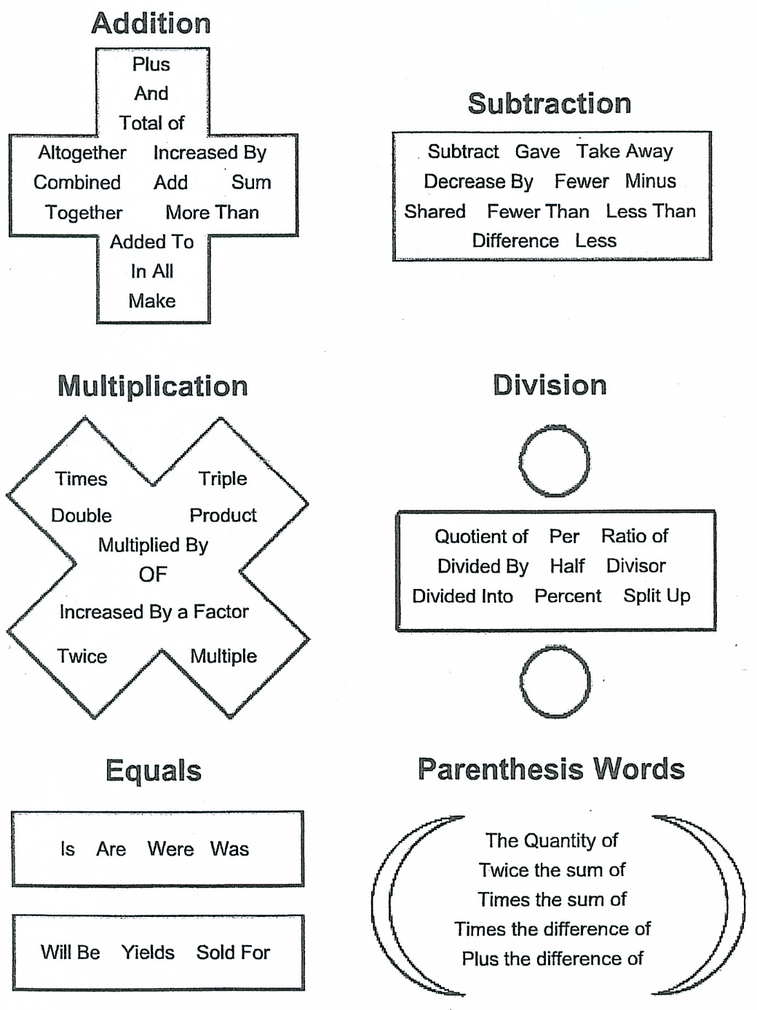
Writing Algebraic Expressions
Translating words into math symbols or math symbols into words can be done in many ways. Here are just a few examples.
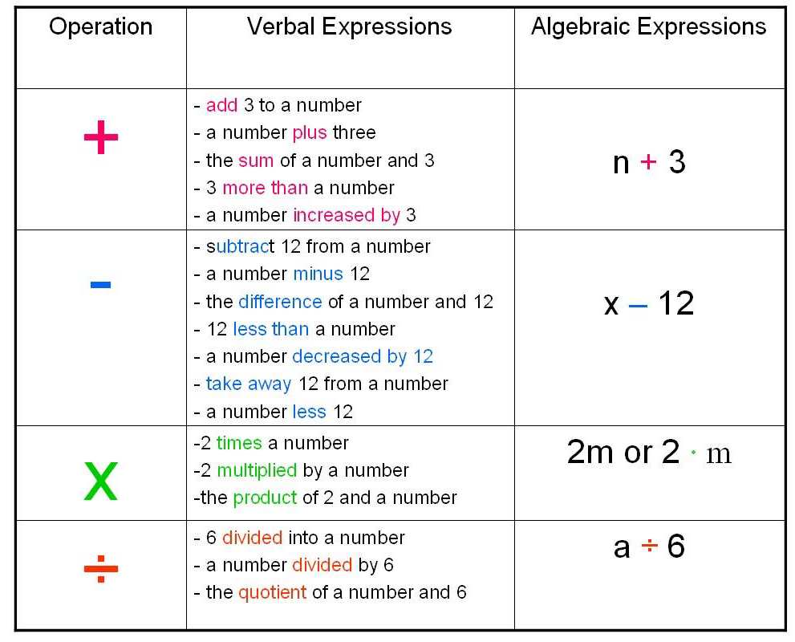
Example:
Translate the words into math symbols.
- add 43 to a number, n
43 + n
- a number, w decreased by 12.
w – 12
- 8 less than a number y
y - 8
You Try:
1. add 43 to a number n
2. a number x divided into 25
3. 7 times a number e
4. take away a number c from 16
5. difference of a number q and 24
6. product of a number r and 41
7. 13 more than a number j
8. a number a less 49
9. a number v decreased by 28
10. a number b multiplied by 46
11. 30 minus a number h
12. a number u divided by 36
13. quotient of 23 and a number e
14. 8 less than a number y
15. subtract a number m from 19
16. 9 more than the twice a number a
17. sum of a number z and 34
18. 3 increased by a number p
19. 33 increased by a number u
20. add 6 to a number k
21. take away a number f from 20
22. The difference of 9 and x
23. sum of a number b and 35
24. a number x times 44
25. a number w decreased by 12
26. a number j minus 10
27. 32 less a number t
28. 48 multiplied by a number q
29. 4 divided by a number s
30. difference of a number c and 2
Commutative & Associative Properties
The Commutative Property says that the order in which you add or multiply two numbers does not change the sum or product. For any numbers a and b: a + b = b + c and a x b = b x a
Think commute, (like how you move to work) the numbers can move position without changing the outcome.
The Associative Property says that the way you group numbers when you add or multiply them does not change the sum or product. For any numbers a, b or c: (a + b) + c = a + (b + c) and (ab)c = a(bc)
Think associate, (like how you associate with your friends) the numbers can “hang out” in different groups and not change the outcome.
Example:
Which property is illustrated by each statement?
1) 13 + 14 = 14 + 13 2) 2 + (3 + 4) = (2 + 3) + 4
You Try:
1) 3 + 4 = 4 + 3 2) 2(9) = 9(2)
3) xy = yx 4) g + h + 2 = g + 2 + h
5) (2 + 5) + 7 = 2 + (5 + 7) 6) (6 • 5) x = 6 (5 • x)
7) 7 + m = m + 7 8) 3 (4 • 5) = (4 • 5) 3
Combining Like Terms
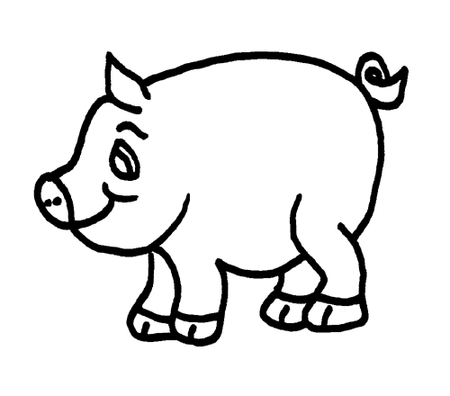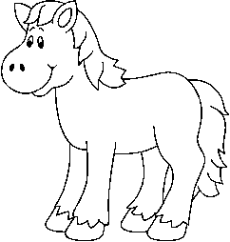
Part 1: Look at the pictures of the farm animals below. Determine how many pigs, chickens, and horses there are.
Pigs: Horses:
Chicken:
Part 2: Write an algebraic expression to show how many of each animal are on your paper. Instead of pictures, use variables to represent each animal. Use p for pig, c for chicken, h for horse.

Part 3: Simplify your algebraic expression by combining like animals.

Part 4: What if a horse got lost? How would you represent that in your expression?

More Combining Like Terms
Combining Like Terms is like matching your socks. In the same way that we put our socks in matching pairs, we can combine like terms to put terms with the same variables and exponents together.
Examples:
- 2x and 3x have the same variable (x) to the same exponent (¹), so they can be combined to make 5x.
- 5y² and 4y² have the same variable (y) and the same exponent (²), so they can be combined to make 9y².
- 8m and 3m² are NOT like terms because they do have the same variable, but not the same exponent.
Some helpful hints to make combining like terms easier.
- You can put different shapes around like terms before you combine them to make sure you don’t miss any terms. Make sure you put the shape around the sign too!
$$6m+2p+3+4p-2m+4$$
- You can also highlight like terms before you combine them to make sure you don’t miss any terms. Make sure you highlight the sign too!
$$6m+2p+3+4p-2m+4=$$
$$6m-2m+2p+4p+3+4$$
$$4m+6p+7$$
Combining Like Terms Error Analysis
Sally is a silly little girl who makes mistakes! In Column #1, analyze her work and circle her mistake. In Column #2, explain what she did wrong. In Column #3, show how Silly Sally should work out the problem correctly. Show ALL work!
Silly Sally’s Work  (Circle her mistake): | What did Silly Sally do wrong? | Show Silly Sally how it’s done!  (Show ALL steps!)
6x + 5x + 2y
11x + 2y
13xy
3a² + 4a² – a²
7a² – a²
8a²
m + 3m – 4m + 2m
4m – 4m + 2m
16m + 2m
18m
6y³ + 2y² + 4y³ + 2y²
8y² + 4y³ + 2y²
10y² + 4y³
13x + 5 + 17x – 4.5 + x
18x + 17x – 4.5 + x
35x – 4.5 + x
30.5x + x
31.5x
12r² + 3 + 8rs + 4r² -16r²
16r² + 3 + 8rs – 16r²
24r²s + 3 – 16r²
8r²s + 3
You Try:
- $5x + x^{2}+ 8y - 2x + 3x^{2}=$ 4x² + 3x + 8y
- $9 + 6k + 3 + 2k^{2}+ 3 + 7k^{2}=$9k² + 6k + 15
- $12x + 3y – 2a + 6y – 5x=$7x + 9y – 2a
- $5 + 6m + 12 - 6m – 17=$ 0
- $12h + 3p – 9h + 3 – 3p=$ 3h + 3
- $3x+2y+x=$ 4x + 2y
- $8d + 2c – 2d + c=$ 6d + 3c
- $10b^{2} + 10b+ 10b^{2}=$ 20b² + 10b
- $7a + 3n+3a^{2}=$ already simplified
- $3m^{4} + m^{2}+ 2m^{4}=$ 5m⁴ + m²
- $\frac{1}{4}d + \frac{2}{3}g + \frac{1}{4}d=$
The Distributive Property
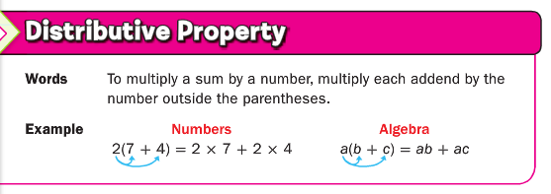
Think of the factor that is being distributed as the mamma bird. What happens when the mamma doesn’t feed her babies? They die! Don’t kill off the baby birds, make sure mamma feeds them all!
10 • 23 = 10 (20 + 3)
10 • 20 + 10 • 3
200 + 30
230

You Try:
1) 12 • 41 2) 11 • 45 3) 2 • 123

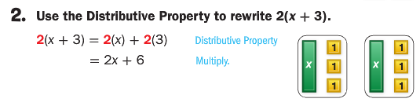
You Try:
1) 8(x + 3) 2) 5(9 + x) 3) 2(x + 3)

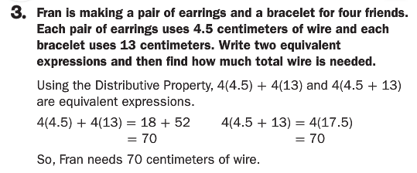
You Try:
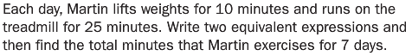
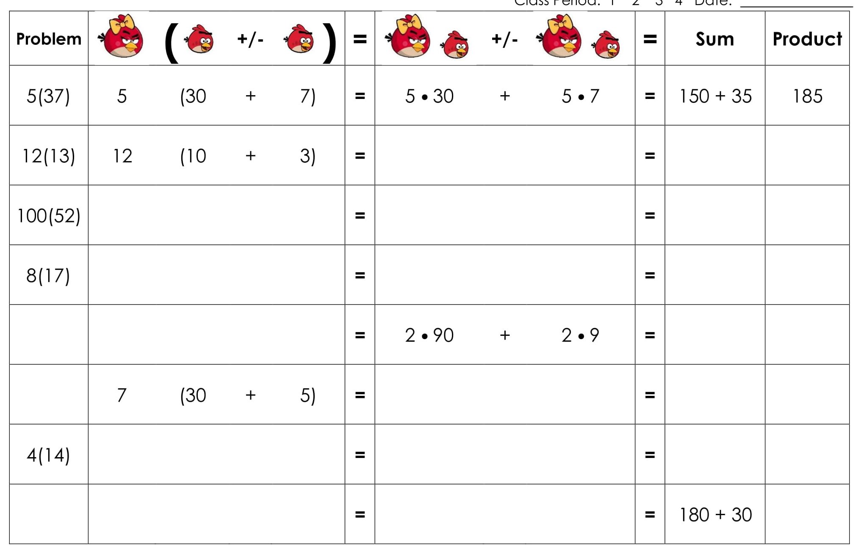
The Distributive Property
Solve these problems two ways, use the distributive property and the order of operations.
1) 5(9 + 11) 2) 12 (3 + 2)

Use the distributive property to rewrite the following expressions. Combine like terms if necessary.
3) 5(2 + 8) 4) 10(x + 2) 5) 14(a + b)
6) 12(a + b + c) 7) 7(a + b + c) 8) 10(3 + 2 + 7x)
9) 1(3w + 3x + 2z) 10) 5(5y + 5y) 11) 9(9x + 9y)
12) 2(x + 1) 13) 6(6 + 8) 14) 4(5v + 6v)
15) 3(2 + 6 + 7) 16) 2(3x + 4y + 10x) 17) 5(5x + 4y)

Factoring
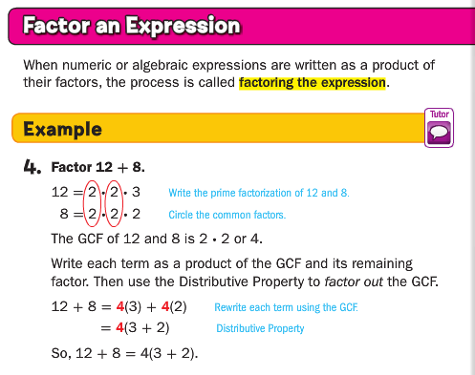
Factoring is the inverse of the distributive property. When you are factoring, you are looking to pull out the common factors that are in the addends. (You have to find the mamma and take her out!)
You Try:
Find the common factor (mamma bird) and factor it out of the expressions below.
1) 9 + 21 2) 14 + 28 3) 80 + 56
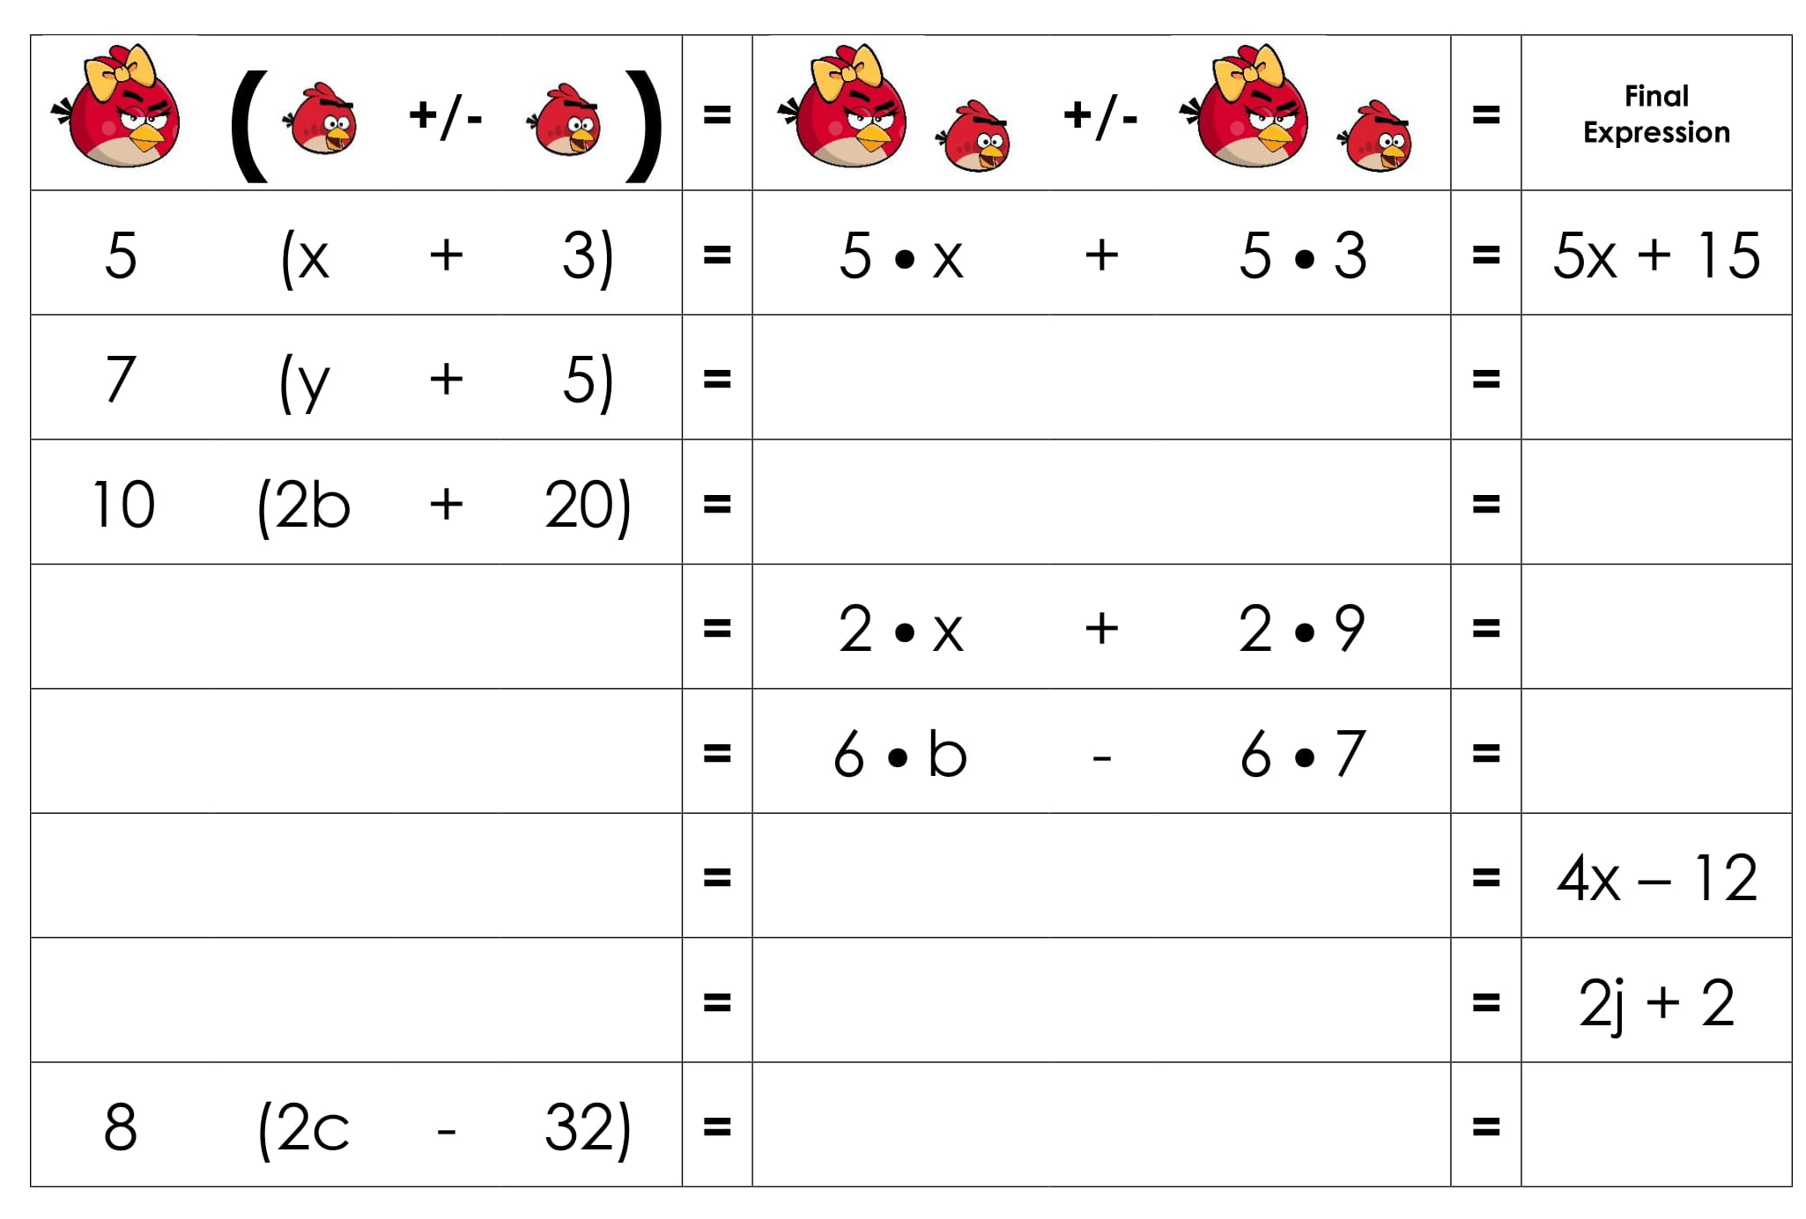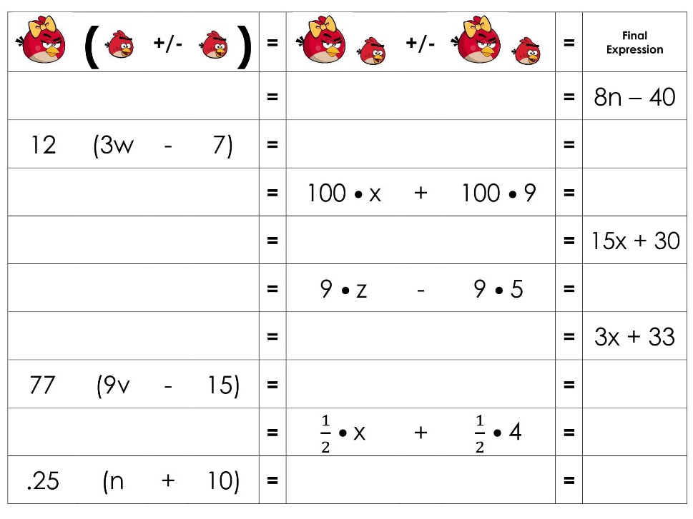

Factoring Practice
Factor the expressions.
1) $20g+45$ | 2) $40+64u$
3) $35d+21$ | 4) $48n+4$
5) $90s+80$ | 6) $55r+44$
7) $99n+45$ | 8) $12m+22$
9) $10c+8$ | 10) $45g+81$
11) $14m+16$ | 12) $21y+9$
13) $35d+40$ | 14) $12+8p$

Distributive Property Extra Practice
Multiply or Factor the expressions using the Distributive Property.
1) Factor: $25g+50$ | 2) Multiply: $7\left(3x+2\right)=$
3) Multiply: $3\left(21x+19\right)=$ | 4) Factor: 36$n+48$
5) Factor: $49s+14$ | 6) Multiply: $6\left(3x+7\right)=$
7) Factor: $5x+15$ | 8) Multiply: $7\left(18m+25\right)=$
9) Multiply: $10\left(c+40\right)=$ | 10) Factor: $64g+68$
11) Factor: $21m+300$ | 12) Multiply: $13\left(14y+23\right)=$
13) Multiply: $7\left(13d+2\right)=$ | 14) Factor: $120+80p$

Distributive Property & Combining Like Terms
Use the Distributive Property and Combine Like Terms.
1) 7$\left(2c+5\right)+3c=$ | 2) $8\left(3+2y\right)-10=$
3) $14g+3\left(6-2g\right)=$ | 4) $4x+9\left(x+7\right)=$
5) $5+4\left(x+3\right)-10=$ | 6) $23x+5x+6\left(x+3\right)=$
7) $\left(5+x\right)4+5x=$ | 8) $15x+7\left(5x+c\right)=$
9) $43\left(x+1\right)+53x=$ | 10) $3.4\left(1.2x+4.5\right)+12=$
11) $2\left(x+14\right)+x+31=$ | 12) $1.2\left(x+7\right)-2=$
13) $8\left(a+2\right)+2\left(2+3a\right)=$ | 14) $12\left(2e+14\right)+e\left(4+5\right)=$

