Math 6/7 and Adv. Math 6– Unit 2: Rate, Ratio, and Proportional Reasoning
Test Review Name _________________________
- What is a ratio? _________________________________________________________________________________

______________________________________________________________________________________________

- What are some differences between the Metric and Customary Systems? __________________________________

_______________________________________________________________________________________________

- Write two equivalent ratios to 6:9. ________________________

- Twenty-one is 30% of what number? ________________________

- Find 110% of 54. _____________________

- Determine the missing value. ________________________

- Write the ratio as a unit rate: $62 for 4 tickets _____________________

- Analee drove 165 miles in 2.5 hours. Miller drove 192 miles in 3 hours. Who drove at the fastest rate of speed? How do you know?

- If 1 inch is approximately 2.54 centimeters, how many centimeters are equal in length to 8.5 inches?

- The table below shows the number of each item sold at the concession stand. What might the ratio 4:3 represent?
Item | Quantity Sold
Popcorn | 20
Nachos | 15
Hot Dog | 25
Candy Bar | 30

- The ratio of boys to girls in a class is 5:3. If there are 32 students in the class, how many are boys?

- In a class of 36 students, 75% returned their permission slips for the school field trip. How many students did not return their permission slips?
- The table below shows the cost for varying number of books. If the rate stays the same, determine the value of n.
Number of Books | Cost
5 | $12.50
8 | $20
12 | n
15 | $37.50

- Bothers Middle School held a car wash as a fundraiser. Out of the 45 vehicles that were washed, 60% were SUVs. How many of the vehicles were SUVs?

- The graph below compares cups to pints. Which of the following ordered pairs would also satisfy this relationship?
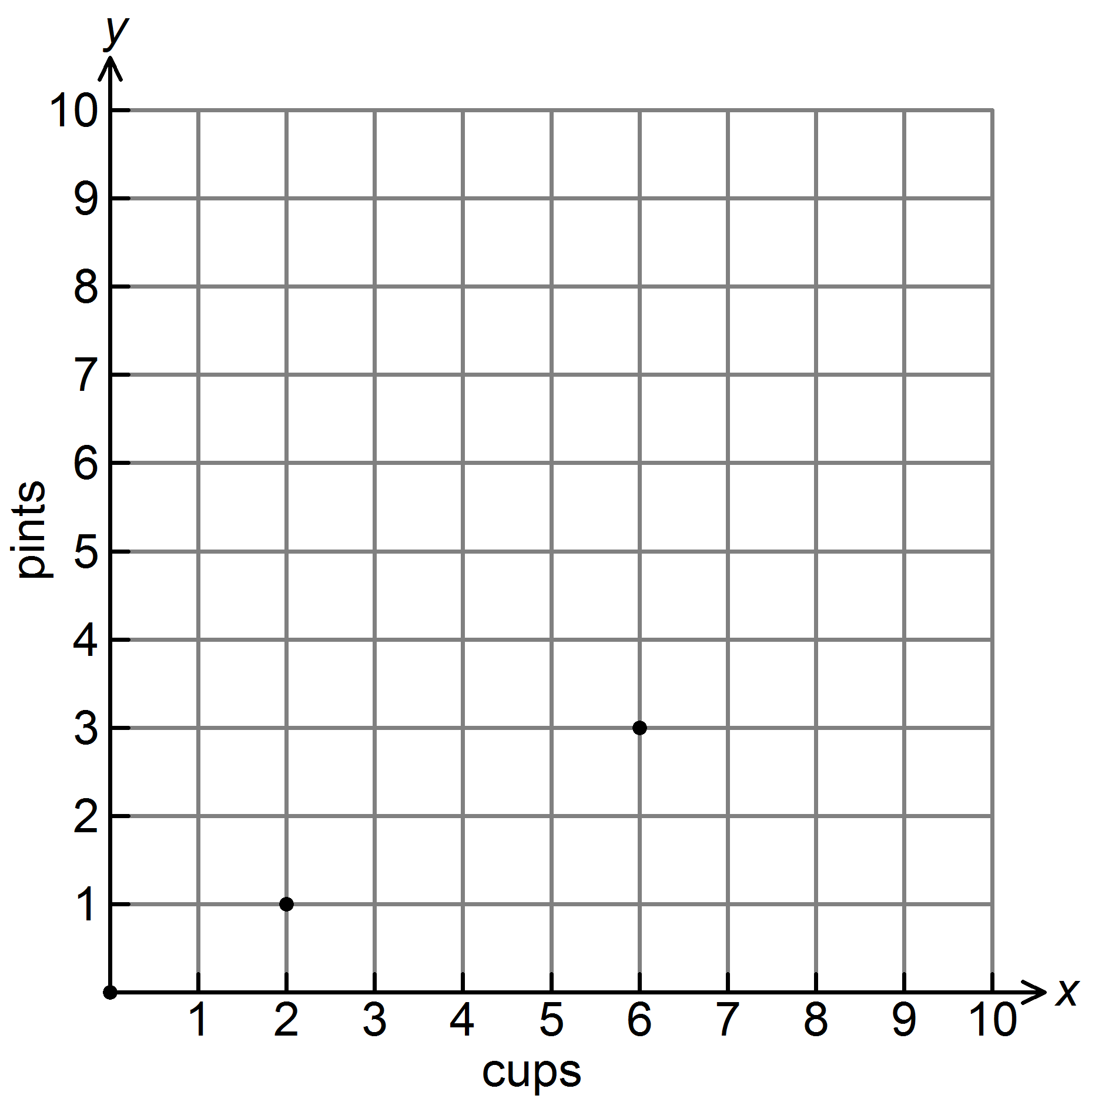
A. | (4, 2) | B. | (2, 4) | C. | (2, 0) | D. | (1, 2)

- Ella’s paycheck last week was $115. She would like to put 20% of her earnings in her savings account. How much money should she put in her savings account?

- The prices of 4 different bottles of lotion are given in the table. Which size bottle is the worst value? Why?
Size | Price
25 ounces | $4.50
15 ounces | $2.40
10 ounces | $1.90
5 ounces | $0.75

- Pierce drives his race car at a constant speed of 140 miles per hour. How can he calculate long it should take him to travel 700 miles?

- Mrs. Bothers surveyed her students to determine their favorite summer snack. She teaches 130 students. 70% of them chose ice cream, and 30% chose smoothies. How many more kids chose ice cream over smoothies?

- The door is 90 inches high. How many feet is this?

