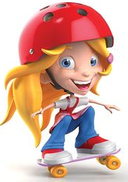
Unit 6: Statistics Performance Task:

What is a typical 6th grader like???

Project is due: Friday, 1/24/20

1) ______ Come up with 3 statistical questions to survey your peers about. You may wish to
include answer choices for each one. The questions must yield numerical data.
Be creative with your questions! Make them interesting!

2) ______ What do you predict? Write a paragraph (minimum 3 sentences) for EACH of
your 3 questions, predicting the outcomes. What do you think will be “typical?”

(Steps 1 & 2 MUST be submitted and approved before conducting your survey.)

3) ______ Conduct your survey! Ask a minimum of 25 sixth graders.

4) ______ Graph your data for each question. You must have one dot plot, one histogram,
and one box plot. (One for each question – not 3 graphs for each question.)
Each graph MUST be neat, colored, and titled. Include axis labels on the histogram.

5) ______ Analyze your data in a paragraph for each question. Explain your conclusions.
Include at least one measure of center, one measure of spread, and one observation about the shape for each graph. Also, compare your findings to your predictions. Were you surprised by anything, or were you on point?

6) ______ Display your project! You may create a poster, PowerPoint, Prezi, PowToon,
booklet, video, brochure, etc. Be creative, NEAT, and thorough!

*It is your choice to work alone or in a pair. If you work in a pair, you must have a total of SIX questions instead of three. We may conduct “peer reviews” of projects on Friday, and that may be factored into your grade.

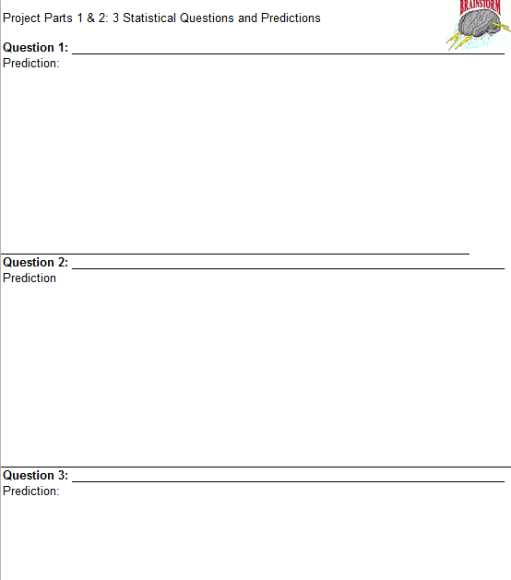

Name:_______________________________________

Statistical Question #1:___________________________________________________________________

Statistical Question #2:__________________________________________________________________

Statistical Question #3:__________________________________________________________________

 | Dot Plot | Histogram | Box Plot
Statistical Question with Numerical Data  3 – Statistical AND Numerical  2 – Statistical OR Numerical  1 – Not Statistical or Numerical | 3 2 1 0 | 3 2 1 0 | 3 2 1 0
Prediction Paragraphs  3 – Minimum of 3 well-written sentences explaining the student’s predictions  2 – Only 2 sentences OR contains errors OR only gives one prediction  1 – Not in paragraph form and contains errors | 3 2 1 0 | 3 2 1 0 | 3 2 1 0
Graphs  12 – Accurate (matches data), neat/organized/easy to follow, colored, and includes titles (and labels for histogram)  10 – All of above EXCEPT has 1 minor inaccuracy (doesn’t match data)  6 – Has 3 inaccuracies OR is not neat and colored OR does not include title/labels  3 – Matches data but is not neat/organized/easy to read | 12 10 6 3 0 | 13 10 6 3 0 | 12 10 6 3 0
Conclusion Paragraphs  15 – Minimum of 4 well-written sentences including accurate measures of center, spread, and shape. Also compares to prediction.  12 – Everything above EXCEPT missing one part (center, spread, shape, comparison)  9 – Everything above except missing 2 parts  6 – Not in paragraph form, but does include a measure of center, spread, shape, and a comparison to predictions.  3 – Followed almost no directions | 15 12 9 6 3 0 | 15 12 9 6 3 0 | 15 12 9 6 3 0
Subtotals | /33 | /34 | /33
Total Score: | /100
“What is the Typical 6th Grader Like?” Rubric
Analysis of Data (Optional Draft/Notes sheet)

Question 1: dot plot histogram box plot
measure of center (identify and give value): ____________________________
measure of spread (identify and give value):____________________________
measure of shape (identify and give value):_____________________________
compare to prediction:

Question 2: dot plot histogram box plot
measure of center (identify and give value):_____________________________
measure of spread (identify and give value):____________________________
measure of shape (identify and give value):_____________________________
compare to prediction:

Question 3: dot plot histogram box plot
measure of center (identify and give value):_____________________________
measure of spread (identify and give value):____________________________
measure of shape (identify and give value):_____________________________
compare to prediction:

