Rectangular Prism: | Surface Area  (Show work and circle your answer.)  (It may help to draw a net!) | Volume  (Show work and circle your answer.)  V = lwh OR V = Bh
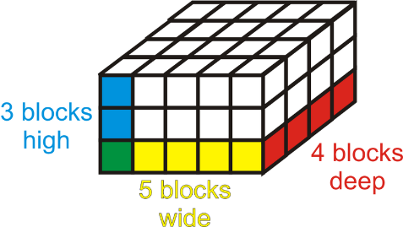 | 1) SA = ________________________ | 2) V = _________________________
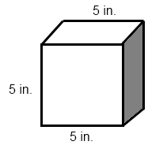 | 3) SA = ________________________ | 4) V = _________________________
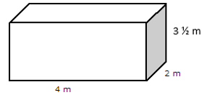 | 5) SA = ________________________ | 6) V = _________________________

7) Circle the choices that relate to volume. Underline the choices that relate to surface area.
Filling a pool with water Wrapping a present The amount of cereal in a box Painting a doghouse
- Noelani wants to paint her jewelry box blue. The jewelry box is in the shape of a cube and has an edge length of 4 in. How much blue paint will Noelani need?
- Is she finding SURFACE AREA or VOLUME?
- Show work below:

- She will need _________________ of paint.

- Jaylen is building a pool in his backyard. The pool measures 10 ½ yards long, 6 yards wide, and 1 ½ yards deep. How much water will fit in the pool?
a. Is he finding SURFACE AREA or VOLUME?
b. Show work below:

c. He will be able to put _________________ of water in the pool.
