Statistical Questions Practice Name:________________________

A ________________________ question is a question that anticipates a variety of answers.
A question that is not statistical will only have ____________ answer.
Directions: Determine whether each question listed below is statistical or non-statistical. If the question is statistical, write “YES.” If it is not statistical, write “NO.”
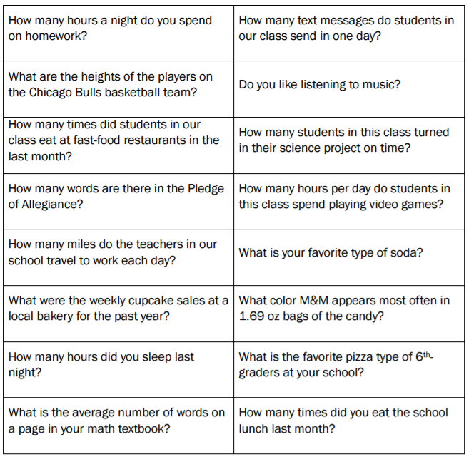

Statistical Questions Practice Name:________________________

A ________________________ question is a question that anticipates a variety of answers.
A question that is not statistical will only have ____________ answer.
Directions: Determine whether each question listed below is statistical or non-statistical. If the question is statistical, write “YES.” If it is not statistical, write “NO.”

