Percent Practice Name:__________________________________
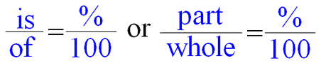
- What is 8% of 200? 2) 12 is 15% of what number?

3) What is 75% of 60? 4) 20 is 125% of what number?

5) What is 200% of 30? 6) 18 is 60% of what number?

7) Farmer Mel owns 30 acres of land. Only 60% of his land can be farmed. How many acres are available for farming?

8) The 6th grade bought 200 lunches yesterday. If this is 30% of the lunches sold in the cafeteria yesterday, what is the total number of lunches sold?

9) Natalia got 95% of the problems right on a quiz. If there were 50 questions on the quiz, how many did she get right?

10) Rachael has read 50% of her library book. If she has read 120 pages, how many total pages are in the book?

