Percent Practice Name:__________________________________

Date:______________ Period:_______

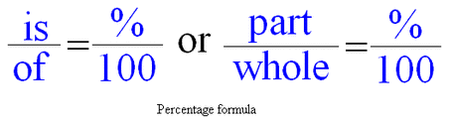

Finding a percent (part) of a number (whole): Finding the whole given the percent (part):

Example: What is 20% of 240? Ex: 60 is 75% of what number?

First, set up your proportion: First, set up your proportion:

 

Then, solve! Then, solve!

 

20 ⦁ 240 = 4800 ÷100 60 ⦁100 = 6,000 ÷75

x = 48 x=80

***48*** *is 20% of 240* *60 is 75% of* ***80***

Now, you try!

1. What is 15% of 400? 2) 4 is 80% of what number?

3) What is 5% of 70? 4) 14 is 35% of what number?

5) What is 75% of 360? 6) 63 is 350% of what number?

**Mixed Bag Problems:** Remember to set up your percent proportion for EVERY problem! SIMPLIFY before solving!

7) 36 is 75% of what number? 8) What is 110% of 20?

9) What is 5% of 80? 10) 8 is 10% of what number?

11) What is 10% of 56? 12) 35 is 100% of what number?

13) H&M has is having a 20% off sale on winter boots! If Caroline wants to buy a pair that originally costs $40, how much will she save?

Will the savings be more or less than $40?______________

Are you finding the PART or the WHOLE?_______________

How much will she save? ___________________________

14) Mrs. Ledesma ate 90% of the candies from a bag of Jolly Ranchers. If she ate a total of 54 candies, how many candies were in the FULL bag?

Will the answer be more or less than 54? ______________

Are you finding the PART or the WHOLE? ______________

How much was in the full bag?_______________________

15) Is a% of b the same as b% of a? Explain and/or show how you know.