Unit 2 Measurement Practice
US and Metric Conversions

1. 6 feet = ___________ inches (1 ft = 12 in)

2. 64 oz = ____________ lbs (16 oz = 1 lb)

3. 54 fl oz = __________ cups (8 fl oz = 1 cup)

4. 3 miles = __________ ft (1 mile = 5,280 ft)

5. A fence measures 30 feet. How many yards long is the fence? (3 ft = 1 yd)

6. Colt is making lemonade for his baseball team. He made 4 gallons. How many cups of lemonade does he have? (1 gal = 16 cups)

7. The average Asian elephant weighs about 3 tons. How many pounds is this? (1 ton = 2000 lbs)

Use the following information to answer questions 8 and 9.
Mrs. Smith picked 16 pints of blueberries for her famous blueberry cobbler.
8. How many quarts of blueberries does she have?
(1 qt = 2 pts)

9. She needs 34 cups of blueberries for her famous cobbler. Does she have enough? Why or why not? (2 cups = 1 pint)

________________________________________
________________________________________

10. 70 m = ___________cm (1 m = 100 cm)

11. 5000 g = __________kg (1 kg = 1000 g)

12. 4 L = ____________ mL (1 L = 1000 mL)

13. Your shadow is 950 millimeters long. How many centimeters is this? (1 cm = 10 mm)

14. Layla’s dog weighs 25,700 grams. How many kilograms does the dog weigh? (1 kg = 1,000 g)

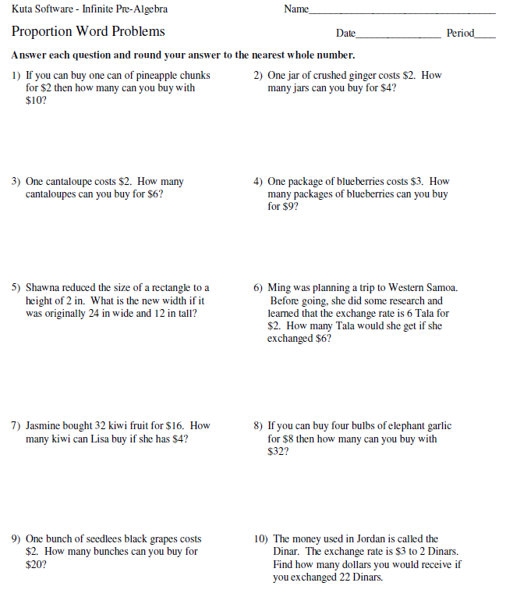

Unit 2 Measurement Practice – KEY
US and Metric Conversions

6.RP.3d (#1-20)
1. 6 feet = _6 x 12 = 72 inches

2. 64 oz = _64 x 16 = 4 _ lbs

3. 54 fl oz = 54 ÷ 8 = 6.75 cups

4. 3 miles = 3 x 5280 = 15840 ft

5. A fence measures 30 feet. How many yards long is the fence?
30 ÷3 = 10 yards

6. Colt is making lemonade for his baseball team. He made 4 gallons. How many cups of lemonade does he have?
4 x 16 = 64 cups

7. The average Asian elephant weighs about 3 tons. How many pounds is this?
3 x 2000 = 6000 pounds

Use the following information to answer questions 8 and 9.
Mrs. Smith picked 16 pints of blueberries for her famous blueberry cobbler.
8. How many quarts of blueberries does she have?
16 ÷ 2 = 8 quarts

9. She needs 34 cups of blueberries for her famous cobbler. Does she have enough? Why or why not? _16 x 2 = 32 cups. She does NOT have enough for her famous recipe.

10. 70 m = 70 x 100 = 7,000 cm

11. 5000 g = 5000 ÷ 1000 = 5 kg

12. 4 L = 4 x 1000 = 4,000 mL

13. Your shadow is 950 millimeters long. How many centimeters is this?
950 ÷ 10 = 95 centimeters

14. Layla’s dog weighs 25,700 grams. How many kilograms does the dog weigh?
25,700 ÷ 1000 = 25.7 kilograms

