Math Whiz Unit 7 Review

1) What is the opposite of 6?
A. -6 B. -1/6 C. 6 D. 1/6

2) The highest temperature ever recorded in Death
Valley was 121⁰, while the lowest ever recorded there
was 13⁰ below zero. Which integers represent these
temperatures?

A. 121 and 13 B. -121 and 13
C. 121 and -13 D. -121 and -13

3) Determine which of these illustrates two quantities
that combine to make zero.

A. Lee lost 10 pounds, then he gained 6 pounds.
B. Ike earned more money than he spent.
C. It is -20⁰ F, and then it rises 10 degrees.
D. Ava earned $10 and then spent $10.

4) What is the opposite of the opposite of -12?

A. -12 B. 0 C. 12 D. 1/12

5) If this triangle is reflected across the y-axis, what are
the resulting coordinates of Point M?
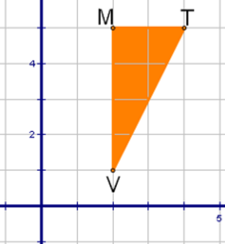

A. (-2, 5) B. (-5, 2) C. (5, -2) D. (-2, -5)

6) In which quadrant is (-4, 6)?

A. 1 B. 2 C. 3 D. 4

7) Which point is located in Quadrant 3?

A. (4, -2) B. (-2, -2) C. (0, -9) D. (-5, 3)

Name: ____________________________________

8) If this triangle is reflected across the x-axis, what are
the coordinates of the reflected points?
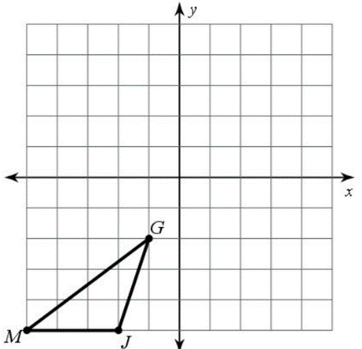

A. G’ (1, -2), J’ (-2, 5), M’ (5, -5)
B. G’ (-1, 2), J’ (-2, 5), M’ (-5, 5)
C. G’ (-1, -2), J’ (-2, -5), M’ (-5, -5)
D. G’ (2, 1), J’ (-5, -2), M’ (-4, 2)

9) Which set of integers is ordered least to greatest?

A. -20, -5, 10, 15, 40
B. -5, -20, 10, 15, 40
C. -5, 10, 15, -20, 40
D. 40, 15, 10, -5, -20

10) Which statement is incorrect?

A. -9 > -10 B. -1.5 < 0
C. 2.3 < 2.9 D. -14 > -10

11) What is the absolute value of -6?

A. -6 B. -1/6 C. 6 D. 1/6

12) Evaluate |6|.

A. -6 B. -1/6 C. 6 D. 1/6

Unit 7 Mastery Score:
_______________/ 20

13) Which point is located at -14?

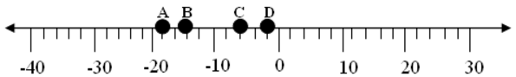

A. A B. B C. C D. D

14) Sea level is located at 0 feet. Which statement is
correct about the depths of the submarines?

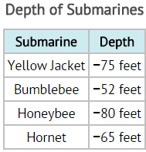

A. Honeybee is closer to sea level than Hornet.
B. Honeybee is closer to sea level than Bumblebee.
C. Bumblebee is closer to sea level than Honeybee.
D. Yellow Jacket is a greater distance from sea
level than Honeybee.

15) Rectangle ABCD has the coordinates shown.
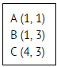
What must be the coordinates of Point D?

A. (5, 1) B. (4, 2) C. (3, 1) D. (4, 1)

16) What is the distance between (-6, 7) and (-6, -2)?

A. 5 units B. 9 units C. 12 units D. 14 units

17) What is the distance between (5, 4) and (8, 4)?

A. 0 units B. 2 units C. 3 units D. 8 units

18) What is the value of Point C?

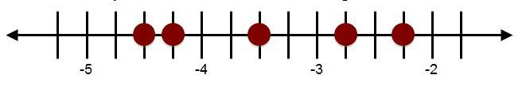
A B C D E

A. 3.5 B. 4.5 C. -3.5 D. -4.5

19) How many units is the star from the square?
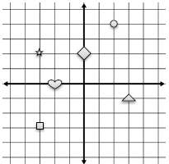

A. 3 units B. 4 units C. 5 units D. 6 units

20) Which is ordered greatest to least?

A. 0, 4, 18, -5, -3
B. 4, 18, 0, -3, -5
C. 18, 4, 0, -5, -3
D. 18, 4, 0, -3, -5

Math Whiz Unit 7 Review

1) What is the opposite of 6?
A. -6 B. -1/6 C. 6 D. 1/6

2) The highest temperature ever recorded in Death
Valley was 121⁰, while the lowest ever recorded there
was 13⁰ below zero. Which integers represent these
temperatures?

A. 121 and 13 B. -121 and 13
C. 121 and -13 D. -121 and -13

3) Determine which of these illustrates two quantities
that combine to make zero.

A. Lee lost 10 pounds, then he gained 6 pounds.
B. Ike earned more money than he spent.
C. It is -20⁰ F, and then it rises 10 degrees.
D. Ava earned $10 and then spent $10.

4) What is the opposite of the opposite of -12?

A. -12 B. 0 C. 12 D. 1/12

5) If this triangle is reflected across the y-axis, what are
the resulting coordinates of Point M?

A. (-2, 5) B. (-5, 2) C. (5, -2) D. (-2, -5)

6) In which quadrant is (-4, 6)?

A. 1 B. 2 C. 3 D. 4

7) Which point is located in Quadrant 3?

A. (4, -2) B. (-2, -2) C. (0, -9) D. (-5, 3)

Name: KEY

8) If this triangle is reflected across the x-axis, what are
the coordinates of the reflected points?

A. G’ (1, -2), J’ (-2, 5), M’ (5, -5)
B. G’ (-1, 2), J’ (-2, 5), M’ (-5, 5)
C. G’ (-1, -2), J’ (-2, -5), M’ (-5, -5)
D. G’ (2, 1), J’ (-5, -2), M’ (-4, 2)

9) Which set of integers is ordered least to greatest?

A. -20, -5, 10, 15, 40
B. -5, -20, 10, 15, 40
C. -5, 10, 15, -20, 40
D. 40, 15, 10, -5, -20

10) Which statement is incorrect?

A. -9 > -10 B. -1.5 < 0
C. 2.3 < 2.9 D. -14 > -10

11) What is the absolute value of -6?

A. -6 B. -1/6 C. 6 D. 1/6

12) Evaluate |6|.

A. -6 B. -1/6 C. 6 D. 1/6

Unit 7 Mastery Score:
_______________/ 20

13) Which point is located at -14?

A. A B. B C. C D. D

14) Sea level is located at 0 feet. Which statement is
correct about the depths of the submarines?

A. Honeybee is closer to sea level than Hornet.
B. Honeybee is closer to sea level than Bumblebee.
C. Bumblebee is closer to sea level than Honeybee.
D. Yellow Jacket is a greater distance from sea
level than Honeybee.

15) Rectangle ABCD has the coordinates shown.
What must be the coordinates of Point D?

A. (5, 1) B. (4, 2) C. (3, 1) D. (4, 1)

16) What is the distance between (-6, 7) and (-6, -2)?

A. 5 units B. 9 units C. 12 units D. 14 units

17) What is the distance between (5, 4) and (8, 4)?

A. 0 units B. 2 units C. 3 units D. 8 units

18) What is the value of Point C?

A B C D E

A. 3.5 B. 4.5 C. -3.5 D. -4.5

19) How many units is the star from the square?

A. 3 units B. 4 units C. 5 units D. 6 units

20) Which is ordered greatest to least?

A. 0, 4, 18, -5, -3
B. 4, 18, 0, -3, -5
C. 18, 4, 0, -5, -3
D. 18, 4, 0, -3, -5

