Math Whiz Unit 6 Review

Statistical Questions

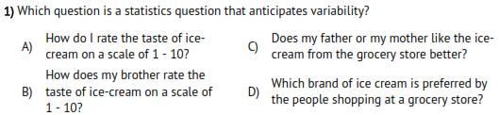

Interpreting and Analyzing Graphs
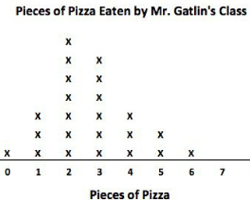
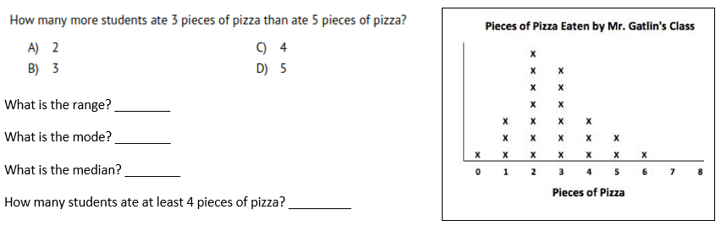

How many people were included in the survey?__________

What is the shape of the data?
A) skewed left B) skewed right C) symmetrical

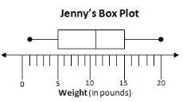
What percent of Jenny’s data
is less than 15? ___________

What is the IQR? __________

What is the shape of the data?
A) skewed left B) skewed right C) symmetrical

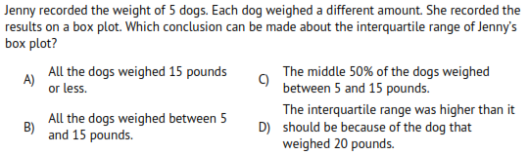
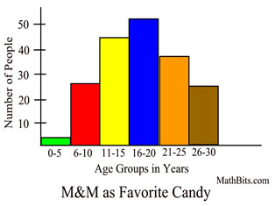
How many people were
younger than 11?
A) 1 B) 5
Unit 6 Mastery Score:

________________ / 17
C) 20 D) 30

What is the shape of
the data?
A) skewed left
B) skewed right
C) symmetrical
Name:_________________________________

Interpreting and Analyzing Data

15.Find the mean and median of the data.
35, 40, 37, 36, 42, 42, 34
a. mean: 38; median: 37
b. mean: 38; median: 42
c. mean: 37; median: 38
d. mean: 42; median: 37

16. Find a set of 5 items that has a range of
9, a mean of 15, a median of 14, and a
mode of 11.
a. 11, 11, 13, 15, 20
b. 5, 11, 14, 14, 31
c. 11, 11, 14, 19, 20
d. 6, 10, 14, 15, 15

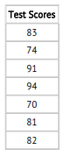
17. What is the IQR of Fred’s
test scores?
a. 2
b. 17
c. 24
d. 82

