**Math Whiz Unit 5 Review**

**Nets & Surface Area:**

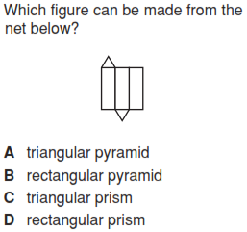

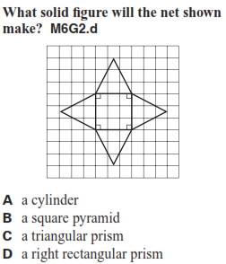

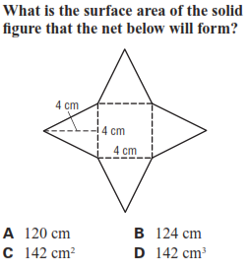

A. 48 sq. cm B. 64 sq. cm

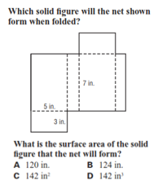 C. 96 sq. cm D. 112 sq. cm

**Name: _________________________**

**Area**:

Using the formula  , find the area.

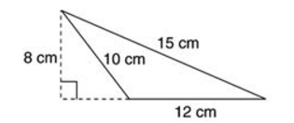

**A**. 48 cm2 **B**. 60 cm2

**C**. 96 cm2 **D**. 120 cm2

What is the area of the composite figure?

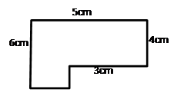

**A**. 20 cm2 **B**. 24 cm2

**C**. 42 cm2 **D**. 60 cm2

**Volume**:

What is the volume of a tank that is 1 ½ inches tall, 8 inches wide, and ¼ inches long?

(V = lwh)

A. 3 cubic inches B. 4 cubic inches

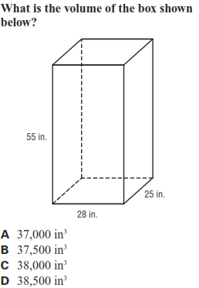 C. 5 ¼ cubic inches D. 9 ¾ cubic inches

