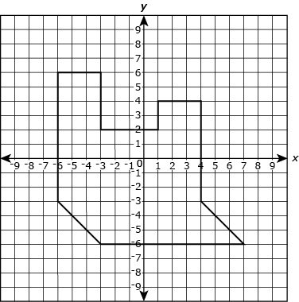
GoFar Performance Task – Composite Area & Distance Name:_____________

Part A
Label the ordered pairs of ALL 10 vertices.

Part B
- Clearly decompose the polygon into smaller polygons.
- Label the base and height of each figure, AND label the area of each one.

Part C
Explain TWO methods that could be used to find the area of the polygon.
1)

2)

Part D
What is the total area, in square units, of the polygon?

GoFar Performance Task – Composite Area & Distance Name:_____________

Part A
Label the ordered pairs of ALL 10 vertices.

Part B
- Clearly decompose the polygon into smaller polygons.
- Label the base and height of each figure, AND label the area of each one.

Part C
Explain TWO methods that could be used to find the area of the polygon.
1)

2)

Part D
What is the total area, in square units, of the polygon?

