**Skills Practice**

**Step 1**: Write your formula.

**Step 2**: Substitute for the base and height.

**Step 3**: Solve.

***Area of Trapezoids***

**Find the area of each figure. Remember to write your answer in square units!**

**1. 2.**

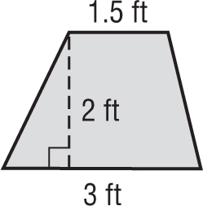

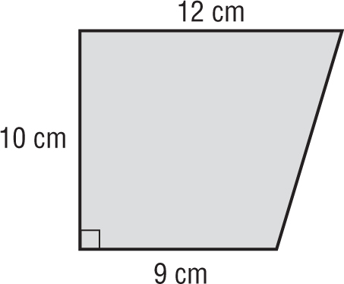

**3. 4.**

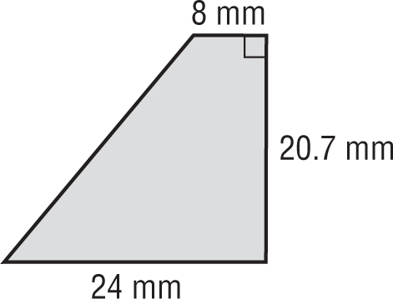

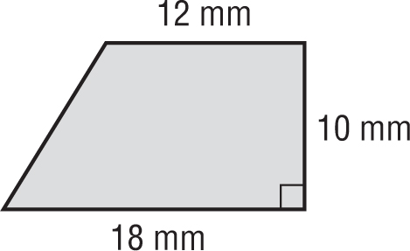

16 mm

**5. 6.**

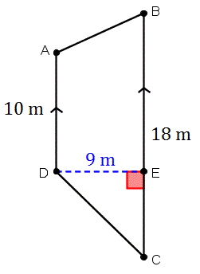

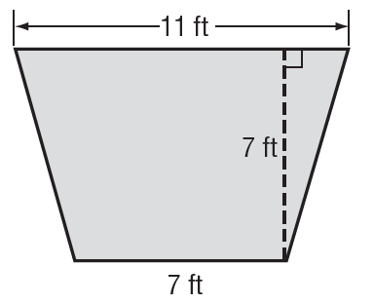

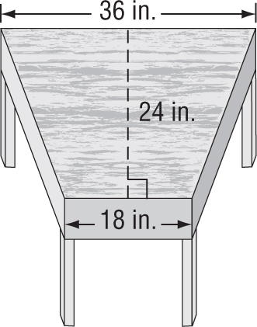

**7. DESKS** What is the area of the top of the desk shown at right?