Student Name: ______________________________Pd: 3
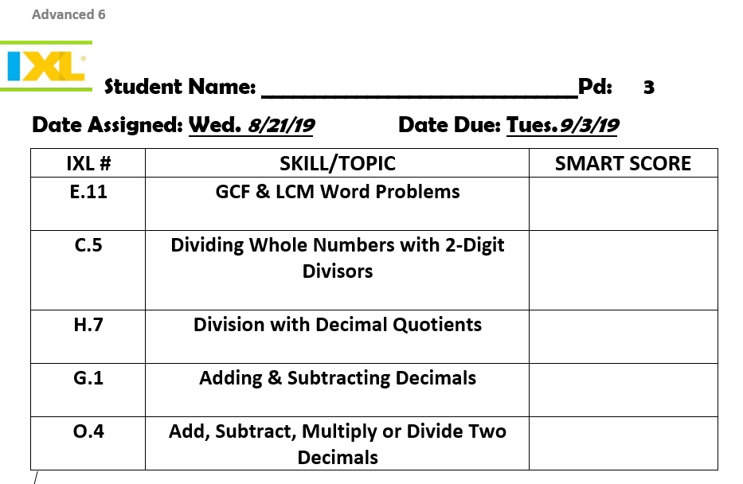
Date Assigned: Wed. 8/21/19 Date Due: Tues.9/3/19
IXL # | SKILL/TOPIC | SMART SCORE
E.11 | GCF & LCM Word Problems
C.5 | Dividing Whole Numbers with 2-Digit Divisors
H.7 | Division with Decimal Quotients
G.1 | Adding & Subtracting Decimals
O.4 | Add, Subtract, Multiply or Divide Two Decimals

