Test Review Name _________________________
Knowledge and Understanding
- What is a ratio? _________________________________________________________________________________

What is a rate?__________________________________________________________________________________

What is a unit rate?______________________________________________________________________________

- What is a percent? __________________________________

Proficiency of Skills
- Fill in the ratio table
9 | 18 |  |  | 45
12 |  | 36 | 48

- 80 is 25% of what number? ________________________

- Find 30% of 70. _____________________

- Determine the missing value. ________________________

- Write the ratio as a unit rate: $27 for 9 tickets _____________________
Application
- Jaden drove 260 miles in 4 hours. Jada drove 210 miles in 3 hours. Who drove at the fastest rate of speed? How do you know?
- Who drove the fastest?______________________________
- How do you know?

- A circus elephant is going to stand on a ball. Lulu the Elephant weighs 2 Tons. If the ball can hold up to 3,000 pounds, will Lulu make it? Explain your answer.

- The table below shows the number of each item sold at the concession stand. What might the ratio 3:4 represent?
Item | Quantity Sold
Popcorn | 20
Nachos | 15
Hot Dog | 25
Candy Bar | 30

- The ratio of boys to girls in a class is 4:8. If there are 24 students in the class, how many are boys?

- In a class of 40 students, 30% DID return their permission slips for the school field trip. How many students did NOT return their permission slips?

- The table below shows the cost for varying number of books. If the rate stays the same, determine the value of n.
Number of Books | Cost
6 | $24
10 | $40
12 | $48
20 | N

- PBIS Middle School held a car wash as a fundraiser. Out of the 50 vehicles that were washed, 15 were trucks. What percent were trucks?

- The graph below compares cups to pints. Which of the following ordered pairs would also satisfy this relationship?
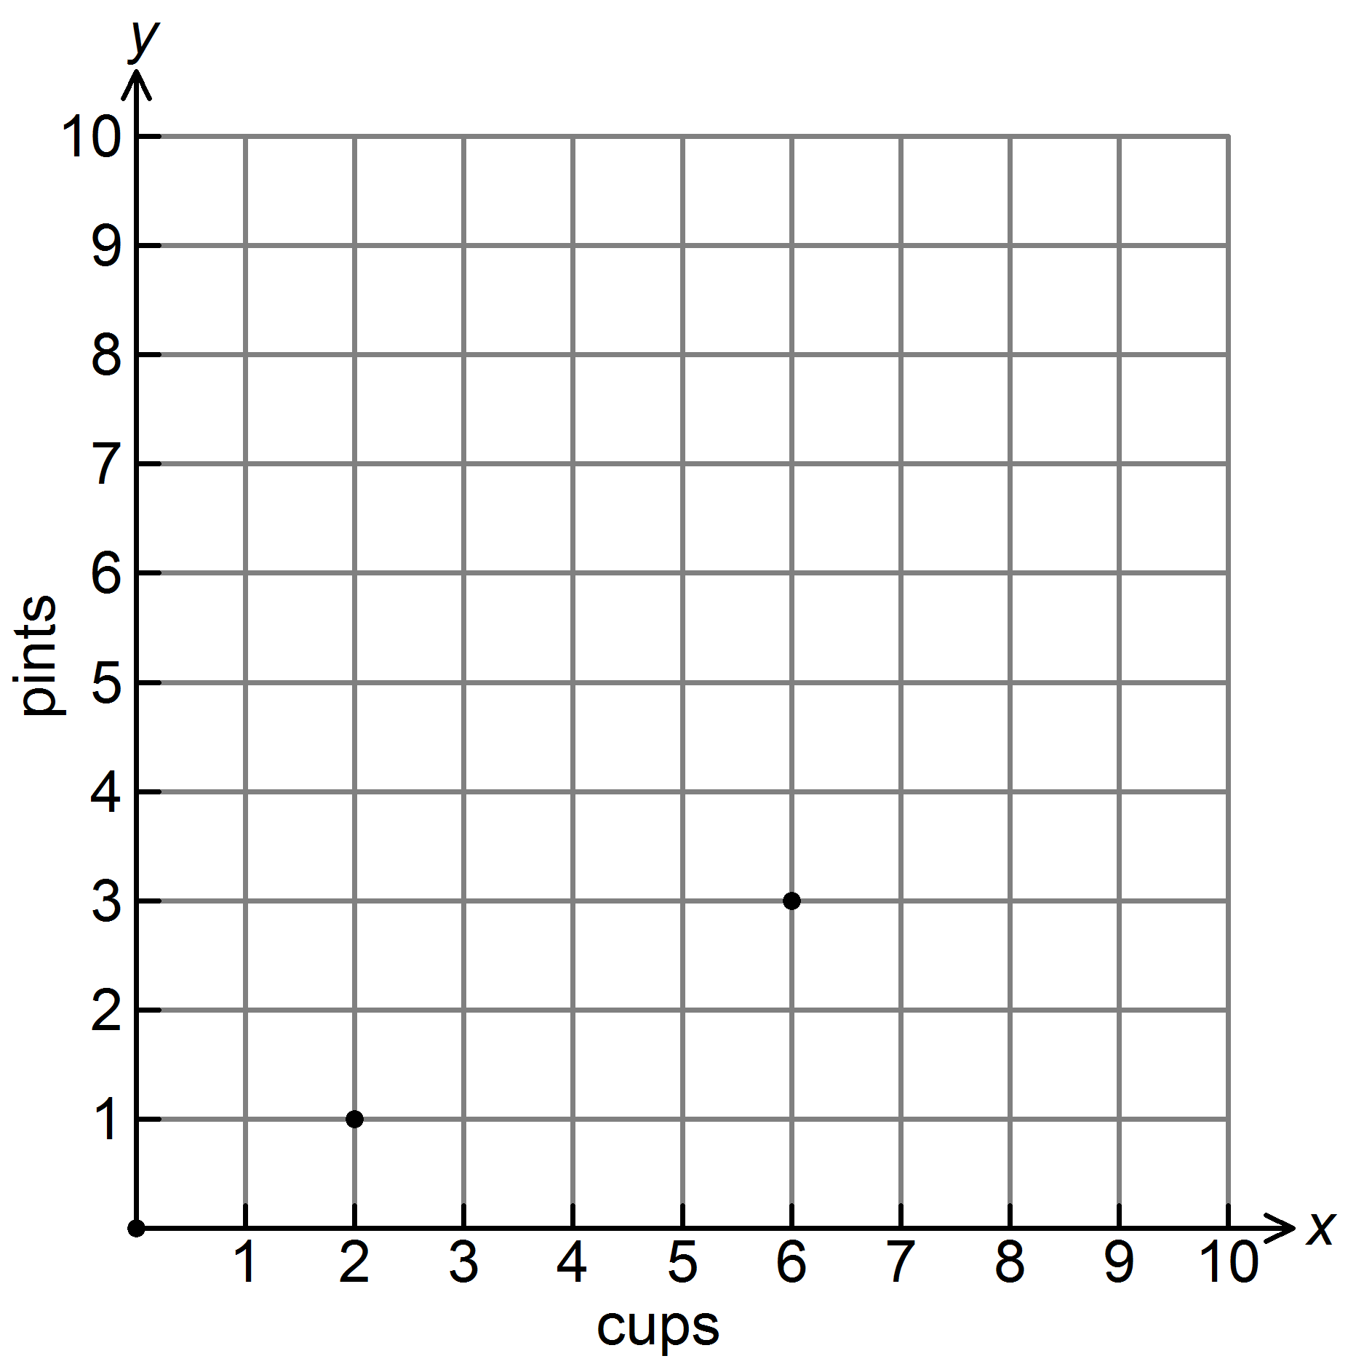
A. | (1, 2) | B. | (2, 4) | C. | (2, 0) | D. | (4, 2)

- Michael’s paycheck last week was $146.50. He would like to put 20% of his earnings in his savings account. How much money should he put in his savings account?
- $5.02 |  | - $15.22 |  | - $29.30 |  | - $88.27

- The prices of 4 different bottles of lotion are given in the table. Which size bottle is the BEST value?
Size | Price
25 ounces | $4.50
15 ounces | $1.80

- The 25-oz bottle
- The 15-oz bottle
- They both have the same unit price
- Neither

- Driving at a constant speed, Daisy drove 240 miles in 6 hours. How far would she drive in 1 hour? 15 hours?

- Chompers is 76 cm long. How many mm is this?

- .76 mm b. 7.6 mm c. 760 mm 7,600 mm

