Modeling Integer Addition on a Number Line
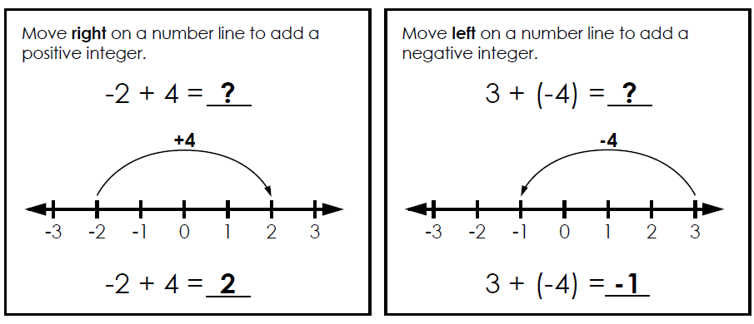

Solve each problem. Show your work using the number lines.
1) | -5 + 4 = _______
2) | -2 + (-7) = _____
3) | 6 + (-4) = _____
4) | 0 + (-8) = _____
5) | -9 + 15 = _____
6) | 3 + (-10) = ____
7) | -2 + (-8) = _____
8) | 6 + (-1) = _____

Modeling Integer Addition on a Number Line

Solve each problem. Show your work using the number lines.
1) | -5 + 4 = _______
2) | -2 + (-7) = _____
3) | 6 + (-4) = _____
4) | 0 + (-8) = _____
5) | -9 + 15 = _____
6) | 3 + (-10) = ____
7) | -2 + (-8) = _____
8) | 6 + (-1) = _____

