**Silly Sally Error Analysis Name:_________________**

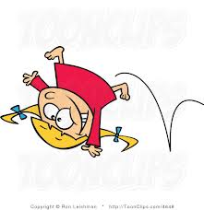

Sally is a silly little girl that makes silly mistakes! Analyze her work in Column #1, and *circle her mistake*. In Column #2, explain what she did wrong. In Column #3, show how Silly Sally should work out the problem. Show ALL work!

|  |  |  |
| --- | --- | --- |
| **Silly Sally’s Work**  **(Circle her mistake):** | **What did Silly Sally do wrong?** | **Show Silly Sally how it’s done!**  **(Show ALL steps!)** |
| -24  144  -144  000 |  |  |
| 86    -80  60  -60  00 |  |  |
|  |  |  |

**Silly Sally Error Analysis Name:_________________**



Sally is a silly little girl that makes silly mistakes! Analyze her work in Column #1, and *circle her mistake*. In Column #2, explain what she did wrong. In Column #3, show how Silly Sally should work out the problem. Show ALL work!

|  |  |  |
| --- | --- | --- |
| **Silly Sally’s Work**  **(Circle her mistake):** | **What did Silly Sally do wrong?** | **Show Silly Sally how it’s done!**  **(Show ALL steps!)** |
| -24  144  -144  000 |  |  |
| 86    -80  60  -60  00 |  |  |
|  |  |  |

