**Math 6 – Unit 1: Number System Fluency REVIEW**  **SHOW ALL WORK!!!**

1. Explain what it means if you are asked to solve the problem  . You may use any method, but explain clearly!
2. Find the greatest common factor of 30 and 48. __________
3. Find the least common multiple of 10 and 6. __________
4.  5. 13.12 + 6 + 7.1 = __________

6. (1.25)(2.3) = __________ 7. _______________

8. 72 – 1.68 = __________ 9. 

10. Talia waters her plants every 4 days. She trims them every 10 days. She did both today. In how many days will she

do both again?

1. A quarterback practiced for hours in 4 weeks. How many hours did he practice per week?
2. Sarah paid $4.80 for 1.2 pounds of sunflower seeds. What is the cost for one pound of sunflower seeds?
3. Hot dogs are sold in packages of 8 and hot dog buns are sold in packages of 10. What is the least number of packages of each that can be bought to make hot dogs (one hot dog and one bun) with no hot dogs or buns left over?

______ total number of hot dogs ______ packs of hot dogs ______ packs of buns

1. A group of friends has ordered 3 pizzas to share. If each person gets 1/4 of a pizza, and there is no pizza left over, how many friends split the pizza?
2. Emma has $3 to buy school supplies. She buys 3 folders that are $0.55 each. She wants to spend the remaining money on pencils that are $0.05 each. How many pencils can she purchase?
3. Chesney is cutting a roll of cookie dough into pieces that are $\frac{1}{3}$ inch thick, if the roll of cookie dough is $\frac{4}{6}$ inches long, which model best represents, the situation?

a.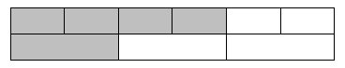 b.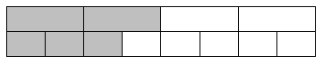 c.