Student Name: __________________________Pd: 1 2 3 4
IXL # | SKILL/TOPIC | SMART SCORE
R.14 | Identify Proportional Relationships (DV) from Graphs
R.17 | Interpret Graphs of Proportional Relationships (DV)
BB.2 | Identify Independent and Dependent Variables
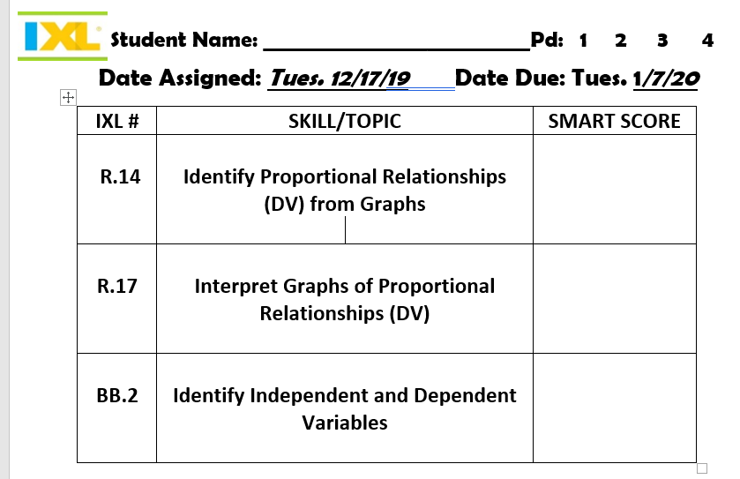
Date Assigned: Tues. 12/17/19 Date Due: Tues. 1/7/20

