IXL # | SKILL/TOPIC | SMART SCORE
4.O-5 | Elapse Time
Y-8 | Properties of Addition
Y-9 | Properties of Multiplication
Y-10 | Distributive Property
Y-15 | Identify Equivalent Expressions

Student Name: ______________________________Pd: 3
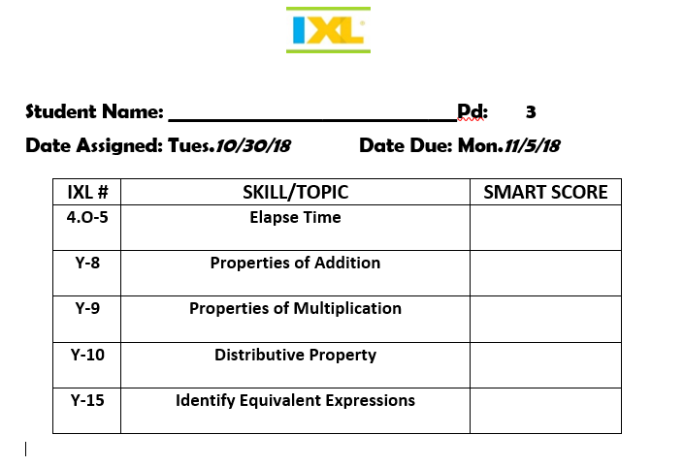
Date Assigned: Tues.10/30/18 Date Due: Mon.11/5/18

