IXL # | SKILL/TOPIC | SMART SCORE
4.O-5 | Elapse Time
0-3 | Evaluate Numerical Expressions
Y-1 | Write Variable Expressions

Student Name: __________________________Pd: 1 2 3 4
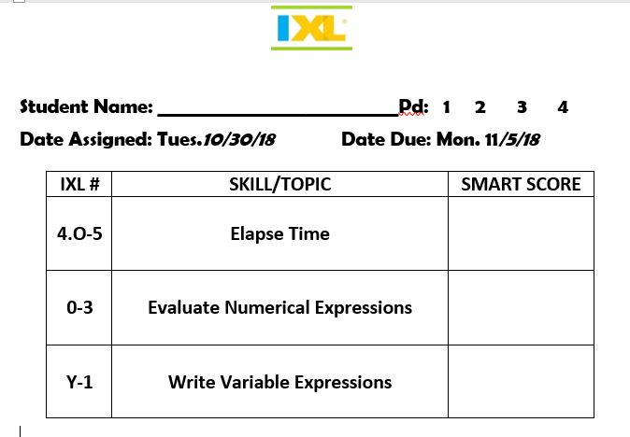
Date Assigned: Tues.10/30/18 Date Due: Mon. 11/5/18

