Unit 9 Quiz 1: Simplifying Expressions

Name:__________________________________________

Write each expression in simplest form.

- 8(m – 3) = ______________________________ | - 2(a + b) + 3(a – b) = ____________________
- -11(x + 4) = _____________________________ | - -6x(3 + 2) – 3x² + 5x² = ___________________
- 7y – 3x + 18y + 3x = ______________________ | - 14a – (-3a - 2) + 20a = ___________________
- 3m – 8m = ______________________________ | - -12(m + 2) + 12m – (-24) = _______________

Area & Algebra

Use this figure to answer problems 9-10. Write each expression in simplest form.  (3x + 4) meters  15 meters | - What is the perimeter of the rectangle?
 | - What is the area of the rectangle?
Use this figure to answer problems 11-12. Write each expression in simplest form.  x + 4  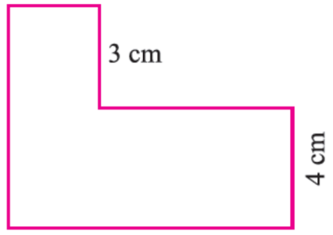  5x + 7 | - What is the perimeter of the rectangle?
 | - What is the area of the rectangle?

