Unit 7

Rational Explorations

Numbers & their Opposites

Number Lines

Real World Examples

Absolute Value

Order Rational Numbers

Graph on Coordinate Plane

Distance on Coordinate Plane

Reflect on Coordinate Plane

Draw Polygons on Coordinate Plane

**Name:**

**Math Teacher:**

|  |  |  |  |  |
| --- | --- | --- | --- | --- |
| Math 6  Unit 7 Calendar | | | | |
| 3/18 | **3/19** | **3/20** | **3/21** | **3/22** |
|  |  |  | **Intro to Integers Graphing on Number Lines** | **Absolute Value** |
| IXL Skills Week of 3/18: M.1, M.2 | | | | |
| 3/25 | **3/26** | **3/27** | **3/28** | **3/29** |
| Computer Lab | **Trip to Mercedes Benz Stadium** | **Above and Below** | **Comparing and Ordering** | **Quiz #1** |
| IXL Skills Week of 3/25: M.3, M.4, M.5, M.6 | | | | |
| Week of 4/1 | | | | |
| SPRING BREAK | | | | |
| IXL Skills Week of 4/1: Work on Any Skills Not Completed | | | | |
| 4/8 | **4/9** | **4/10** | **4/11** | **4/12** |
| Coordinate Graphing | **Distance Between 2 Points & Drawing Polygons** | **Reflection** | **Review** | **Unit 7 End of Unit Test** |
| IXL Skills Week of 3/11: X.1, X.2, X.4, X.5 | | | | |
| 4/15 | **4/16** | **4/17** | **4/18** | **4/19** |
| Milestone Review | **Milestone Review** | **Milestone Review** | **Milestone Review** | **Milestone Review** |
| IXL Skills Week of 3/11: X.1, X.2, X.4, X.5 | | | | |

**Unit 7: Rational Explorations: Numbers & their Opposites**

**Standards, Checklist and Concept Map**

**Georgia Standards of Excellence (GSE):**

**MGSE6.NS.5**: Understand that positive and negative numbers are used together to describe quantities having opposite directions or values (e.g., temperature above/below zero, elevation above/below sea level, debits/credits); use positive and negative numbers to represent quantities in real-world contexts, explaining the meaning of 0 in each situation.

**MGSE6.NS.6**: Understand a rational number as a point on the number line. Extend number line diagrams and coordinate axes familiar from previous grades to represent points on the line and in the plane with negative number coordinates.

**MGSE6.NS.6a**: Recognize opposite signs of numbers as indicating locations on opposite sides of 0 on the number line; recognize that the opposite of the opposite of a number is the number itself, e.g., -(-3) = 3, and that 0 is its own opposite.

**MGSE6.NS.6b**: Understand signs of numbers in ordered pairs as indicating locations in quadrants of the coordinate plane; recognize that when two ordered pairs differ only by signs, the locations of the points are related by reflections across one or both axes.

**MGSE6.NS.6c** : Find and position integers and other rational numbers on a horizontal or vertical number line diagram; find and position pairs of integers and other rational numbers on a coordinate plane

**MGSE6.NS.7**: Understand ordering and absolute value of rational numbers*.*

**MGSE6.NS.7a** : Interpret statements of inequality as statements about the relative position of two numbers on a number line diagram.

**MGSE6.NS.7b** : Write, interpret, and explain statements of order for rational numbers in real-world contexts.

**MGSE6.NS.7c** : Understand the absolute value of a rational number as its distance from 0 on the number line; interpret absolute value as magnitude for a positive or negative quantity in a real-world situation.

**MGSE6.NS.7d** : Distinguish comparisons of absolute value from statements about order.

**MGSE6.NS.8** : Solve real-world and mathematical problems by graphing points in all four quadrants of the coordinate plane. Include use of coordinates and absolute value to find distances between points with the same first coordinate or the same second coordinate.

**MGSE6.G.3** : Draw polygons in the coordinate plane given coordinates for the vertices; use coordinates to find the length of a side joining points with the same first coordinate or the same second coordinate. Apply these techniques in the context of solving real-world and mathematical problems.

**Unit 7 Concept Map:** Make a concept map of the standards listed above. Underline the verbs and circle the nouns they modify. Then, place those verbs on the connector lines of your concept map, and the nouns in the bubbles of the concept map.

**What Will I Need to Learn??**

_______ How to describe real-world situations using positive and negative numbers

_______ To represent numbers as locations on number lines

_______ To understand opposites (inverses) on a number line

_______ To graph ordered pairs (including negatives) on a coordinate plane

_______ To understand that opposites in ordered pairs indicate a reflection on a coordinate plane

_______ Interpret inequalities, comparing two numbers on a number line

_______ Order rational numbers

_______ Understand absolute value (distance from zero)

_______ Compare and order absolute value

_______ Determine the distance between points on a coordinate plane

_______ Draw polygons in the coordinate plane, given the coordinates for the vertices

**Unit 7 IXL Tracking Log**

|  |  |  |
| --- | --- | --- |
|  | **Required Skills** | |
|  | **Skill** | **Your Score** |
| **Week of 3/18** | **M.1** (Understanding Integers) |  |
| **M.2** (Integers on Number Lines) |  |
| **Week of 3/25** | **M.3** (Absolute Value and Opposites) |  |
| **M.4** (Graph Integers on Horizontal & Vertical Number Lines) |  |
| **M.5** (Comparing Integers) |  |
| **M.6** (Ordering Integers) |  |
| **Week of 4/8** | **X.1** (Objects on Coordinate Planes) |  |
| **X.2** (Graph Points on a Coordinate Plane) |  |
| **X.4** (Coordinate Planes as Maps) |  |
| **X.5** (Distance Between Two Points) |  |
| **Optional Skills** | | |
|  |  |  |

**Unit 7 Vocabulary**

|  |  |
| --- | --- |
| **Vocabulary Term** | **Definition** |
| absolute value | The distance between a number and zero on a number line. |
| coordinate plane | A plane, also called a coordinate grid or coordinate system, in which a horizontal number line and a vertical number line intersect at their zero points. (0,0) |
| Inequality | A statement that compares two quantities using the symbols >, <, >, <, or ≠. |
| integer | Any number from the set {… -4, -3, -2, -1, 0, 1, 2, 3, 4 …} where … means *continues without end*. |
| negative integer | A number that is less than zero. |
| Opposites | Two integers are opposites if they are represented on the number line by points that are the same distance from zero, but on opposite sides of zero. The sum of two opposites is zero. |
| ordered pair | A pair of numbers used to locate a point in the coordinate plane. An ordered pair is written in the form (*x*-coordinate, *y*-coordinate). |
| Origin | The point (0, 0) in a coordinate plane where the *x*-axis and the *y*-axis intersect. |
| positive integer | A number that is greater than zero. It can be written with or without a + sign. |
| Quadrants | The four regions in a coordinate plane separated by the *x*-axis and *y*-axis. |
| Reflection | A transformation in which a figure or ordered pair is flipped over a line of symmetry. |
| Sign | A symbol that indicates whether a number is positive or negative. |
| x-coordinate | The first number in an ordered pair. (It tells you how far left or right to go from the origin.) |
| y-coordinate | The second number in an ordered pair. (It tells you how far up or down to go from the origin.) |

**Unit 7 Vocabulary – You Try**

|  |  |
| --- | --- |
| **Vocabulary Term** | **Definition** |
| absolute value | The distance between a number zero on a number line. |
| coordinate plane | A plane, also called a coordinate grid or coordinate system, in which a horizontal number line and a vertical number line intersect at their zero points. (0,0) |
| inequality | A statement that compares two quantities using the symbols >, <, >, <, or ≠. |
| integer | Any number from the set {… -4, -3, -2, -1, 0, 1, 2, 3, 4 …} where … means *continues without end*. |
| negative integer | A number that is less than zero. |
| opposites | Two integers are opposites if they are represented on the number line by points that are the same distance from zero, but on opposite sides of zero. The sum of two opposites is zero. |
| ordered pair | A pair of numbers used to locate a point in the coordinate plane. An ordered pair is written in the form (*x*-coordinate, *y*-coordinate). |
| origin | The point (0, 0) in a coordinate plane where the *x*-axis and the *y*-axis intersect. |
| positive integer | A number that is greater than zero. It can be written with our without a + sign. |
| quadrants | The four regions in a coordinate plane separated by the *x*-axis and *y*-axis. |
| reflection | A transformation in which a figure or ordered pair is flipped over a line of symmetry. |
| sign | A symbol that indicates whether a number is positive or negative. |
| x-coordinate | The first number in an ordered pair. (It tells you how far left or right to go from the origin.) |
| y-coordinate | The second number in an ordered pair. (It tells you how far up or down to go from the origin.) |

**Integers & Graphing on a Number Line**

Positive whole numbers, their opposites and the number zero are called _______________. To represent data that are less than a 0, you can use _______________ integers. A negative integer is written with a ___ sign. Data that are greater than zero are represented by _______________ integers.

_______________ and sets of integers can be graphed on a horizontal or vertical _______________ line. To graph a point on a number line, draw a _______________ on the number line at its location. A set of integers is written using braces, such as {2, -9, 0}.

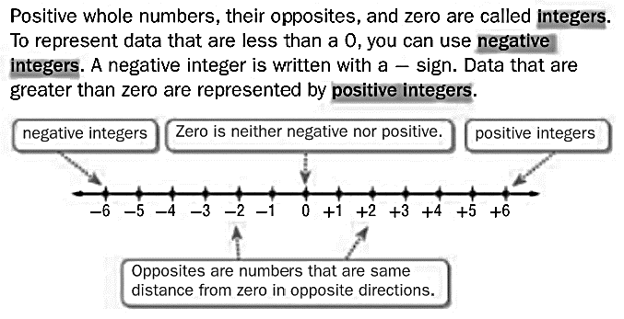

**Example:**

***Write an integer for each situation.***

1. a 10-yard loss - Because it represents a loss, the integer is ***-10***. In football, the integer 0 represents the normal amount of rain.
2. 4 inches above normal - Because it represents **above** normal, the integer is ***4***. In this situation, the integer 0 represents the normal amount of rain.
3. 16 feet under the ground - Because it is *under* the ground, the integer is ***–16***.
4. a gain of 5 hours - Because it is a *gain*, the integer is ***5***.

**You Try:**

***Write an integer for each situation.***

1) a profit of $60 2)a decrease of 10°

3)a loss of 3 yards 4)a gain of 12 ounces

5) a gain of $2 6) 20° below zero

**Example:**

**Graph the set of integers {–5, –2, 3} on a number line.**

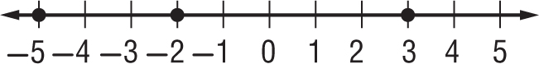

**You Try:**

1)Graph the set {–6, 5, –4, 3, 0, 7} on a number line.



2)Graph the set {–5, 1, –3, -1, 3, 5} on a number line.



**Opposites**

Positive numbers, such as 2, are graphed to the _______ of zero on a number line. Negative numbers, such as -2, are graphed to the ________ of zero on a number line.

Opposites are numbers that are the same _______________ from zero in opposite directions. Since 0 is not negative or positive, it is its own opposite.

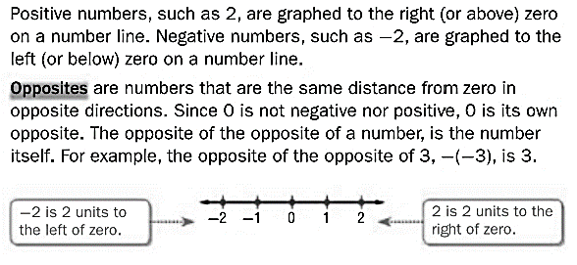

**Example:**

***Find the opposite of the given number.***

1) The opposite of **-12** is: 12 2)The opposite of **8** is: -8

**You Try:**

***Find the opposite of the given number.***

1) The opposite of **-5** is: 2)The opposite of **0** is:

3)The opposite of **100** is: 4)The opposite of **-34** is:

5) The opposite of **-13** is: 6) The opposite of **7** is:

7) The opposite of **-1000** is: 8) The opposite of **50** is:

9) The opposite of **-48** is: 10) The opposite of **1** is:

**Absolute Value**

**Graph A:**

Number of Siblings

**Graph B:**

Number of Pets

**WORDS** The absolute value of a number is the __________ between the number and zero on a number line.

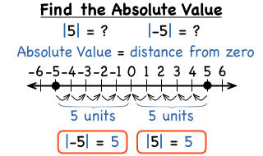**MODEL**

**SYMBOLS** |5| = 5 The absolute value of 5 is 5.

|-5| = 5 The absolute value of -5 is 5.

_______________ _______________ is always _________________!

Absolute value is a **distance** and distance is always positive.

**Example:**

|125| = 125 |-5|+ |25| = 5 + 25 = 30

|-8|-|-5| = 8 – 5 = 3 -|-16| = -16

**You Try:**

***Find the absolute value for each of the problems below.***

1) |25| 2) |-150| 3) -|379|

4) |-2486| 5) |1273| 6) -|-68|

7) |-5| + |16| 8) |-30|-|-12| 7) |-7| + |13| + |49|

10) Graph |-6| on the number line below and show that it is a distance from zero.

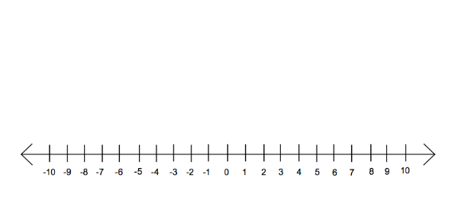

Above and Below Sea Level

***In the space to the right, draw the following and then answer the questions below to discover the shipwreck’s treasure.***

A wavy line for sea level, **a bird at +10 meters**, a diver at +20 meters, **an airplane taking off at +70 meters**, a fish at -20 meters, **a whale at -50 meters**, a shipwreck at -90 meters, **an underwater diver at -30 meters**, a boat at sea level, and **a submarine at -70 meters**. Also draw a cliff with a height of +80 meters.

What is the treasure in the shipwreck? To find the treasure, draw the items on the next page and then answer the questions below and write the letters in the spaces that represent the correct answers.

|  |  |  |  |
| --- | --- | --- | --- |
| 1) | How many meters from the top of the cliff to the shipwreck? | ________ | (O) |
| 2) | How many meters from the whale to the submarine? | ________ | (S) |
| 3) | How many meters from the airplane to the boat? | ________ | (A) |
| 4) | How many meters from the fish to the whale? | ________ | (E) |
| 5) | Which is farther from the submarine, the fish or the whale? BY how many meters? | ________ | (I) |
| 6) | Which is closer to the shipwreck, the fish or the underwater diver? By how many meters? | ________ | (L) |
| 7) | The whale swims to sea level and then swims to the shipwreck. How far does he swim in all? | ________ | (R) |
| 8) | The submarine rises to sea level and then dives to the bottom of the sea. How far does a the submarine travel in all? | ________ | (P) |
| 9) | The boat springs a leak and sinks to the bottom of the sea. How many meters did it sink? | ________ | (M) |
| 10) | The underwater diver wants to reach the submarine, how much farther does he need to swim? | ________ | (N) |
| 11) | The diver makes 3 trips from the boat (before it sinks) to the shipwreck. How many meters will he travel? | ________ | (D) |

|  |  |  |  |  |  |  |  |  |  |  |  |
| --- | --- | --- | --- | --- | --- | --- | --- | --- | --- | --- | --- |
| ____ | ____ | ____ | ____ | ____ | ____ | ____ | ____ |  | ____ | ____ | ____ |
| 540 | 50 | 70 | 90 | 170 | 40 | 540 | 20 |  | 70 | 40 | 540 |

|  |  |  |  |  |  |
| --- | --- | --- | --- | --- | --- |
| ____ | ____ | ____ | ____ | ____ | ____ |
| 160 | 30 | 70 | 140 | 60 | 20 |

Meters

+80

+70

+60

+50

+40

+30

+20

+10

sea level 0

-10

-20

-30

-40

-50

-60

-70

-80

-90

**Comparing Integers & Absolute Values**

To ____________ integers, you can compare signs as well as the magnitude, or size, of the numbers. Greater numbers are graphed farther to the ____________.

If two numbers are different signs, the ____________ number is always greater than the negative number.

If two numbers are the same sign, use a ____________ line to determine which number is greater.

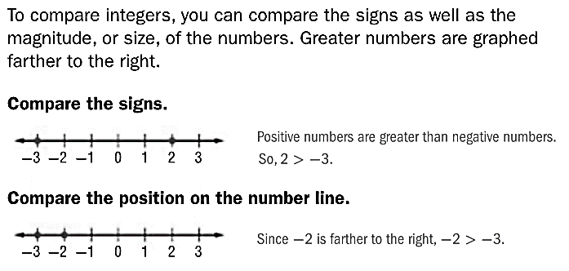

Don’t forget, alligators always eat the bigger number.

**13**

**-20**

**3**

**-2**

**You Try:**

1) |8| _____ |-6| 2) |-6| _____ |6|

3) -122 _____ 300 4) |-4| _____ 4

5) |-12| _____ 9 6) |-21| _____ 0

7) 1 _____ |-1| 8) -2 _____ -4

9) |4| _____ -4 10) 20 _____ 0

**Ordering Integers & Absolute Values**

You can use a number line to order a set of integers. ______________ can be ordered from least to greatest or from greatest to least.

**Example:**

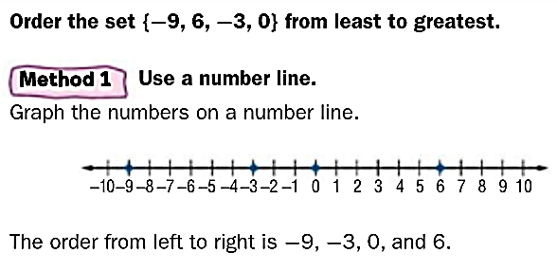

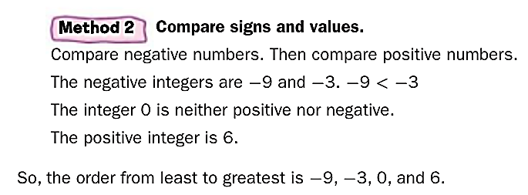Before you put absolute values in order, find their value.

**Example:**

***Put the following numbers in order from* LEAST *to* GREATEST*:*** |6|, |-12|, |-2|, |1|

|6| = 6 |-12| = 12 |-2| = 2 |1| = 1

From least to greatest: |1|, |-2|, |6|, |-12|

**You Try**

1) 0, 3, −21, 9, −89, 8, −65, −56

2) 70, −9, 67, −78, 0, 45, −36, −19

3) . 0, -1, |-2|, |3|

4) -24, |-20|, 21, -26

5) . |1|, -1, |-2|, -2

6) 12, 8, −9, −12, 10, 16

**Extra Practice**

***For #’s 1-4, write an integer for each situation:***

1) 45 feet below sea level 2) a gain of 8 yards

3) $528 deposit into your account

4) 10 units to the left on a number line

5)Graph the set {–4, 3, 0, -3, 7, -5} on the number line.



6) The opposite of **-57** is: 7)The opposite of **-43** is:

8)The opposite of **1000** is: 9)The opposite of **325** is:

***Find the absolute value for each of the problems below.***

10) |4| 11) |-41| 12) -|11|

13) |-125| 14) |526| 15) -|-3|

***Use the symbols $<, >, =$ to compare the following numbers.***

16) |66| _____ |33| 17) |-24| _____ |82|

18) 88 _____ -99 19) |-37| _____ 37

***Put the numbers in order from least to greatest.***

20) -89, 42, -26, 8

21) -91, -46, 52, 12, 0

**The Coordinate Plane**

* The Coordinate Plane is a grid consisting of two perpendicular number lines, the (horizontal) **x-axis** and (vertical) **y-axis**
* The axes intersect at point **(0,0),** also known as the “**origin**”
* The four open areas are called “**quadrants**”
* Points can be plotted on the plane using a pair of x- and y- coordinates called “**ordered pairs**”.

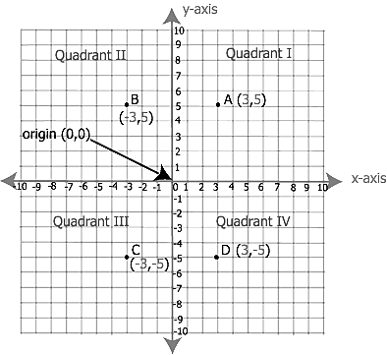

**Plotting Points**

ALL ordered pairs are written as (x,y).

The **1st** number tells how far to go **ACROSS** on the **X**-axis

The **2nd** number tells how far to go **UP OR DOWN** the **Y**-axis.

*Remember you have to walk* ***IN*** *a building before you can go* ***UP*** *or* ***DOWN*** *the elevator!*

**Points and Ordered Pairs**

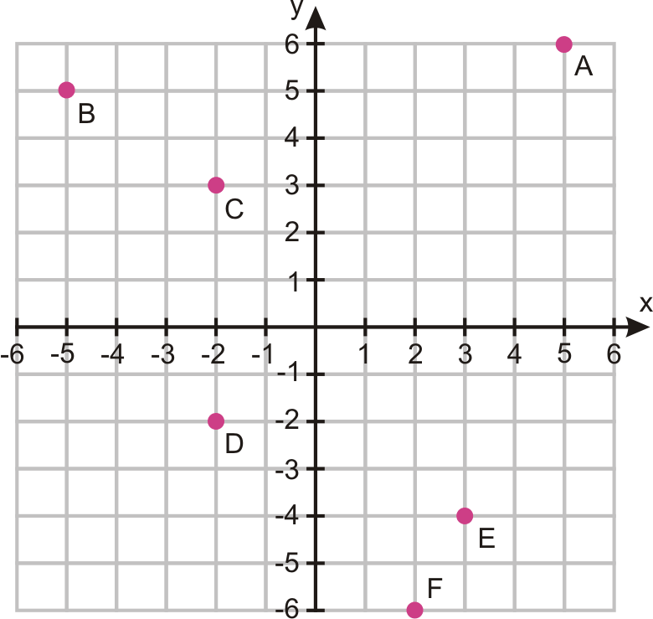

***Use the coordinate grid above to find the coordinates for each point and tell what quadrant they are in.***

**Example:**

A: (5 , 6) Quadrant I

**You Try:**

B: ( , ) Quadrant ____ C: ( , ) Quadrant ____

D: ( , ) Quadrant ____ E: ( , ) Quadrant ____

F: ( , ) Quadrant ____

***Use the coordinate plane below to graph the following points.***

**Example:**

**J** (-5, 4)

**You Try:**

**C** (0,0) **H** (4,3) **O** (-2,-1)

**R** (-4,0) **A** (-2,3) **K** (3,-1)

**M** (-4,5) **T** (0,4) **S** (4,-3)

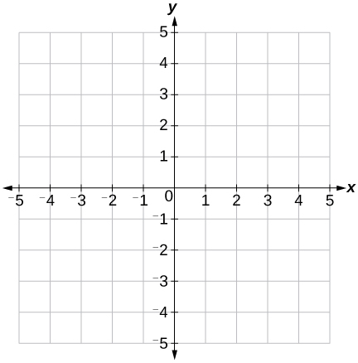

**J**

**Reflections on the Coordinate Plane**

A ______________ is a “mirror image” of an object that has been “flipped” over an axis. You can use what you know about number lines and opposites to compare locations on the coordinate plane. Consider the number line and coordinate plane below.

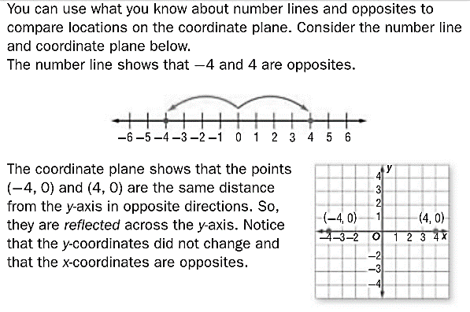

**Example:**

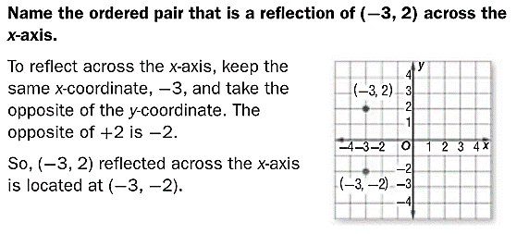

**You Try:**

***Find the ordered pair that is a reflection over the x-axis and then the y-axis of each of the points below.***



**(-3,-1)**

**(-2,5)**

**(1,-4)**

|  |  |  |
| --- | --- | --- |
| **Original Point** | **Reflected over**  **x-axis** | **Reflected over**  **y-axis** |
| (-2,5) | **( , )** | **( , )** |
| (-3,-1) | **( , )** | **( , )** |
| (1,-4) | **( , )** | **( , )** |

***Find the ordered pair that is a reflection over the x-axis and then the y-axis of each of the points below.***



**(4,5)**

**(-2,2)**

**(3,-3)**

|  |  |  |
| --- | --- | --- |
| **Original Point** | **Reflected over**  **x-axis** | **Reflected over**  **y-axis** |
| (-2,2) | **( , )** | **( , )** |
| (4,5) | **( , )** | **( , )** |
| (3,-3) | **( , )** | **( , )** |

***Graph each ordered pair and find a reflection over the x-axis and then the y-axis for each point.***



|  |  |  |
| --- | --- | --- |
| **Original Point** | **Reflected over**  **x-axis** | **Reflected over**  **y-axis** |
| **S ( -5 , 4 )** | **( , )** | **( , )** |
| **U ( -2 , -1 )** | **( , )** | **( , )** |
| **M ( 4 , 3 )** | **( , )** | **( , )** |

**Graphing Polygons**

You can graph polygons on a coordinate plane by graphing their vertices and connecting them.

**Example:**

A rectangle has vertices *A*(1,1), *B*(1,3), *C*(5,3), and *D*(5,1). Graph the polygon on the coordinate plane.

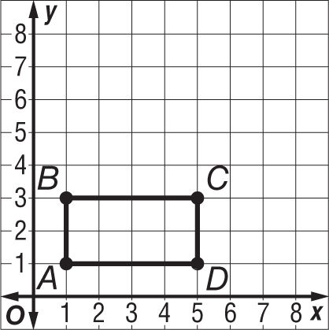

**You Try:**

A rectangle has the following vertices:

***D***(–1, –1), **E**(–1, 3), ***F***(2, 4), and ***G***(2, –3)

Graph the polygon on the coordinate plane.

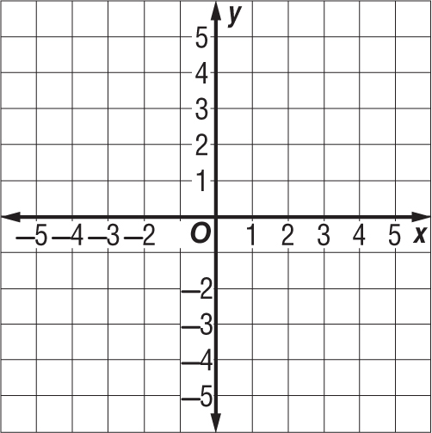

**Distance on a Coordinate Plane**

When two ordered pairs have the same x-coordinate or y-coordinate, they are on the same line.

The distance between these two points can be found by **counting the spaces** between the points.



Points A and C have the same first coordinate. The distance between them is 7 units.

Points A and B have the same second coordinate. The distance between them is 5 units.

Point A is 5 units from Point B. Likewise, B is 5 units from A. We wouldn’t say that they are -5 units away, even though you may move to the left on the number line, because distance is ALWAYS positive. For example, if you traveled 5 blocks to school and forgot your lunch and had to go back for it, you would have traveled another 5 blocks for 10 round trip. In other words, absolute value is always used to calculate distance!

Point A = (-3,3)

Point B = (2,3)

Point C = (-3,4)

You can also use **absolute value** to determine the distance between points!

* Notice Point A = (-3,3) and Point B = (2,3). They have the same y-coordinate, ______.
* That means you’re finding the distance between the x-coordinates, _____ and _____.
* -3 is 3 units from the y-axis, or |-3| = _____
* 2 is 2 units from the y-axis, or |2| = _____
* |-3| + |2| = _______ units

**Examples**:

1. On the coordinate plane below, (2,9) and (2,3) have the same x-coordinate. The distance between them is 6 unites. You can figure this out by:

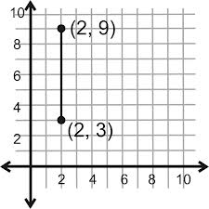

1. Area of a triangle = ½ (b • h). In the figure below, the base is the distance from A to C and which is __________.

The height is the distance from B to C which is __________.

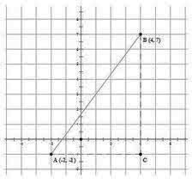What is the area of the triangle? __________

[](http://www.google.com/imgres?hl=en&tbo=d&biw=1600&bih=697&tbm=isch&tbnid=Szsr1hd58YeHEM:&imgrefurl=http://www.heritagepreservation.org/cap/ReCAP.html&docid=Sv8MvY9ODOPE7M&imgurl=http://www.heritagepreservation.org/cap/images/revisedRECAP.png&w=392&h=294&ei=VQfmUKv_EMPw2QXw1IEY&zoom=1&iact=hc&vpx=828&vpy=162&dur=250&hovh=194&hovw=259&tx=115&ty=95&sig=118279028075191188497&page=1&tbnh=141&tbnw=188&start=0&ndsp=34&ved=1t:429,r:5,s:0,i:130)

(1) Count the spaces between the points!

--- OR ---

(2) If one point is positive and one negative, use absolute value and add.

There are 2 WAYS to find the distance between two points…

**You Try:**

Use the graph below to answer the questions in Part 1:

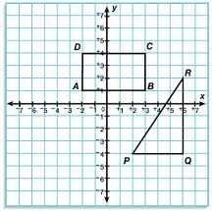

**PART 1**

1) Write the ***ordered pair*** next to each point on the graph.

2) Determine the ***length of each side*** of the rectangle.

If you have room, you may also label them on the graph.

 = _________  = _________

 = _________  = _________

3) What is the ***perimeter*** of rectangle ABCD? ____________

4) What is the ***area*** of rectangle ABCD? ________________

5) Determine the length of the triangle’s base and height:

 = _________  = _________

6) What is the ***area*** of ΔPQR? _________________

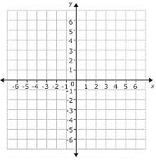

**PART 2**

Bugs Bunny’s home is located at point B (-5 , 4). Yosemite Sam’s home is located at point Y (6 , 4). Sylvester’s home is located at point S (6 , -2). Daffy Duck’s home is located at point D (-5 , -2).

7) Plot each character’s home on the graph above. Label them B, Y, S and D. Connect their homes in the same order they are listed (then connect B & D).

8) What polygon was formed?

9) Find the distance from each house (length of sides):

 = _________  = _________

 = _________  = _________

10) If they march in a parade that begins at Bugs’ house, goes around the rectangle and ends at Bugs’ house, how many units did they travel?

**Area and Perimeter of Polygons**

When two ordered pairs have the same x-coordinate or y-coordinate, they are on the same line.

The ______________ between these two points can be found by **counting the spaces** between the points.

**Example:**

A rectangle has vertices ***A***(1,1), ***B***(1,3), ***C***(5,3), and ***D***(5,1). Find the length of the sides of the rectangle.

$\overline{AB}$ = 2 $\overline{BC}$ = 4 $\overline{CD}$ = 2 $\overline{DA}$ = 4



Use the lengths of the sides to find the area and perimeter of the rectangle.

**Example:**

Perimeter is the distance around the rectangle. Add all of your sides.

P = 2 + 4 + 2 + 4 = 12 units

Find the area by multiplying the base times the height.

A = 4 • 2 = 8 units2

**You Try:**

A rectangle has the following vertices:

***D***(–1, –1), **E**(–1, 3), ***F***(2, 3), and ***G***(2, –1)

1) Find the length of each side of the rectangle.

= _____ = _____ = _____ = _____



2) Find the perimeter of the rectangle above.

3) Find the area of the rectangle above.

**Find the Missing Points**

If the points on the coordinate plane below are three of the vertices of a rectangle, what are the coordinates of the fourth vertex? Remember that opposite sides of a rectangle are congruent (equal)!

**Example:**



**(2,2)**

**(-4,-3)**

**(-4,2)**

1) What is the missing point?

2) What is the perimeter of the rectangle?

3) What is the area of the rectangle?

**You Try:**

Graph the given coordinates below to find the missing ordered pair to finish the rectangle.

(-3, 4), (-3, -2), (2, -2)



1) What is the missing point?

2) What is the perimeter of the rectangle?

3) What is the area of the rectangle?

**Reflecting a Polygon**

Using what we know about reflections, we can reflect a polygon across an axis as well. Simply reflect each __________ and then redraw the figure.

**Example:**

Graph the following points to form a rectangle and then reflect it across the **Y** axis.

**A**(1, 3) **B**(4, 3) **C**(1, -2) **D**(4, -2)



**B′**

**A′**

**C′**

**D′**

**D**

**C**

**B**

**A**

**A′** (-1, 3) **B′** (-4, 3) **C′** (-1, -2) **D′** (-4, -2)

**A′** is said A “prime” and it represents the new, reflected, point. That way it is easy to match up the original point with its reflection.

***Remember:*** Perimeter is the sum of all the sides. Find the distance of each side and add them together.

Area is the base times the height. Find those distances and then find the product.

**You Try:**

Graph the following points to form a rectangle and then reflect it across the **Y** axis.

**A**(2,5) **B**(5,5) **C**(2,-5) **D**(5, -5)

**A′** ( , ) **B′** ( , ) **C′** ( , ) **D′** ( , )

1) What is the perimeter of the new rectangle?

2) What is the area of the new rectangle?



Graph the following points to form a rectangle and then reflect it across the **X** axis.

**A**(-4, 3) **B**(-4,1) **C**(3,3) **D**(3, 1)

**A′** ( , ) **B′** ( , ) **C′** ( , ) **D′** ( , )

1) What is the perimeter of the new rectangle?

2) What is the area of the new rectangle?



**Extra Practice**

***For #’s 1-4, write an integer for each situation:***

1) withdraw $20 2) a gain of 3 days vacation

3) 27 feet below sea level

4) 10 units to the right on a number line

5)Graph the set {–2, 2, 0, -1, 6, -4} on the number line.



6) The opposite of **-23** is: 7)The opposite of **-16** is:

8)The opposite of **150** is: 9)The opposite of **56** is:

***Find the absolute value for each of the problems below.***

10) |8| 11) |-91| 12) -|100|

13) |-13| 14) |729| 15) -|-2|

***Use the symbols $<, >, =$ to compare the following numbers.***

16) 15 _____ 12 17) |-32| _____ |37|

18) 68 _____ -79 19) |-47| _____ 47

***Put the numbers in order from LEAST to GREATEST.***

20) -23, 58, 9, -38, 0

21) -71, -56, 2, 92, -7

Graph the given coordinates below to find the missing ordered pair to finish the rectangle.

(-2, 2), (-2, 5), (-5, 2) ( , )



1) What is the missing point?

2) What is the perimeter of the rectangle?

3) What is the area of the rectangle?

***Use the rectangle above and the coordinate plane to find the reflection of the rectangle across the x and y axis.***

Reflection over the x-axis:

**A′** ( , ) **B′** ( , ) **C′** ( , ) **D′** ( , )

Reflection over the y-axis:

**A′** ( , ) **B′** ( , ) **C′** ( , ) **D′** ( , )

**Unit 7 Study Guide**

**Knowledge and Understanding**

1. What does the absolute value of a number tell you about the number?

1. Describe how to use a number line to order integers.

**Proficiency of Skills**

1. Evaluate |-15| = ___________
2. Evaluate |2| = _______________
3. Order from least to greatest: -10, 0, |-12|, -12, |-9|

______ , _______ , _______ , ________ , _______

1. Plot and label the following points on the coordinate plane

A (-3, 2) B (0,-3) C (-2, -10) D (8,-5)

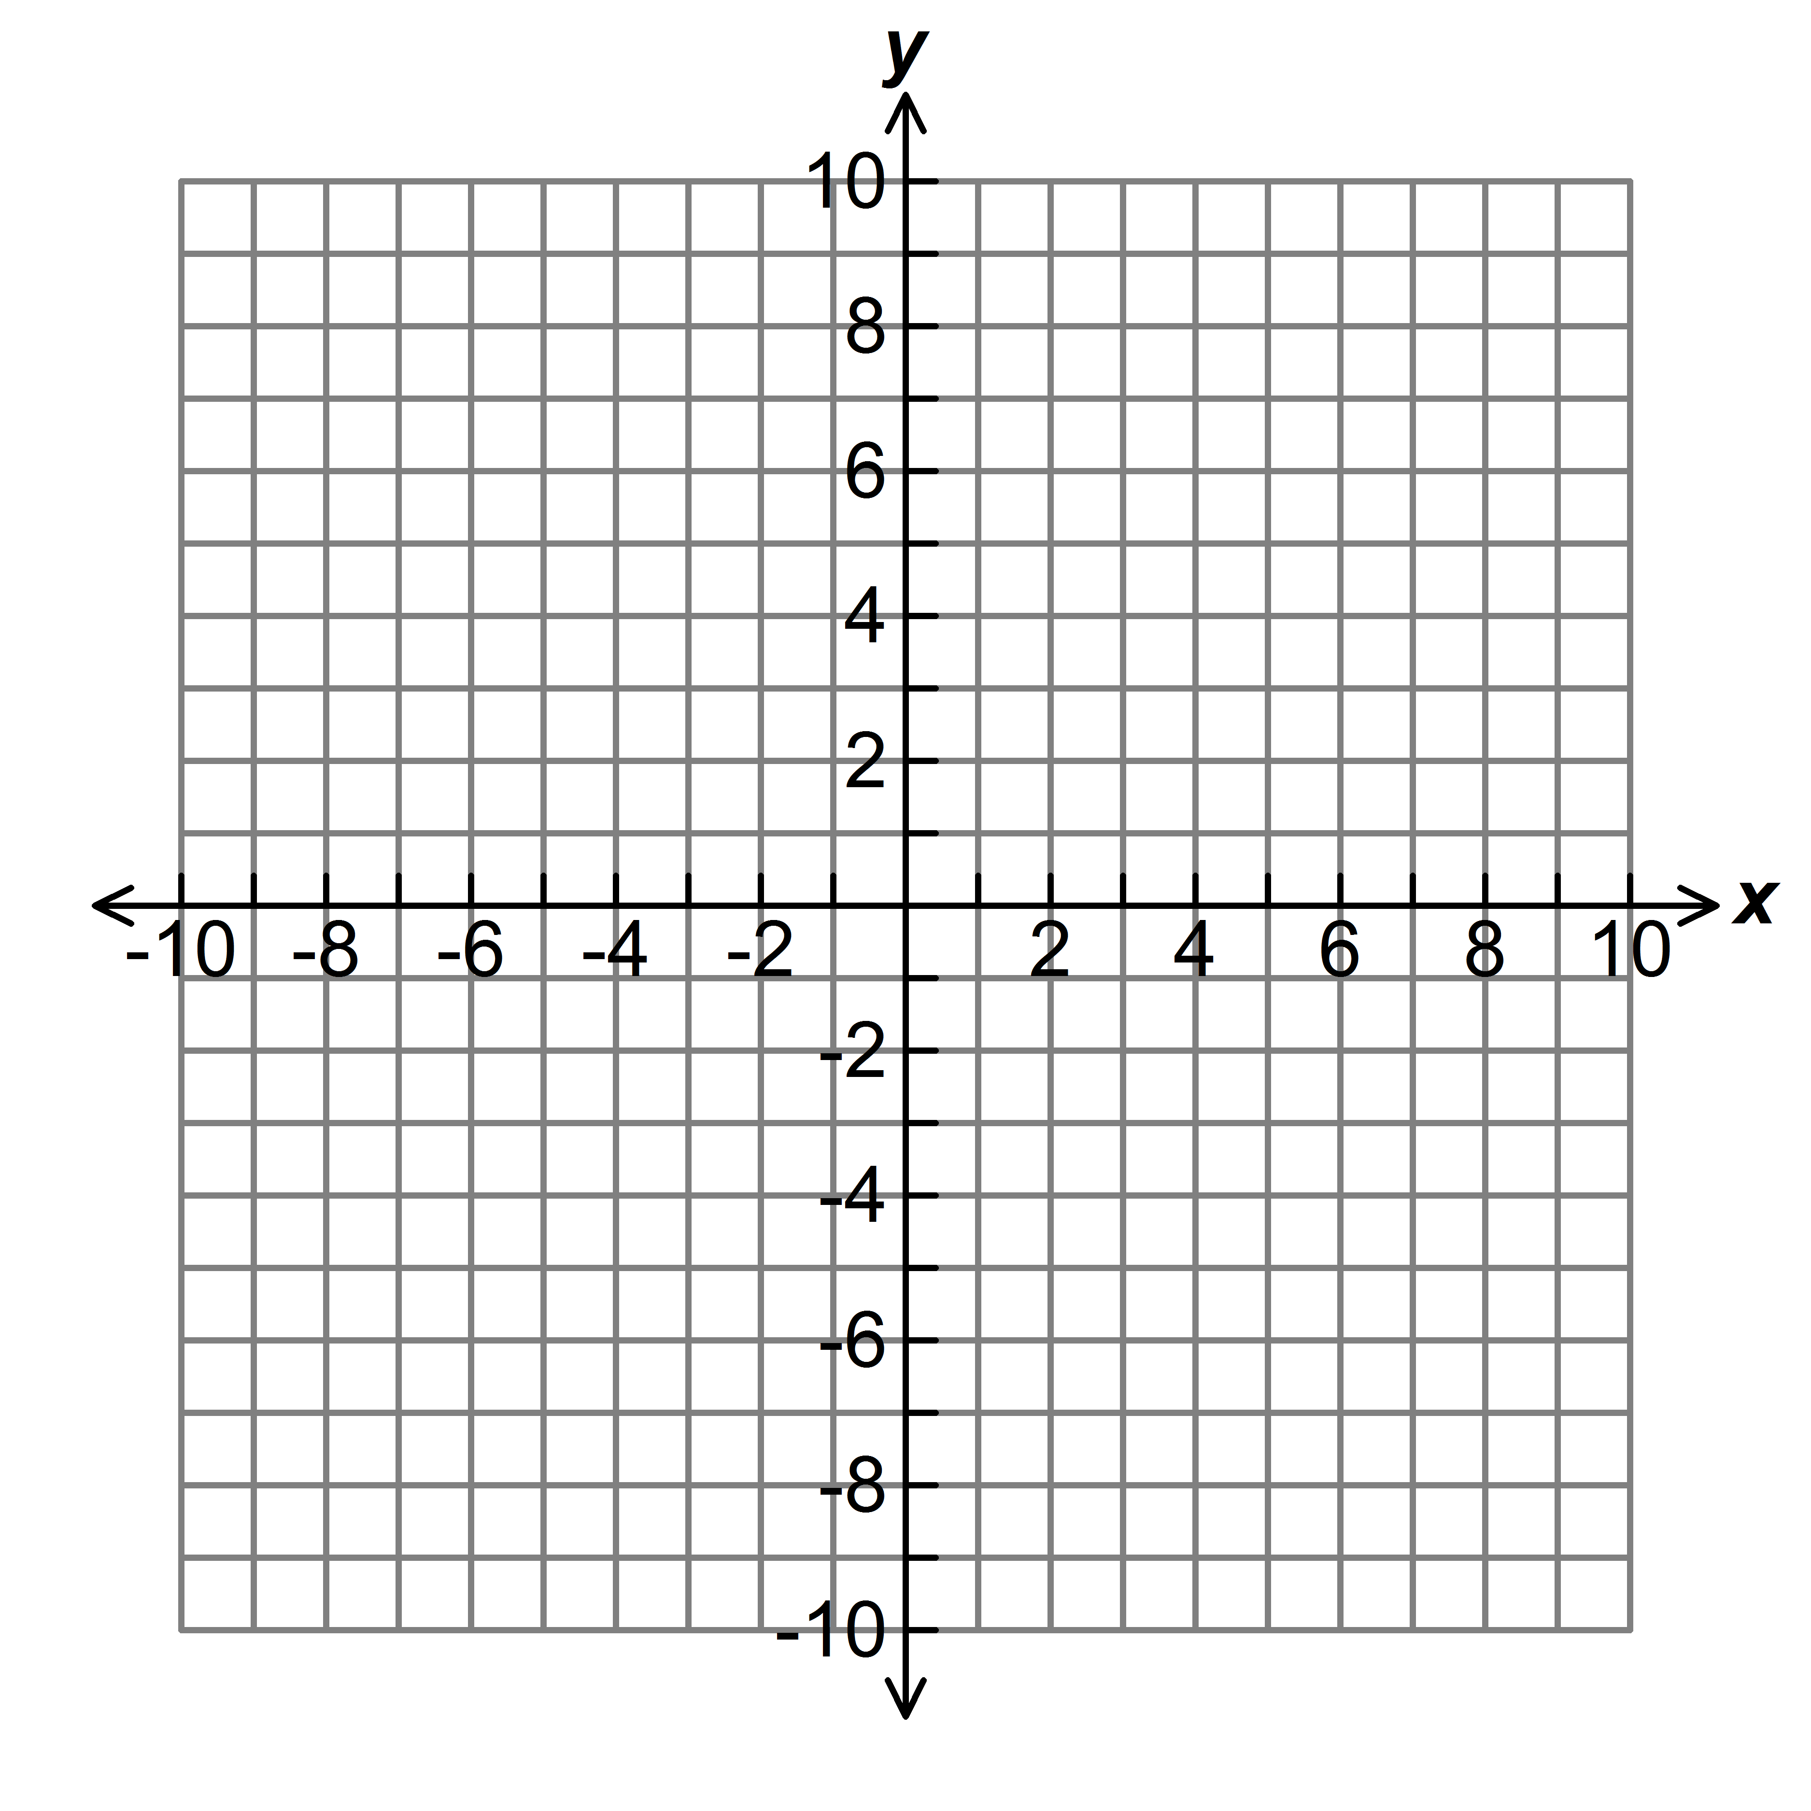

1. Finish labeling the number line below. Plot a point on 4 and its opposite.

0

1

-1

**Application**

1. Kellen has reached the peak of Mathclassrocks Mountain at 1,000 feet above sea level. He hikes down 400 feet to check out an old cannon. How many more feet must he hike to reach sea level ? (Hint: Drawing a picture may help to visualize the problem!!)

________

|  |  |  |  |  |
| --- | --- | --- | --- | --- |
| **City** | **McKinley Park** | **Bethel** | **Fairbanks** | **King Salmon** |
| **Temperature (⁰Celsius)** | -22 | -11 | -20 | -13 |

1. The table below shows today’s temperature for 5 cities in Alaska.
2. Write an inequality statement comparing the temperature of King Salmon and Bethel: _____________________
3. Order the cities from warmest to coldest:

1. Graph point *A* (4, -8) on the coordinate plane.
2. Reflect the point across the x-axis.
3. What is the distance between point *A* and the reflected point? ______ units

Justify your answer:

1. Andrew owes $6.50 in late fees to the library. Represent this value on the number line below. Mark the point **A** (Hint: If he **OWES**, is that a positive or negative number?)

0

1

-1

1. Hayleigh owes $0.50 in late fees to the library. Plot a point for this value on the number line. Mark the point **H**.
2. How much more does Andrew owe than Hayleigh? _________

***Use the map below for questions 12 – 14.***

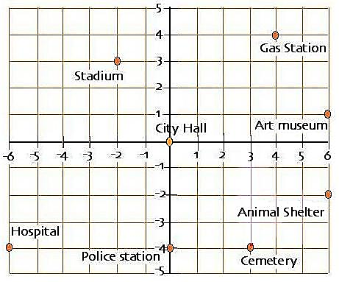

1. Name the ordered pair that represents the location of the gas station.
2. How many blocks apart are the hospital and the cemetery?

___________ blocks

1. Name the building that is located in quadrant 3. _______
2. Graph (7,-3) and (7, 5) on the coordinate plane to the right.
3. Reflect both points across the *y*-axis to form the vertices of a rectangle.
4. Name the two reflected ordered pairs: _____ & _____
5. What is the perimeter of the rectangle? __________
6. What is the area of the rectangle? __________
7. If you reflected the ordered pair (-2, 5) across the *x*-axis, what would be the coordinates of the reflection?

|  |  |  |  |  |  |  |  |
| --- | --- | --- | --- | --- | --- | --- | --- |
| a) | (-2, -5) | b) | (2, 5) | c) | (2, -5) | d) | (-2, 5) |

1. Which statement below is NOT true?

|  |  |
| --- | --- |
| a) | -3 < -1 |
| b) | -2 ≥ -5 |
| c) | -4 ≤ -14 |
| d) | -3 < 4 |

1. It is 89 degrees above zero in Miami. It is 20 degrees below zero in Anchorage. Use the number line below to determine how many degrees warmer it is in Miami than in Anchorage.

0⁰ F

-20⁰ F

89⁰ F

|  |  |  |  |  |  |  |  |
| --- | --- | --- | --- | --- | --- | --- | --- |
| a) | 69⁰F | b) | 79⁰F | c) | 109⁰F | d) | 129⁰F |

1. A Bolivian monkey is jumping around on a number line. He starts at -3 and jumps 8 units to the right. Where is he now on the number line?

|  |  |  |  |  |  |  |  |
| --- | --- | --- | --- | --- | --- | --- | --- |
| a) | -5 | b) | -11 | c) | -11 | d) | 5 |

0

1

-1

**Performance Task**

1. A newly developed neighborhood has dedicated a portion of their land to be used as a children’s playground. The neighborhood would like to build a fence around a rectangular **area of 100 square yards** for a dog run. The coordinate planes below each represent the dedicated land. Each square on the grid represents one square yard. **Each yard of fencing costs $12**. Develop **two** plans for the neighborhood to choose from.

**Label the coordinates** of the vertices and **determine the price** of the fencing for each plan (based on the perimeter). Then write a letter to the neighborhood explaining which design you recommend and why.

|  |  |
| --- | --- |
| **Plan 1** | 20by20 |
| **Plan 2** | 20by20 |