Math 6 Name ___________________________________
Unit 6: Statistics Post-Test REVIEW Date _______________

- What is a measure of center? ________________________________________________________________

Give 2 examples of a measure of center: _____________________________________________________

What is a measure of spread?________________________________________________________________

Give 2 examples of a measure of spread. ____________________________________________________

- What information does a box plot provide? ___________________________________________________

______________________________________________________________________________________________

______________________________________________________________________________________________

3-6. Big Bob scored the following points at eight basketball games: 21, 24, 9, 11, 16, 7, 24. Calculate the following:

MEAN
MEDIAN
MODE
RANGE

7. Which set of intervals CAN be used to create a histogram for data that ranges from 5 to 99?

A. 0-20, 20-40, 40-60, 60-80, 80-100, 100-120
B. 3-6, 11-50, 52-82, 85-120
C. 1-20, 21-40, 41-60, 61-80, 81-100
D. 1-20, 21-80, 81-82, 83-89, 90-100

8. Give one example of a statistical question. What makes it statistical?

9. Data from unit test grades from 3 different classes are displayed in the box plots below. Compare and contrast the data.

10-15. Use the following data to create a box plot:
Identify:
Ages of Cal’s Cousins

10 18 17 12 13 15 15 14 14

Minimum: ________
Lower Quartile: _________
Median: _________
Upper Quartile: _________
Maximum: __________

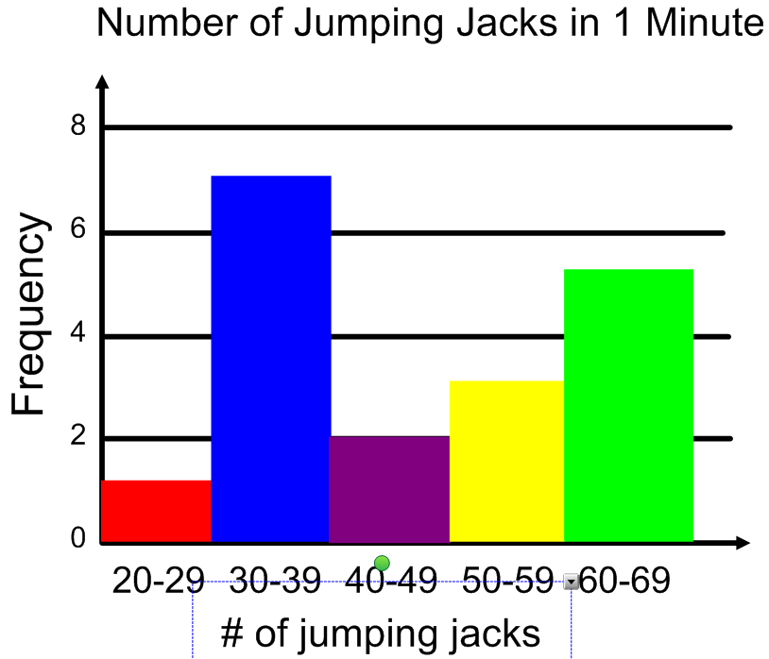

16. According to the histogram on the left, how many students can do more than 49 jumping jacks in 1 minute? _________

17. How many students participated in the survey?______________

18. Which interval is the mode of the histogram?______________

19. How many people did EXACTLY 45 jumping jacks?_______

20. Create a dot plot of the following data:
Sit-Ups Completed by Students During a Fitness Test

13 13 10 14 15 12
17 12 18 14 15 12

21. Circle the set of intervals CAN be used for the data given in problem # 6. Explain why the others cannot be used.

A. 0-2, 3-5, 6-8, 9-11, 12-14 ______________________________________________________________

B. 0-1, 2-5, 6-7, 8-15____________________________________________________________________

C. 1-2, 3-4, 5-6, 7-8, 9-10 ________________________________________________________________

D. 0-3, 3-6, 6-9, 10-12___________________________________________________________________

22. Baddat Skool’s test scores are 72, 68, 76. What does he need to score on the next test for his test
average to be a 75?

23. Which measure is MOST affected by an outlier?

A. | Mean | B. | Median | C. | IQR | D. | Mode

24. Identify the interquartile range from the box plot below. _____________

0
5
1020
15
2030
25
3040
35
4050

25. Look at the box plot in #24. What do you know about the data?

__________________________________________________________________________________________________________________________________________________________________________

__________________________________________________________________________________________________________________________________________________________________________

26. At a car dealership, the salespeople sold the following numbers of cars during 2018.

28, 15, 35, 19, 22, 59, 23, 28, 19, 11

Determine the following:

- the mean = ___________ b. the median = ____________ c. the mode = ___________

d. the range = ___________ e. the IQR = ________________ f. the MAD = _____________

g. outlier(s) = _____________ h. minimum = ______________ i. maximum = ____________

27. According to the problem above, the “typical” salesperson sold _______________ cars during 2018.
Explain your answer.

28. Determine a set of data that has a mean of 12, a range of 10, and a median of 14.

29. Elisabeth’s test scores are 72, 90, 94, 83, and 85. If she needs to maintain an 85 test average, what
is the minimum score she needs on her next test?

30. Answer the following questions about the data in the dot plot.

- 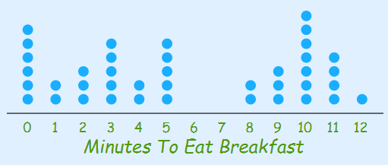mean = ________ b. median = _______

c. range = ________ d. mode = ________

e. Describe at least 3 attributes about the SHAPE of the data.

