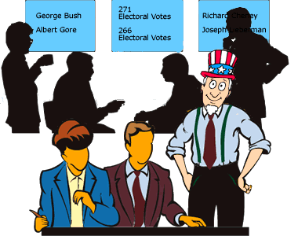
Electoral College Votes
Unlike many elections for public office where a person is elected strictly based on the results of a popular vote (i.e., the candidate who earns the most votes in the election wins), in the United States, the election for President of the United States is determined by a process called the Electoral College. According to the National Archives, the process was established in the United States Constitution "as a compromise between election of the President by a vote in Congress and election of the President by a popular vote of qualified citizens." (http://www.archives.gov/federal-register/electoral-college/about.html accessed September 4, 2012).
Each state receives an allocation of electoral votes in the process, and this allocation is determined by the number of members in the state's delegation to the US Congress. This number is the sum of the number of US Senators that represent the state (always 2, per the Constitution) and the number of Representatives that represent the state in the US House of Representatives (a number that is directly related to the state's population of qualified citizens as determined by the US Census). Therefore the larger a state's population of qualified citizens, the more electoral votes it has. Note: the District of Columbia (which is not a state) is granted 3 electoral votes in the process through the 23rd Amendment to the Constitution.
The following table shows the allocation of electoral votes for each state and the District of Columbia for the 2012, 2016, and 2020 presidential elections. (http://www.archives.gov/federal-register/electoral-college/allocation.html accessed September 4, 2012).
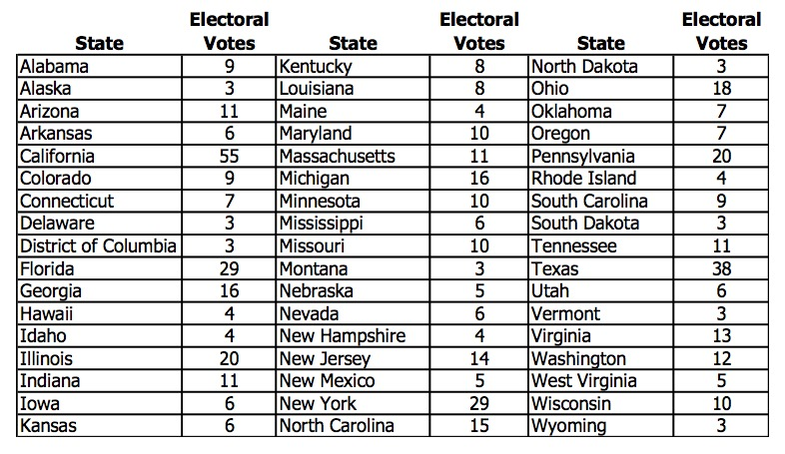
- Which state has the most electoral votes?___________________ How many votes does it have?_____
- Based on the given information, which state has the second highest population of qualified citizens?

3. Based on the dot plot of the distribution, what is the shape of this distribution: skewed left, symmetric, or skewed right?

4. Does the dot plot lead you to think that any states are outliers in terms of their number of electoral votes? Explain your reasoning, and identify the corresponding states. What affect do you think these outliers have on elections?

Mean Means
Each of these students must have an 85 test average to get into the class they want to take next year. Find out what their minimum grade must be on their last test in order to have an 85 average.
Suzie Q: 90 80 83 ? Billy Bob: 100 88 90 54 ?

Silly Sally: 78 96 98 89 ? Joe Schmoe: 72 92 74 80 ?

Each student above has a pass worth 10 bonus points on a test. They can use it in any class. Would you recommend that any of these students use that pass on their last test? If so, who? Explain your answer.

Goofy Gilbert has a 72 test average after 5 tests. Give a set of possible test scores he could have.

Instagram Histogram
Selfie Tay Kerr conducted a survey of her classmates to find out how many pictures each of them had uploaded to Instagram last month. Her results are shown in the histogram.
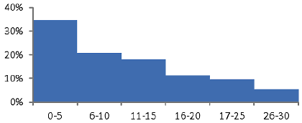
Instagram Uploads in December

% of classmates

# of uploads

#uploads | 0-5 | 6-10 | 11-15 | 16-20 | 21-25 | 26-30
%classmates | 35% | 20% | 18% | 12% | 10% | 5%
She organized the data in a table:

- Did she make any mistakes in her histogram? If so, explain.

- What percentage of people had more than 10 uploads?

- Which interval has the most data? ___________________ the least? __________________

- Are there any outliers? _____________ Explain:

- What observation can you make about the shape of the data?

- Can you calculate an exact mean, median, mode, and range? If so, list them. If not, explain why not.

Statistics Matching
Write the correct answer in the box above each problem.
Answer Choices: 0 2 2.8 3 20.5 43 55 75 97
