**Math 6/7** Name ___________________________________  
**Unit 5: Area and Volume** Date _______________  
**Post Test Review HW**

**Answers:**

1. Multiply l • w • h or

Multiply area of the base

(B) by the height (h) or

Count the unit cubes inside

the prism

1. Area measures the square units inside a 2-dimensional figure; volume measures the cubic units inside a 3-dimensional figure.
2. 126/216 cubic inches
3. 300 square inches
4. 15 square cm
5. 40 square cm
6. 1350 square cm
7. 64 square m
8. How could you determine the **volume** of a rectangular prism?
9. What is the difference between area and volume?
10. Determine the **volume** of the cube pictured below.

 in.

1. Find the **area** of the shaded section of the square below.

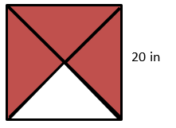

1. Find the **area** of the triangle pictured below.

12 cm

10 cm

4 cm

3 cm

1. Determine the **area** of the trapezoid.

1 cm

1 cm

9 cm

4 cm

1. How much paper is needed to **wrap** a **cube** with a side length of 15 cm?
2. 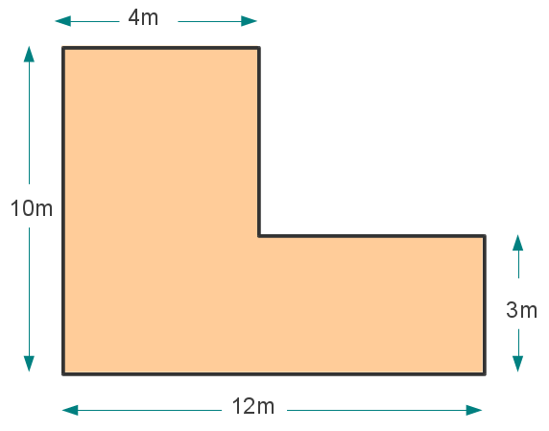Find the **area** of the figure shown below.
3. If carpet costs $2.50 per square yard, how much would it cost to carpet a rectangular room that is 5 yards wide and 12 yards long?
4. A rectangular pool is 22 ¾ feet long, 12 feet wide, and 5 feet deep. How many **cubic feet** of water can it hold?
5. 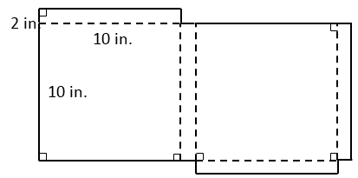The net of a pizza box is shown below. How many **square inches** of cardboard is needed to make the box?

**Answers:**

9) $150

10) 1365 cubic feet

11) 280 square inches

12) 294 square cm

13) 200 square feet

14) 1680 cubic in

15) 34 cubic in

16) 46 square feet

17) 94 square cm

18) answers vary

19) 8

1. 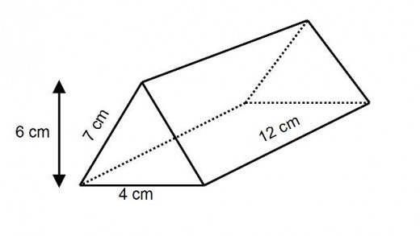What is the **surface area** of the triangular prism below?

7cm

1. The white square below is 10 feet wide. What is the **area** of the gray frame?

15 ft

20 ft

1. How many cubic inches of water can fit **inside** a fish tank that is 8 in. tall, 20 in. long, and 10 ½ in. wide?
2. The base of a prism is a square with side lengths of 2 inches, and the height of the prism is  inches. Find the **volume** of the prism.

2 in.

8 ½ in.

1. Determine the **area** of the pentagon pictured below. 18. Draw 3 different nets that can be folded to form a cube.

8 ft

6 ft

6 ft

4 ft

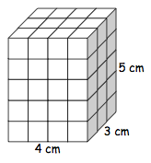17. How many **square cm** of paper are needed to cover the figure? 19. How many 3/4-in. cubes can fit **inside** of a 1 ½ -in. cube?

