**Math 6/7** Name ___________________________________  
**Unit 5: Area and Volume** Date _______________  
**Post Test Review HW**

1. How could you determine the **volume** of a rectangular prism?
2. What is the difference between area and volume?
3. Determine the **volume** of the cube pictured below.

 in.

1. Find the **area** of the shaded section of the square below.

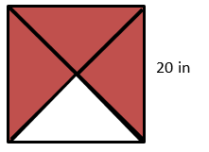

1. Find the **area** of the triangle pictured below.

12 cm

10 cm

4 cm

3 cm

1. Determine the **area** of the trapezoid.

1 cm

1 cm

9 cm

4 cm

1. How much paper is needed to **wrap** a **cube** with a side length of 15 cm?
2. 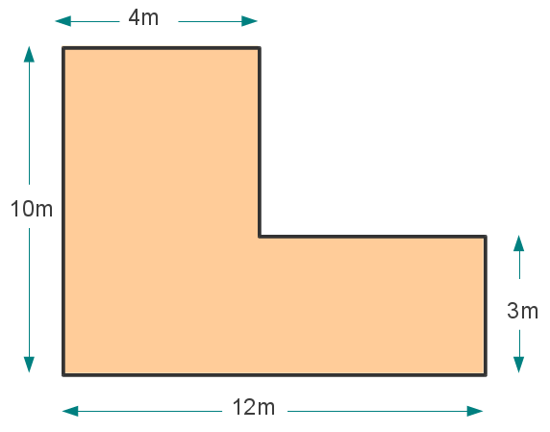Find the **area** of the figure shown below.
3. If carpet costs $2.50 per square yard, how much would it cost to carpet a rectangular room that is 5 yards wide and 12 yards long?
4. A rectangular pool is 22 ¾ feet long, 12 feet wide, and 5 feet deep. How many **cubic feet** of water can it hold?
5. 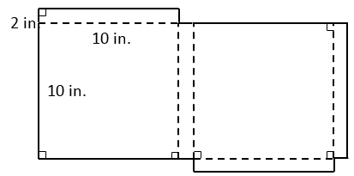The net of a pizza box is shown below. How many **square inches** of cardboard is needed to make the box?
6. 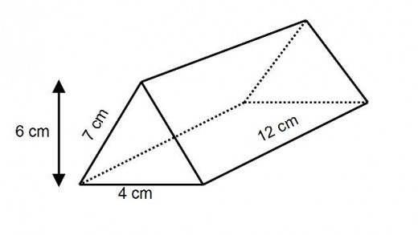What is the **surface area** of the triangular prism below?

7cm

1. The white square below is 10 feet wide. What is the **area** of the gray frame?

15 ft

20 ft

1. How many cubic inches of water can fit **inside** a fish tank that is 8 in. tall, 20 in. long, and 10 ½ in. wide?
2. The base of a prism is a square with side lengths of 2 inches, and the height of the prism is  inches. Find the **volume** of the prism. 2 in.

8 ½ in.

1. Determine the **area** of the pentagon pictured below. 18. Draw 3 different nets that can be folded to form a cube.

8 ft

6 ft

6 ft

4 ft

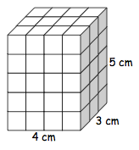17. How many **square cm** of paper are needed to cover the figure? 19. How many ¾ inch cubes can fit **inside** of a 1 ½ -inch cube?

