Math 6 - Unit 4: Equations & Inequalities Name:
Study Guide – End of Unit Test
Class Period: 1 2 3 4 Date:
MULTIPLE CHOICE
Identify the choice that best completes the statement or answers the question.

- List out the characteristics of a direct variation graph. (Where does it start, what does it look like?)

Solve the equations below. Show all of your work, including the check.

- $\frac{1}{5}x=42$
- $67+c=183$
4. $j-5.6=4.6$
- Jennifer spent $8.99 on a bag of Jolly Ranchers that cost x dollars a piece. If there were 110 Jolly Ranchers in the bag, write an equation that could be solved using inverse operations to find out how much each Jolly Rancher would cost. (You do not need to solve the equation.
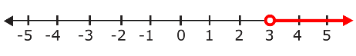
- Write a situation that could describe the following inequality graph.

- Write an inequality to represent the fact that there are at least 13 questions on your test.
- Write an inequality to represent that there are more than 125 cars in the parking lot.
- Gabriel wants to solve the equation, $\frac{3}{4}m=25$.
Which step should he do to isolate m on one side of the equation?
- Judy spent $5.67 on oranges that cost $0.63 each. If x = the number of oranges, write an equation that would determine how many oranges Judy purchased?
- Write a direct variation equation to represent the data in the table.
x | 0 | 1 | 2 | 5
y | 0 | 5 | 10 | 25
- Write one possible solution and one non-solution to the inequality, x > 4.
- Explain how to solve an equation.
- Complete the table to satisfy the direct variation equation, y=12x
x | 0 | 1 | 2 |  | 5
y | 0 |  |  | 48
- What inequality is graphed on the number line?
- What inequality is graphed on the number line?
- What direct variation is graphed on the coordinate plane below?
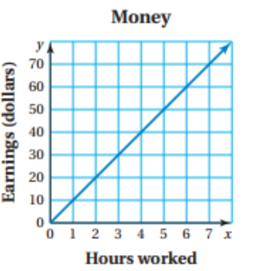
- Julia paid $140 for 7 gift cards. Each gift card was the same price. Write an equation that that represents the situation and find the price of each gift card?
- A music teacher bought 17 recorders of equal price. She spent a total of $51. The equation $17r=51$ can be used to find r, the price of each recorder in dollars. What was the price of each recorder?
- Mrs. Katz bought chick-fil-a biscuits for her homeroom and spent a total of $160. If each biscuit cost $5, write an equation that you could use inverse operations to solve and solve it to find out how many biscuits Mrs. Katz bought.
- Which solution makes the equation true? $x-6.5=19$

For questions 19-21, determine whether the given value is a solution of the equation by selecting true or false.
- $25= \frac{k}{3}$ for k = 3
  - TRUE b. FALSE
- $0.7y=49$ for y = 70
  - TRUE b. FALSE
- Silly Sally solved the equation for x and shows her solution below. What should Silly Sally do to correct her mistake?
36 + x = 54
36 + x = 54
-36 +36
x = 90
- Opposite operations that “undo” each other are called _______________.
- Which step should be taken to isolate the variable in the following equation?
$$213n=1418$$

