 **Adv Math 6**  Name ___________________________________  
**Unit 4: Post Test REVIEW ☺** Date _______________

**Knowledge and Understanding**

1. Make up a real-world situation, and an equation that goes along with it. Solve your equation. _______________________________________________________________________________________________

_______________________________________________________________________________________________

_______________________________________________________________________________________________

1. Explain how to graph the solution to an inequality. _____________________________________________________

_______________________________________________________________________________________________

_______________________________________________________________________________________________

**Proficiency of Skills**

Solve each equation. Remember to show all work… **perform the inverse operation to BOTH sides of the equation**!

1.  4.  5. 

Write and graph the solution to each inequality.

6. Andrea’s grade was higher than 7. The speed limit is 45 miles per hour. 8. Riders must be at least 54’’

an 85. tall to ride the Goliath.

____________________ ______________________ ________________________

**Application**

9. A quarterback threw the ball x total yards over 4 games. If he averaged 14 yards per game, write an equation that

represents this situation, and solve for x, the total number of yards thrown. (Hint: Draw a **model** to help!)

Equation:____________________

Solution:_____________________

10. Fiona had x dollars in her bank account. After spending $675 on Christmas gifts, she has $562.57 left in her account.

Write an equation and solve for x, the amount she originally had in her account. (Hint: Draw a **model**!)

Equation:____________________

Solution:_____________________

1. The weight limit on a cargo plane is 20 Tons. Write an inequality to represent the weight limit, w, and graph it.

Inequality:___________________

1. What inequality is graphed on the number line? ________________________

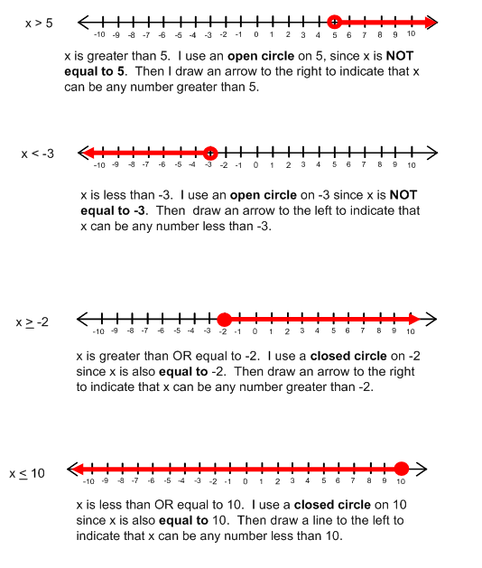

1. Which of the following is NOT a solution to the inequality ?

|  |  |  |  |  |  |  |  |
| --- | --- | --- | --- | --- | --- | --- | --- |
| A. | 7 | B. | 8 | C. | 9 | D. | 10 |

1. Which problem situation matches the equation ?

|  |  |
| --- | --- |
| A. | Jamie sold 240 newspaper subscriptions each month for 12 months. What is *x*, the total number of newspaper subscriptions that Jamie sold in 1 year? |
| B. | Brenna cycled a total of 240 miles this month. She cycled 12 miles less this month than last month. What is *x*, the number of miles Brenna cycled last month? |
| C. | Mary charges $12.00 per hour for labor to paint houses. What is *x*, the number of hours Mary worked if she charged $240.00 for labor? |
| D. | Sara bought 12 ride tickets and *x* game tickets. How many game tickets did she buy if she bought 240 tickets in all? |

1. Quadrilateral *ABCD* has side lengths of 6 units, 10 units, 4 units, and *x* units. If each side of *ABCD* is doubled to create quadrilateral *WXYZ*, which expression represents the perimeter of quadrilateral *WXYZ*?

|  |  |  |  |  |  |  |  |
| --- | --- | --- | --- | --- | --- | --- | --- |
| A. | 40 + *x* | B. | 20 + 2*x* | C. | 40 + 2*x* | D. | Not here |

1. Which table satisfies the equation ?

|  |  |  |  |  |  |  |  |  |  |  |  |  |  |  |  |  |  |  |  |  |  |  |  |  |  |  |  |
| --- | --- | --- | --- | --- | --- | --- | --- | --- | --- | --- | --- | --- | --- | --- | --- | --- | --- | --- | --- | --- | --- | --- | --- | --- | --- | --- | --- |
| A. | |  |  |  |  |  |  | | --- | --- | --- | --- | --- | --- | | *x* | 0 | 1 | 4 | 12 | 100 | | *y* | 0 | 0.25 | 1 | 3 | 25 | | C. | |  |  |  |  |  |  | | --- | --- | --- | --- | --- | --- | | *x* | 0 | 1 | 2 | 3 | 4 | | *y* | 0.25 | 4 | 5.6 | 11 | 12.5 | |
| B. | |  |  |  |  |  |  | | --- | --- | --- | --- | --- | --- | | *x* | 0 | 1 | 2 | 5 | 8 | | *y* | 0 | 4 | 8 | 20 | 32 | | D. | |  |  |  |  |  |  | | --- | --- | --- | --- | --- | --- | | *x* | 0 | 2 | 4 | 6 | 8 | | *y* | 0 | 0.5 | 2 | 12 | 18 | |

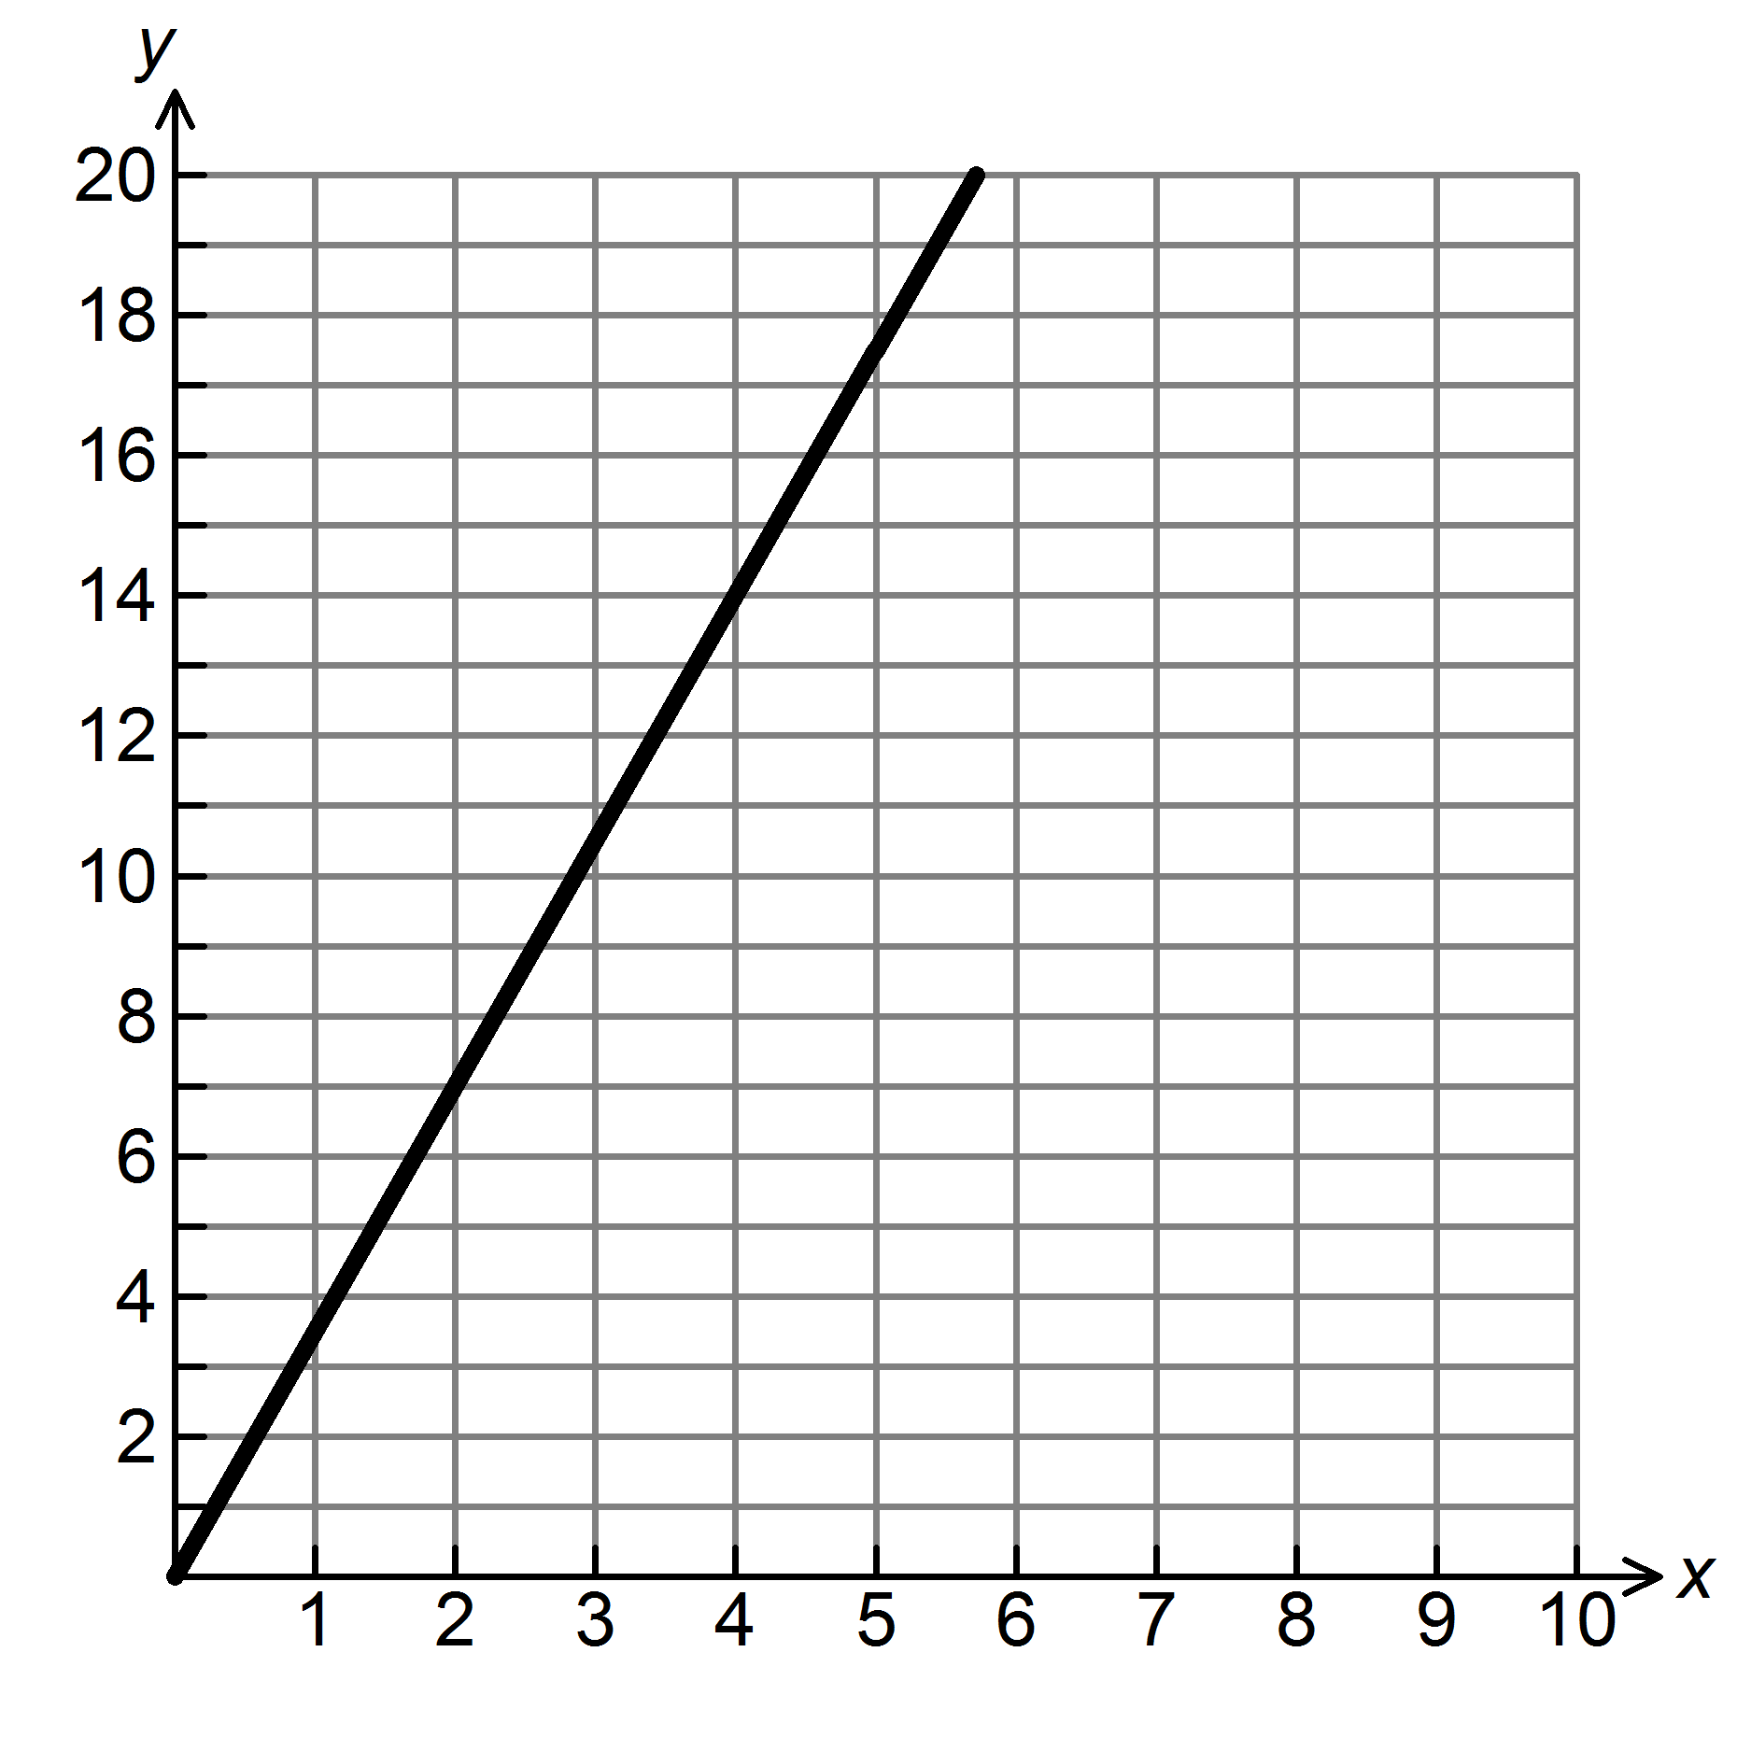17. The graph below shows the cost of gasoline at $3.50 per gallon.

Gasoline (gallons)

Cost ($)

a. How would the graph change if the price changed to $3.95 per gallon?________________________________

b. How would the graph change if the price changed to $3.10 per gallon?________________________________

c. Choose ANY point on the line graphed above, and explain its meaning. ________________________________

___________________________________________________________________________________________

18. Donald sold wrapping paper for a school fundraiser. Each roll cost the same amount. At the end of the sale, he had

sold 86 rolls and made a total of $473. Write a direct variation equation that could be used to determine y, the total

amount made if x rolls are sold, where k = the unit cost per roll.

19. Maria’s Maids charges $150 per home. Fill in the table of values and plot the values on a graph to show how much

total money, y, they make after cleaning x homes. Remember to **label** the x- and y-axes.

|  |  |  |  |  |  |
| --- | --- | --- | --- | --- | --- |
| x (# of homes) | 0 | 2 |  |  | 10 |
| y (total money) |  |  | 600 | 1,350 |  |



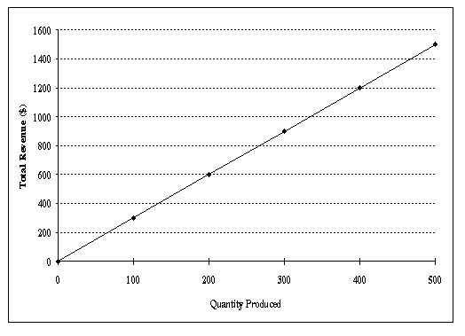20. What equation is shown by the graph below?

a. 

b. 

c. 

d. 