Unit 4

One-Step Equations & Inequalities

Checking Solutions to Equations

Solving Equations

Writing Equations

Checking Solutions to Inequalities

Writing Inequalities

Graphing Inequalities on Number Lines

Independent & Dependent Variables

Direct Variation

**Unit 4: One-Step Equations and Inequalities**

**Standards, Checklist and Concept Map**

**Georgia Standards of Excellence (GSE):**

**MGSE6.EE.5**: Understand solving an equation or inequality as a process of answering a question: which values from a specified set, if any, make the equation or inequality true? Use substitution to determine if a given number in a set makes an equation or inequality true.

**MGSE6.EE.6**: Use variables to represent numbers and write expression when solving a real-world or mathematical problem; understand that a variable can represent an unknown number, or, depending on the purpose at hand, any number in a specified set.

**MGSE6.EE.7**: Solve real-world and mathematical problems by writing and solving equations of the form x+p=q and px=q for cases in which p,q and x are all nonnegative rational numbers.

**MGSE6.EE.8** : Write an inequality of the form x > c or x < c to represent a constraint or condition in real-world problem. Recognize that inequalities of the form x > c or x < c have infinitely many solutions; represent solutions of such inequalities on number line diagrams.

**MGSE6.EE.9** : Use variables to represent two quantities in a real-world problem that change in relationship to one another; write an equation to express one quantity, thought of as the dependent variable, in terms of the other quantity, thought of as the independent variable. Analyze the relationship between the dependent and independent variables using graphs and tables, and relate these to the equation. *For example, in a problem involving motion at constant speed, list and graph ordered pairs of distances and times, and use the equation d = 65t to show the relationship between distance and time.*

What Will I Need to Learn?? Mark a check next to each concept as you master them.

________ I can write expressions (from word problems) with a variable that represents a number

C:\Users\baj10446\AppData\Local\Microsoft\Windows\Temporary Internet Files\Content.IE5\HW62Y2RF\MC900441880[1].wmf________ I can substitute to check the solution of an equation

________ I can write equations based on real-world problems

________ I can solve equations based on real-world problems

________ I can substitute to check the solution of an inequality

________ I can write inequalities to represent real-world problems and show on number line

________ I can show relationships between two variables (independent and dependent)

using an equation, a table, and a graph



**Unit 4 Circle Map:** Make a Circle Map of the concepts listed in the checklist and standards above! The Circle Map should be on the LEFT page. Include important vocab as well!

|  |  |  |
| --- | --- | --- |
| Unit 4: One-Step Equations and Inequalities | | |
| Vocabulary Term | What does it mean?  Definition | What does it look like?  Picture/Example |
| Equation | A mathematical sentence containing an equal sign, showing two equivalent values |  |
| Inverse operation | Opposite operations that “undo” each other |  |
| Variable | A symbol, usually a letter, that represents a number |  |
| Inequality | A statement showing that two values are NOT equal, using one of the following signs: >, <, ≥, ≤, or ≠ |  |
| Constant of proportionality | The constant *k* in a direct variation equation; it is the ratio of $\frac{y}{x}$, or of $\frac{dependent variable}{independent variable}$. It is the same as the unit rate. |  |
| Direct proportion (direct variation) | A relationship between two variables, *x* (independent) and *y* (dependent), that can be written as *y* = *kx*, where *k* ≠ 0 |  |
| Dependent variable | The “output,” or y value, which “depends” on the input/x value/independent variable |  |
| Independent variable | The “input,” or x value, which determines on the output/y value/dependent variable |  |

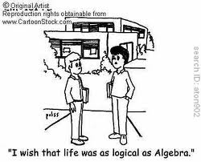

**Math 6/7**    
**Unit 4: Post Test REVIEW ☺**

1. Thoroughly explain how to solve an equation. _________________________________________________________

_______________________________________________________________________________________________

_______________________________________________________________________________________________

1. Explain how to graph the solution to an inequality. _____________________________________________________

_______________________________________________________________________________________________

_______________________________________________________________________________________________

Solve each equation. Remember to show all work… **perform the inverse operation to BOTH sides of the equation**!

1.  4.  5. 

Write and graph the solution to each inequality.

6. Andrea’s grade was higher than 7. The speed limit is 45 miles per hour. 8. Riders must be at least 54’’

an 85. tall to ride the Goliath.

____________________ ______________________ ________________________

9. A quarterback threw the ball x total yards over 4 games. If he averaged 14 yards per game, write an equation that

represents this situation, and solve for x, the total number of yards thrown.

Equation:____________________ Solution:_____________________

10. Fiona had x dollars in her bank account. After spending $675 on Christmas gifts, she has $562.57 left in her account.

Write an equation and solve for x, the amount she originally had in her account.

Equation:____________________ Solution:_____________________

1. The weight limit on a cargo plane is 20 Tons. Write an inequality to represent the weight limit, w, and graph it.

Inequality:___________________

1. What inequality is graphed on the number line? ________________________

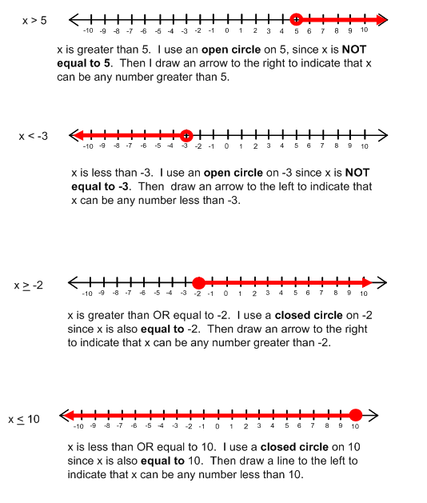

1. Which of the following is NOT a solution to the inequality ?

|  |  |  |  |  |  |  |  |
| --- | --- | --- | --- | --- | --- | --- | --- |
| A. | 7 | B. | 8 | C. | 9 | D. | 10 |

1. Write an equation for each scenario below. Then, solve each one.

|  |  |
| --- | --- |
| A. | Jamie sold 240 newspaper subscriptions each month for 12 months. What is *x*, the total number of newspaper subscriptions that Jamie sold in 1 year?  Equation:_______________________________ Solution: _________________ |
| B. | Brenna cycled a total of 240 miles this month. She cycled 12 miles less this month than last month. What is *x*, the number of miles Brenna cycled last month?  Equation:_______________________________ Solution: _________________ |
| C. | Mary charges $12.00 per hour for labor to paint houses. What is *x*, the number of hours Mary worked if she charged $240.00 for labor?  Equation:_______________________________ Solution: _________________ |
| D. | Sara bought 12 ride tickets and *x* game tickets. How many game tickets did she buy if she bought 240 tickets in all? |

Equation:_______________________________ Solution: _________________

1. Which table satisfies the equation ?

|  |  |  |  |  |  |  |  |  |  |  |  |  |  |  |  |  |  |  |  |  |  |  |  |  |  |  |  |
| --- | --- | --- | --- | --- | --- | --- | --- | --- | --- | --- | --- | --- | --- | --- | --- | --- | --- | --- | --- | --- | --- | --- | --- | --- | --- | --- | --- |
| A. | |  |  |  |  |  |  | | --- | --- | --- | --- | --- | --- | | *x* | 0 | 1 | 4 | 12 | 100 | | *y* | 0 | 0.25 | 1 | 3 | 25 | | C. | |  |  |  |  |  |  | | --- | --- | --- | --- | --- | --- | | *x* | 0 | 1 | 2 | 3 | 4 | | *y* | 0.25 | 4 | 5.6 | 11 | 12.5 | |
| B. | |  |  |  |  |  |  | | --- | --- | --- | --- | --- | --- | | *x* | 0 | 1 | 2 | 5 | 8 | | *y* | 0 | 4 | 8 | 20 | 32 | | D. | |  |  |  |  |  |  | | --- | --- | --- | --- | --- | --- | | *x* | 0 | 2 | 4 | 6 | 8 | | *y* | 0 | 0.5 | 2 | 12 | 18 | |

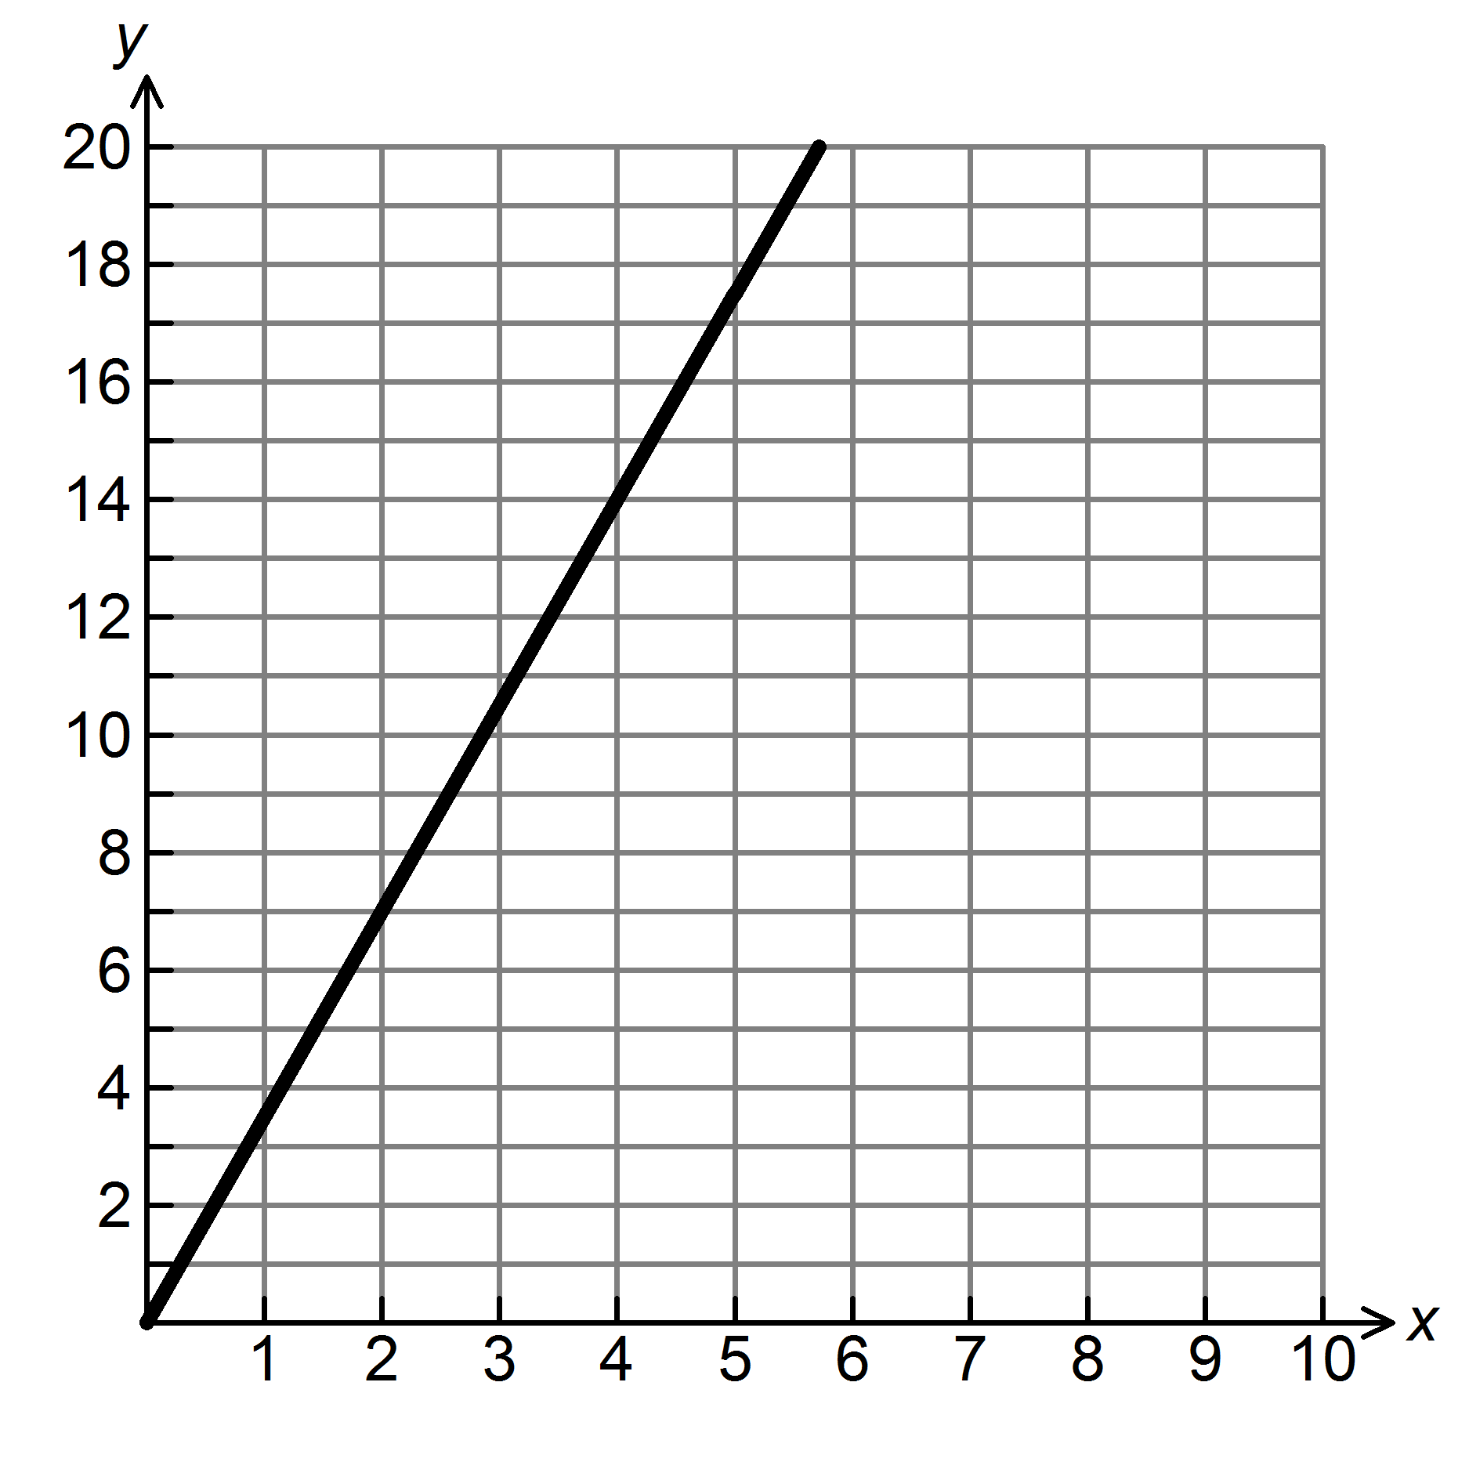16. The graph below shows the cost of gasoline at $3.50 per gallon.

Gasoline (gallons)

Cost ($)

a. How would the graph change if the price changed to $3.95 per gallon?________________________________

b. How would the graph change if the price changed to $3.10 per gallon?________________________________

17. Marci’s Maids charges $150 per home. Fill in the table of values and plot the values on a graph to show how much

total money, y, they make after cleaning x homes. Remember to **label** the x- and y-axes.

|  |  |  |  |  |  |
| --- | --- | --- | --- | --- | --- |
| x (# of homes) | 0 | 2 |  |  | 10 |
| y (total money) |  |  | 600 | 1,350 |  |



**Equation:____________________________**

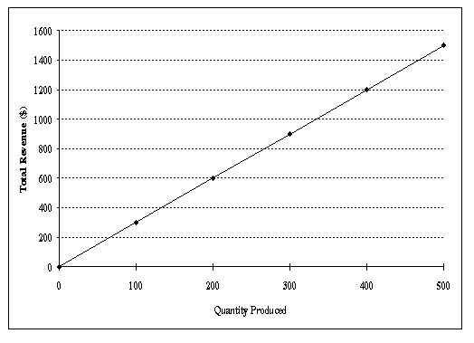18. What equation is shown by the graph below?

a. 

b. 

c. 

d. 

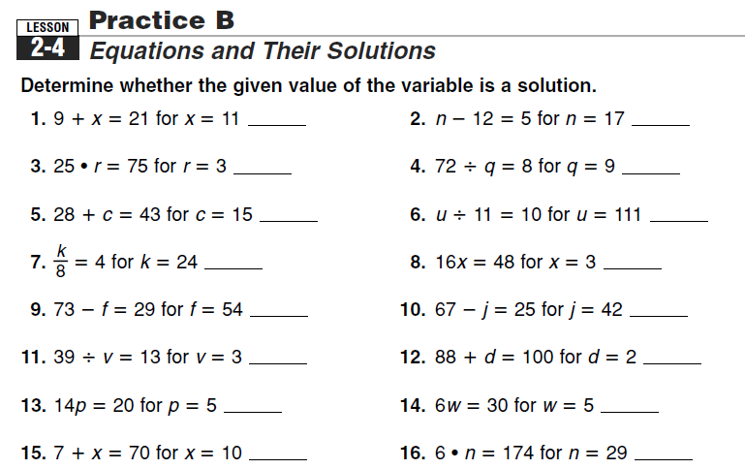

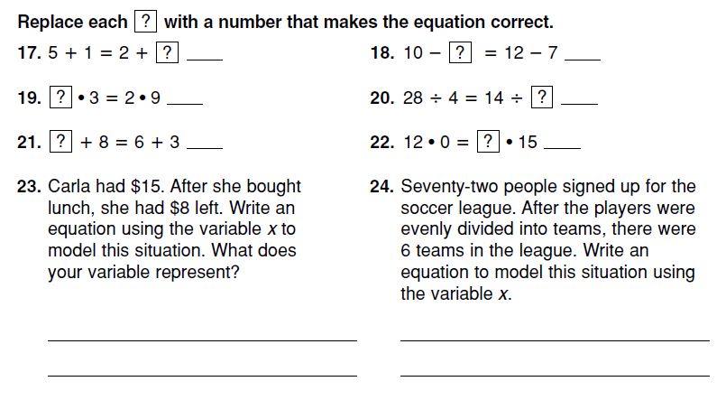

**Equations**

When solving an equation, you must first determine the ______________________ operation.

Then, apply the inverse operation to ____________ sides of the equation (to keep it BALANCED).

Lastly, you should ALWAYS ___________________ your solution back into the equation to check your work.

**-**

**+**

Solving

Equations

**÷**

**x**

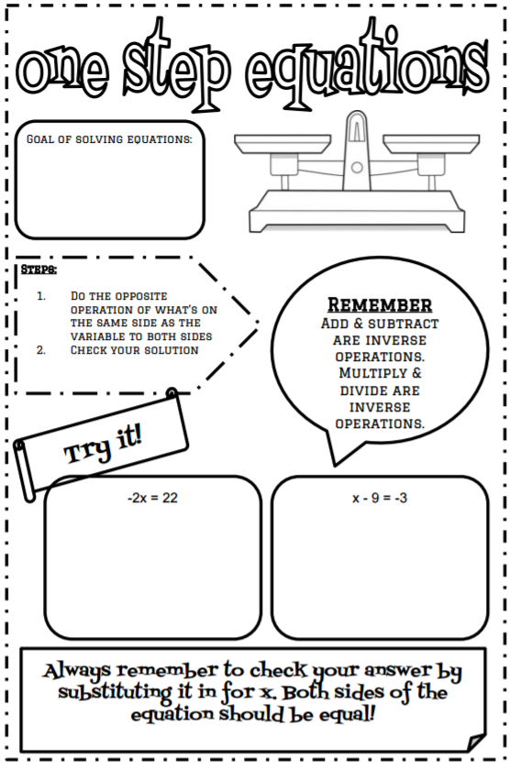

**Silly Sally Error Analysis**

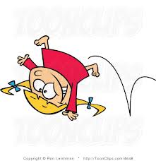

Sally is a silly little girl that makes silly mistakes! She also forgets to check her work when solving equations! ☹ Analyze her work in Column #1, and *circle her mistake*. In Column #2, explain what she did wrong. In Column #3, show how Silly Sally should work out the problem. Show ALL work.

|  |  |  |
| --- | --- | --- |
| Silly Sally’s Work  (Circle her mistake): | What did Silly Sally do wrong? | Show Silly Sally how it’s done!  (Include the “check!” |
| x + 5 = 28  + 5 + 5  x = 33 |  |  |
| 12a = 108  12 12  a = 8 |  |  |
| w - 42 = 18  + 18 +18  w = 36 |  |  |
| = 3  ÷ 15 ÷ 15  y = 5 |  |  |
| x + 23.45 = 32  - 23.45 - 23.45  x = 9.45 |  |  |
| b = 162 |  |  |

**\*\* Choose ONE Extension Problem, and complete it on the back of this sheet. \*\***

**Extension A**: Create a flow map to show how to solve equations.

**Extension B**: Write an equation for both of these situations AND solve:

a. Mrs. Bothers went shopping and spent $45.62. She had $34.38 left over. How much did she start with?

b. A class of 32 students was given a homework assignment that had “x” number of problems to solve. The class had a total of 320 problems. Solve for “x”, the number of problems on the assignment.

**One Step Equation Word Problem Notes:**

*A one step equation has to have a **VARIABLE** for you to find the solution to*Always look for a total in the word problem. That will go on the **RIGHT** side of your = **EQUAL** = sign.

*Work backwards! What operation did you use to solve the word problem? Your one step equation will use the **OPPOSITE** operation.

*You should be able to solve your one step equation and get your solution. Always **CHECK YOUR WORK!**

**PRACTICE:**

1. **Caleb jogs for 20 minutes. He stretched then jogs some more. Altogether, he jogs for 35 minutes. How far does he jog after he stretches?**

What does your variable represent in the word problem? ________________________

What operation is used in the word problem?_________________________ Inverse Operation?__________________

One Step Equation:_____________________________ Solution:___________________

2. **Talia used 22 gallons of water in the shower. This amount is 7 gallons less than the amount she used for washing clothes. How much water does Talia use to wash clothes?**

What does your variable represent in the word problem? ________________________

What operation is used in the word problem?_________________________ Inverse Operation?___________________

One Step Equation:_____________________________ Solution:___________________

3. **While training for a sports event, Joshua hiked 5.3 miles each day. If he hiked for a total of 42.4 miles, how many days did Joshua hike?**

What does your variable represent in the word problem? ________________________

What operation is used in the word problem?________________________ Inverse Operation? __________________

One Step Equation:_____________________________ Solution:___________________

4. **At a restaurant, Garrison and his three friends decided to split the bill evenly. If each person paid $11 dollars, what was the cost of their bill?**

What does your variable represent in the word problem? ________________________

What operation is used in the word problem?_____________________ Inverse Operation?_______________________

One Step Equation:_____________________________ Solution:___________________

Statement: __________________________________________________________________________________

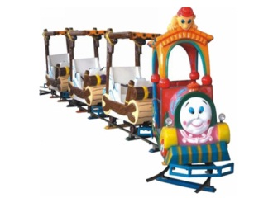Practice Writing & Graphing Inequalities!

**Write an inequality for each situation, and graph on a number line.**

1) Students must score at least 70 to pass the test.

2) You must be shorter than 48” to ride the kiddie train.

3) You should brush your teeth at least twice a day.



4) A good credit score is higher than 699.

5) Classes can have no more than 36 students.

[](http://www.google.com/imgres?q=saving+money&hl=en&gbv=2&biw=1600&bih=697&tbs=itp:clipart&tbm=isch&tbnid=_nz52Ph11sMoEM:&imgrefurl=http://www.shutterstock.com/pic-70920148/stock-vector-saving-money-with-children.html&docid=xoBRQHXzsW5SXM&imgurl=http://image.shutterstock.com/display_pic_with_logo/230902/230902,1297329018,2/stock-vector-saving-money-with-children-70920148.jpg&w=450&h=374&ei=gm7VT4PFC4f-8ASh8pDOAw&zoom=1&iact=hc&vpx=883&vpy=374&dur=405&hovh=205&hovw=246&tx=122&ty=118&sig=117083562964103036125&page=1&tbnh=128&tbnw=154&start=0&ndsp=27&ved=1t:429,r:23,s:0,i:213)6) AJ needs to save more than $500.

7) A book costs less than $20

8) The speed limit is 35 miles per hour.

~ Inequalities and Substitution ~

An inequality shows that two amounts are NOT equal, using the symbols >, <, ≥, ≤, or ≠.

|  |  |
| --- | --- |
| **Symbol** | **Meaning** |
| > | Greater than |
| < | Less than |
| ≥ | Greater than or equal to |
| ≤ | Less than or equal to |
| ≠ | Not equal |

[](http://www.google.com/imgres?q=dollar+store&um=1&hl=en&sa=X&biw=1600&bih=697&tbs=itp:clipart&tbm=isch&tbnid=TDatfj-6M4DscM:&imgrefurl=http://www.buckstore.com/dollar-store-pictures/&docid=bCwEQ_430qxF9M&imgurl=http://www.buckstore.com/wp-content/uploads/2012/01/Dollar-Shop-Texas-00.jpg&w=600&h=411&ei=Ul_VT9TpBYH88gSD5vHyAw&zoom=1&iact=hc&vpx=668&vpy=220&dur=296&hovh=186&hovw=271&tx=111&ty=108&sig=117083562964103036125&page=1&tbnh=121&tbnw=176&start=0&ndsp=25&ved=1t:429,r:3,s:0,i:151)The “Dollar Savers” store sells everything less than $5. x < 5

What sale prices CAN they have? A. 2 2 < 5 Yes

B. 4.50 Let’s substitute! 4.50 < 5 Yes

C. 5 5 < 5 No

D. 5.25 5.25 < 5 No

To ride a roller coaster, you must be *at least* 48” tall. x > 48

Which heights CAN ride? A. 46 46 > 48 Nope! ☹

 B. 47 Let’s substitute! 47 > 48 Nope! ☹

C. 48 48 > 48 Yes! ☺

D. 50 50 > 48 Yes! ☺

YOU Try!! Circle all values that will work for the given inequalities.

1) y > 8 2) m < 525 3) c < 22 4) f > 80

a. 6 a. 500 a. 12 a. 81

b. 8 b. 510 b. 22 b. 80

c. 9 c. 525 c. 25 c. 75

d. 15 d. 650 d. 30 d. 0

5) g > 27 6) n < 16 7) a > 48 8) z < 100

a. 20 a. 0 a. 24 a. 1

b. 25 b. 10 b. 36 b. 55

c. 26 c. 15 c. 48 c. 100

d. 27 d. 16 d. 64 d. 110

**Graph the following inequalities for numbers 1 – 6. Also write a word phrase to match each inequality**



**Write the inequality AND graph for each problem below in 7 – 10.**

7. Marshmello has **at least 6 fans** in Mrs. Bothers’s homeroom.

Graph:Inequality:______________________________

8. Mr. Bothers should send Mrs. Bothers **more than 6 roses per day**.

Graph:Inequality:______________________________

9. Shawn snuck into a G Rated movie because he thought you had to be **at most 10 years old**.

Graph:Inequality:______________________________

10. When trick or treating, Max’s dream came true. A lady told him he could take **no less than 5 pieces of candy**.

Graph:Inequality:______________________________

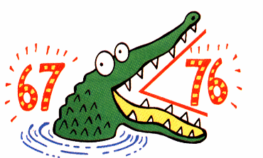**Inequalities Practice**

|  |  |
| --- | --- |
| 1. Which number is a solution to the inequality below? **x > 4**  A. 1 B. 2  C. 4 D. 5 | 2. Which number is NOT a  solution to the inequality? **x < 8**   1. 6 B. 7   C. 8 D. 9 |
| 3. Which statement describes “a number more than 22”?   1. x < 22 B. x > 22 2. x < 22 D. x > 22 | 4. Which statement describes “ a number less than or equal to 43”?   1. x < 43 B. x > 43   C. x < 43 D. x > 43 |
| 5. Which statement describes “ a number no more than 17”?  A. x < 17 B. x > 17  C. x < 17 D. x > 17 | 6. Which statement describes “at least 32”?   1. x < 32 B. x > 32   C. x < 32 D. x > 32 |
| 7. Which number is a solution to x + 4 > 12   1. 3 B. 5   C. 7 D. 9 | 8. Which number is **NOT** a solution to  x – 3 < 10   1. 7 B. 8 2. 10 D. 14 |
| 9. Which number is a solution to  3x > 12   1. 4 B. 5 2. 2 D. 3 | 10. Which number is **NOT** a solution to  2x < 10   1. 3 B. 4 2. 5 D. 6 |
| 11. Which inequality matches the graph below? | 12. Which inequality matches the graph below? |
| 13. Which inequality matches the graph below?  [Number Line](http://www.mathwarehouse.com/number-lines/inequality-outputter.php?&w=400&sineq=3&etype=22&startAt=-5&endAt=5&label=labelall&bg=FFFFFF&random=128&download=1)   1. x > 3 b. x > 3 2. x ≤ 3 d. x ≥ 3 | 14. Which inequality matches the graph below?  [Number Line](http://www.mathwarehouse.com/number-lines/number-line-outputter.php?s=-7&e=7&w=300&label=labelall&endtype=arrows&inc=1&bg=FFFFFF&col=000033&download=1)   1. n < 0 b. n ≤ 0   c. n ≥ 0 d. n > 0 |
| 15. Solve x + 11 > 19 | 16. Graph the solution to the inequality from question #15.  Number Line |
| 17. Solve x – 3 < 5 | 18. Graph the solution to the inequality from question #17.  Number Line |
| 19. Solve 3x < 12 | 20. Graph the solution to the inequality from question #19.  Number Line |
| 21. Solve $\frac{x}{4}$ > 2 | 22. Graph the solution to the inequality from question #21.  Number Line |
| 23. Write an inequality for this statement “x is less than or equal to 7”. | 24. Write an inequality for this statement  “x is greater than -9” |

Putting It All Together…

What exactly IS Direct Proportion??

What? Meaning… Example:

|  |  |  |
| --- | --- | --- |
| 1: The Situation | You have a problem or situation with a __________ variable; in other words, one number, the “k”, will stay the same. | Bozo performs in 10 circus acts per day.  *(10 is the constant, k, because it stays the same)* |
| 2. The Rule | An equation written as __________, where k is the constant. | y = 10x  *(x represents the # days*  *y represents the total # of circus acts)* |
| 3. The Table of Ordered Pairs (x,y) | For every ____________, x, there is one ____________, y. Each (x,y) pair gives you an ordered pair you can graph on a coordinate plane.  FYI: The x value is the *____________* variable, and the y value is the *_____________* variable. | |  |  | | --- | --- | | X | Y | | 0 | 0 | | 1 | 10 | | 2 | 20 | | 3 | 30 |   Plug in input values for x. In 0 days, Bozo performs 0 times. In 1 day, he performs 10 times, and so on. Write the data in a table:  *Each set is an ordered pair to be graphed, such as (0,0), (1,10), etc.* |
| 4. The Graph | The ordered pairs can be _______________. Because x and y vary proportionally, they will ALWAYS:  1) start at (0,0)  2) form a straight line | Bozo’s Performances  http://ancastermath.wikispaces.com/file/view/Distance_time_graph_slope.yeh.JPG/77011895/Distance_time_graph_slope.yeh.JPG  total  perfs.  # days |

On the left side, make up your OWN situation. Then, create the rule, a table of at least 5 ordered pairs, and a graph. Be sure to label everything appropriately.

Putting It All Together…

What exactly IS Direct Proportion??

What? Meaning… Example:

|  |  |  |
| --- | --- | --- |
| 1: The Situation | You have a problem or situation with a __________ variable; in other words, one number, the “k”, will stay the same. | Bozo performs in 10 circus acts per day.  *(10 is the constant, k, because it stays the same)* |
| 2. The Rule | An equation written as __________, where k is the constant. | y = 10x  *(x represents the # days*  *y represents the total # of circus acts)* |
| 3. The Table of Ordered Pairs (x,y) | For every ____________, x, there is one ____________, y. Each (x,y) pair gives you an ordered pair you can graph on a coordinate plane.  FYI: The x value is the *____________* variable, and the y value is the *_____________* variable. | |  |  | | --- | --- | | X | Y | | 0 | 0 | | 1 | 10 | | 2 | 20 | | 3 | 30 |   Plug in input values for x. In 0 days, Bozo performs 0 times. In 1 day, he performs 10 times, and so on. Write the data in a table:  *Each set is an ordered pair to be graphed, such as (0,0), (1,10), etc.* |
| 4. The Graph | The ordered pairs can be _______________. Because x and y vary proportionally, they will ALWAYS:  1) start at (0,0)  2) form a straight line | Bozo’s Performances  http://ancastermath.wikispaces.com/file/view/Distance_time_graph_slope.yeh.JPG/77011895/Distance_time_graph_slope.yeh.JPG  total  perfs.  # days |

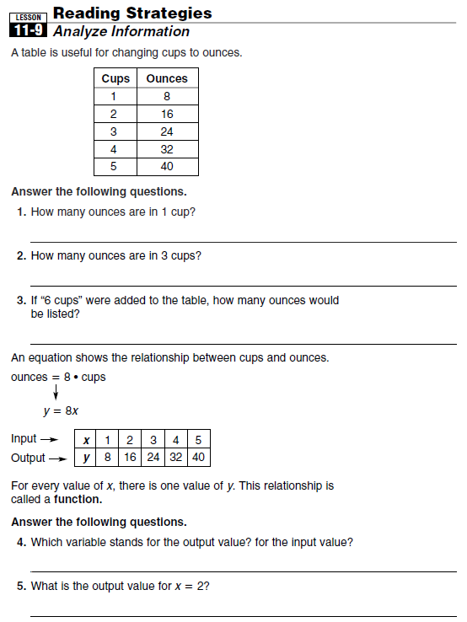

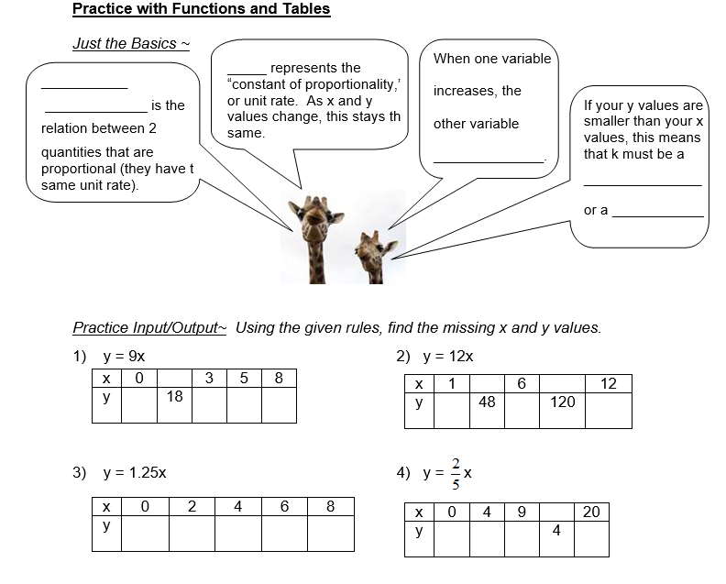

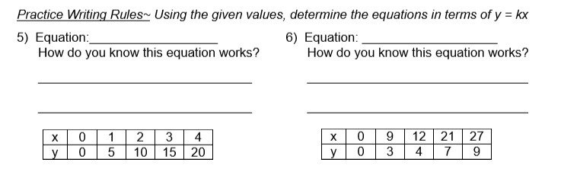

1) Rhea is purchasing tickets to a One Direction concert. Tickets cost $35 apiece.

[](http://images.google.com/imgres?imgurl=http://www.sixthman.net/blog/wp-content/uploads/2009/03/tickets.jpg&imgrefurl=http://www.sixthman.net/blog/2009/03/19/all-of-my-friends%E2%80%A6-come-to-see-me-last-night/&usg=__DysXAIacL4uNsC4Wdqm8VgaSmzU=&h=467&w=365&sz=35&hl=en&start=2&itbs=1&tbnid=U1_KrZL_kxaZGM:&tbnh=128&tbnw=100&prev=/images?q%3Dtickets%26hl%3Den%26gbv%3D2%26tbs%3Disch:1) Since tickets cost $35, that is the ______________, because this won’t change.

X is the input (or independent variable), and this is the number of tickets purchased.

Y is the output (or dependent variable), and this is the total cost.

 Since the constant is 35, the equation is ____________________

Rule: y = 35x

|  |  |  |  |  |  |
| --- | --- | --- | --- | --- | --- |
| X (# tickets) | 0 | 2 | 3 |  | 6 |
| Y (total cost) |  |  |  | 140 |  |

2) Rocky is saving up for a new Tony Hawk game for his Wii. He earns $7.50 for each chore he does.

 What is k, the constant? ____________________________________________

X, the input, is the number of chores Rocky completes.

Y, the output, is the amount of money Rocky makes.

What is the equation? ______________________________________________

Using this rule/equation, fill in the values in the table below.

|  |  |  |  |  |  |
| --- | --- | --- | --- | --- | --- |
| X (# chores completed) |  | 2 |  | 15 | 50 |
| Y (total money earned) | 0 |  | 75 |  |  |

3) There are 37 boys in the drama club. They want to buy new props, so they are all going to pitch in money.

They all want to pitch in the same amount.

K, the constant, is 37. This number is not going to change.

The amount that each boy brings in is the input, or the _________ value.

[](http://images.google.com/imgres?imgurl=http://images.faithclipart.com/images/3/f0914912aa/img_large_watermarked.jpg&imgrefurl=http://www.faithclipart.com/image/three-choir-boys-with-vests.html&usg=__ZqopTS7dEIptWJl3mfT7aqKzHPc=&h=173&w=300&sz=24&hl=en&start=32&itbs=1&tbnid=8BM15LfjaOkb_M:&tbnh=67&tbnw=116&prev=/images?q%3Dboys%2Bchoir%2Bclip%2Bart%26start%3D20%26hl%3Den%26sa%3DN%26gbv%3D2%26ndsp%3D20%26tbs%3Disch:1) The total amount raised is the output, or the _________ value.

What is the equation? ______________________________________________

Using this rule/equation, fill in the values in the table below.

|  |  |  |  |  |  |
| --- | --- | --- | --- | --- | --- |
| X (amount each boy brings) | 0 | 3 | 5 | 8.50 |  |
| Y (total amount raised) |  |  |  |  | 370 |

4) Notice that direct variation ALWAYS uses the formula y = kx,

Therefore, when x = 0, y ALWAYS equals ____________!

[](http://www.google.com/imgres?num=10&hl=en&tbo=d&biw=1600&bih=697&tbm=isch&tbnid=SeCPt-PbIykHpM:&imgrefurl=http://store.apple.com/us/browse/home/shop_ipod/family/ipod_shuffle&docid=qexTI8tLxGL05M&imgurl=http://store.storeimages.cdn-apple.com/3155/as-images.apple.com/is/image/AppleInc/2012-ipodshuffle-product-initial?wid%3D410%26hei%3D190%26fmt%3Djpeg%26qlt%3D95%26op_sharpen%3D0%26resMode%3Dbicub%26op_usm%3D0.5,0.5,0,0%26iccEmbed%3D0%26layer%3Dcomp&w=410&h=190&ei=rUnuUPOFIYL09gSgmYGQDQ&zoom=1&iact=rc&sig=118279028075191188497&page=1&tbnh=133&tbnw=266&start=0&ndsp=31&ved=1t:429,r:3,s:0,i:173&tx=130&ty=43)

**An iPod Nano can hold up to 16 gigabytes (GB) of data.**

1) How many gigabytes can be stored on 0 iPod Nanos? ________________

1? ___________________

5?________________________ 12?__________________________

2) If you have enough iPod Nanos to hold 80 GB, how many of them do you have? ________

3) Fill in the table:

|  |  |  |  |  |  |
| --- | --- | --- | --- | --- | --- |
| X (# of iPods) | 0 | 2 |  |  | 25 |
| Y (total GB) |  |  | 64 | 160 |  |

4) What is the direct variation equation (in the terms of y=kx)? _____________________

5) Based on this problem, answer the following. (Hint: Refer to the table in #3.)

a. In words, what does the input (x) represent? ____________________

b. In words, what does the output (y) represent? ____________________

c. In words, what does the constant (k) represent? ___________________

6) As the number of iPod Nanos increases, the total number of gigabytes ______________.

7) Look at the values in the table on #3. Write each set of (x,y) values as an ordered pair.

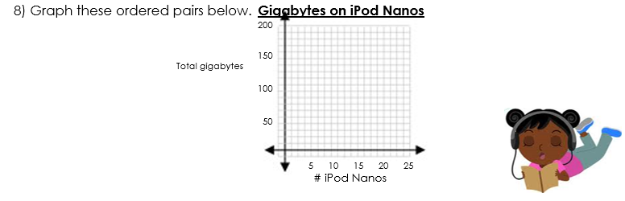 (0, 0) (2, ) __________ __________ __________