Unit 3

Expressions

Exponents

Order of Operations

Evaluating Algebraic Expressions

Translating Words to Math

Identifying Parts of Expressions

Evaluate Formulas

Properties

Simplifying Expressions

Identifying Equivalent Expressions

|  |  |  |  |  |
| --- | --- | --- | --- | --- |
| Unit 3 Calendar: Math 6/7 | | | | |
| 10/1 | **10/2** | **10/3** | **10/4** | **10/5** |
| Unit 3 Pretest  Exponents | **Order of Operations** | **Order of Operations** | **Evaluating Algebraic Expressions** | **Quiz** |
| 10/8 | **10/9** | **10/10** | **10/11** | **10/12** |
| Translating Words to Math  Identifying Parts of Expressions | **Combining Like Terms** | **Combining Like Terms & Distributive Property** | **Combining Like Terms & Distributive Property** | **Quiz** |
| 10/15 | **10/16** | **10/17** | **10/18** | **10/19** |
| Properties & Factoring | **Unit 3 Pre/POST Test**  **Review** | **Unit 3 Review Stations** | **Unit 3 Review**  **Stations** | **Unit 3 Test** |

**Unit 3: Expressions**

**Standards, Checklist and Concept Map**

**Georgia Standards of Excellence (GSE):**

**MGSE6.EE.1**: Write, evaluate numerical expressions with whole-number exponents.

**MGSE6.EE.2**: Write, read, and evaluate expressions with variables.

**MGSE6.EE.2a**: Write expressions that record operations with numbers and with letters standing for numbers. *For example, express “Subtract y from 5” as 5-y.*

**MGSE6.EE.2b** : Identify parts of an expression using mathematical terms (sum, term, product, factor, quotient, coefficient); view one or more parts of an expression as a single entity. *For example, describe the expression 2(8 + 7) as a product of two factors; view (8 + 7) as both a single entity and a sum of two terms.*

**MGSE6.EE.2c** : Evaluate expressions at specific values of their variables. Include expressions that arise from formulas used in real-world problems. Perform arithmetic operations, including those involving whole-number exponents, in the conventional order when there are no parentheses to specify a particular order.

**MGSE6.EE.3**: Apply the properties of operations to generate equivalent expressions. *For example, apply the distributive property to the expression 3(2 + x) to produce the equivalent expression 6 + 3x; apply the distributive property to the expression 24x + 18y to produce the equivalent expression 6(4x + 3y); apply the properties of operations to y + y + y to produce the equivalent expression 3y.*

**MGSE6.EE.4** : Identify when two expressions are equivalent (i.e., when the two expressions name the same number regardless of which value is substituted into them). *For example, the expressions y + y + y and 3y are equivalent because they name the same number regardless of which number y stands for.*

**What Will I Learn??** Check off topics as you master them.

C:\Users\baj10446\AppData\Local\Microsoft\Windows\Temporary Internet Files\Content.IE5\HW62Y2RF\MC900441880[1].wmf_______ I can evaluate expressions, including with variables and exponents

_______ I can translate words to expressions

_______ I can apply Order of Operations

_______ I can identify parts of expressions

_______ I can simplify expressions (combine like terms, distributive prop)

_______ I can substitute to evaluate formulas

_______I can identify equivalent expressions

Expressions

Vocabulary

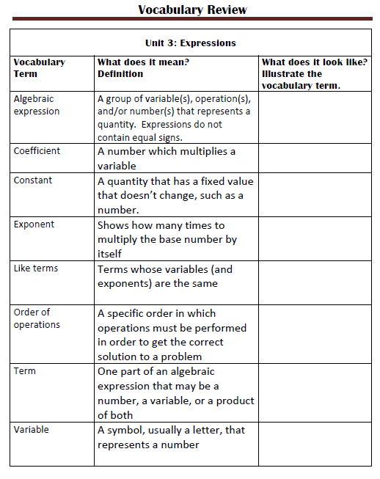

Vocabulary

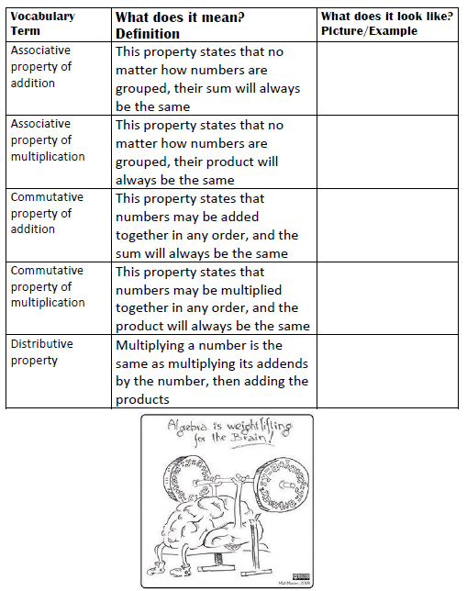

**Unit 3: Expressions Post-Test Review ~ Math 6/7**

1. Identify each part of the expression. Write “N/A” if the part is not in this expression: 9(3x² + 4)

a. coefficient: ___________ b. constant: ______________

c. variable: _____________ d. exponent: ___________

e. quotient: ______________ f. product: _____________

g. factors: ______________ h. sum: __________________

1. What does it mean when a number is “squared” or “cubed?”

___________________________________________________________

___________________________________________________________

1. Evaluate the expression. Show EACH step: 10² - 3(14 – 2 + 8) ÷ 5
2. Write using exponents AND solve: 5 • 5 • 5 • 5 = _________________
3. If m = 5, evaluate the expression: 4m² + 6m ___________________
4. Apply the distributive property to simplify 9(y – 3) _________________
5. Simplify this expression: 8x³ + 4x² + 12x³ - x² ____________________
6. The cost of renting a moving truck is $39.99 plus an additional $0.50 for each mile driven. Write an expression to represent the cost of renting the truck for *m* miles.

______________________

1. Give an example equivalent expressions using:

a. commutative property:____________________________________

b. distributive property:_____________________________________

c. associative property:______________________________________

1. The formula V= *lwh* is used to find volume of a rectangular prism. Solve for the volume if l = 14, w = 2.5, and h = 6.2.
2. Use the formula V = s3 to find the volume of a cube in which s =  inch.
3. Factor the expression 8z + 480. ____________________
4. The expression 100 + 5*n* can be used to find the total price for a field trip to the science museum, where n = the number of students. Determine the cost for 250 students to attend the trip.

_______________

_

1. Evie ordered 3 “Number 1” combos, each with 1 burger, 1 order of fries, and 1 Coke. Parker ordered a “Number 1” combo, along with an extra Coke. Mrs. Bothers ordered 2 “Number 1” combos, but she upgraded the Cokes to milkshakes. Write an expression for their combined orders, if b = burgers, f = fries, c = Cokes, and m = milkshakes.

__

__

1. Write the following statement as an expression:

six less than the product of 4 and x _________________________

1. Nicolas and 2 friends order a large pizza for $19.99, an order of wings for $7.59, and *n* medium drinks for $1.50 each. If they split these costs evenly, write an expression can be used to find the amount each boy should pay.

___

1. Laurel bought *b* blouses that were originally priced at $24.50 each. Each blouse was on sale for $6.50 off the original price when she bought them. Which expression can be used to find the total sale price of *b* blouses?

A. 24.50(b – 6.50) B. b(24.50 – 6.50)

C. 24.50b – 6.50 D. 24.50 – 6.50 - b

|  |  |
| --- | --- |
|  |  |

1. A family of four (2 adults and 2 kids) is going to the pumpkin patch. Regular admission is $10.75 for adults and $8 for kids. They also have a coupon for 25% off kids’ admission. How much will they pay to get in?

_________________________

1. Evaluate each expression: 80 = ______ 1,4000 = ______ (¼)0 = ______

Explain/show the reasoning behind each answer above.