Adv Unit 2

Rate, Ratio and Proportional Reasoning

Ratios

Unit Rate

Proportions

Percents

Measurement Conversion

**Name:**

**Math Teacher:**

|  |  |  |  |  |
| --- | --- | --- | --- | --- |
| Adv Unit 2 Calendar | | | | |
| 9/2 | **9/3** | **9/4** | **9/5** | **9/6** |
| No School  Labor Day | **Unit 2 Pretest**  **Ratios** | **Ratios Activity** | **Ratio Tables** | **Unit Rate** |
| IXL Skills Week of 9/2: R.1, R.3, R.6, R.8 | | | | |
| 9/9 | **9/10** | **9/11** | **9/12** | **9/13** |
| Computer Lab  Touchstones  IXL | **Solving Proportions** | **Proportion Problem Solving** | **Putting it all Together** | **Quiz** |
| IXL Skills Week of 9/9: R.9, R.11, R.12, R.13 | | | | |
| 9/16 | **9/17** | **9/18** | **9/19** | **9/20** |
| Percent of a Number | **Whole if Given the Percent** | **Percent Problem Solving** | **Review/**  **Performance Task or Activity** | **Quiz** |
| IXL Skills Week of 9/16: S.8, S.9, S10 | | | | |
| 9/23 | **9/24** | **9/25** | **9/26** | **9/27** |
| Fall Break | | | | |
| 9/30 | **10/1** | **10/2** | **10/3** | **10/4** |
| Measurement | **Measurement and Unit 2 Post Test** | **Review** | **Review** | **Test** |
| IXL Skills Week of 9/30: T.3, T.7 | | | | |

**Unit 2: Rate, Ratio and Proportional Reasoning**

**Standards, Checklist and Concept Map**

**Georgia Standards of Excellence (GSE):**

**MGSE6.RP.1**: Understand the concept of a ratio and use ratio language to describe a ratio between two quantities. *For example, “The ratio of wings to beaks in the bird house at the zoo was 2:1, because for every 2 wings there was 1 beak.” “For every vote Candidate A received, Candidate C received nearly 3 votes.”*

**MGSE6.RP.2**: Understand the concept of a unit rate a/b associated with a ratio a:b with b ≠ 0, and use rate language in the context of a ratio relationship. *For example, “This recipe has a ratio of 3 cups of flour to 4 cups of sugar, so there is ¾ cup of flour for each cup of sugar.”*

**MGSE6.RP.3b**: Solve unit rate problems including those involving unit pricing and constant speed. *For example, if it took 7 hours to mow 4 lawns, at that rate, how many lawns could be mowed in 35 hours?*

**MGSE6.RP.3** : Use ratio and rate reasoning to solve real-world mathematical problems, e.g., by reasoning about tables of equivalent ratios, tape diagrams, double number line diagrams, or equations.

**MGSE6.RP.3a** : Make tables of equivalent ratios relating quantities with whole-number measurements, find missing values in tables, and plot the pairs of values on the coordinate plane. Use tables to compare ratios.

**MGSE6.RP.3c** : Find a percent of a quantity as a rate per 100 (e.g., 30% of a quantity means 30/100 times the quantity); solve problems involving finding the whole, given a part and the percent.

**MGSE6.RP.3d** : Use ratio and rate reasoning to convert measurement units; manipulate and transform units appropriately when multiplying or dividing quantities.

**What Will I Need to Learn??**

________ I can understand ratios

________ I can understand unit rates

________ I can solve unit rate problems

________ I can make tables of equivalent ratios, find missing values, and plot points in a coordinate plane; compare ratios in a table

________ I can solve problems with tables, tape or number line diagrams, or equations

________ I can find percent of a number

________ I can find the whole when given part and %

________ I can convert Metric units

________ I can convert Customary units

**Unit 2 Circle Map:** On the left page, make a Circle Map of important vocab and topics from the standards listed above.

**Unit 2 IXL Tracking Log**

|  |  |  |
| --- | --- | --- |
|  | **Required Skills** | |
|  | **Skill** | **Your Score** |
| **Week of 9/2** | **R.1** (Write a Ratio) |  |
| **R.3** (Write a Ratio: Word Problems) |  |
| **R.6** (Ratio Tables) |  |
| **R.8** (Unit Rates) |  |
| **Week of 9/9** | **R.9** (Equivalent Rates) |  |
| **R.11** (Unit Rates: Word Problems) |  |
| **R.12** (Do the ratios form a proportion?) |  |
| **R.13** (Solve the Proportion) |  |
| **Week of 9/16** | **S.8** (Find what percent one number is of another) |  |
| **S.9** (Find what percent one number is of another – Word Problems) |  |
| **S.10** (Find the total given a part and a percent) |  |
| **Week of 8/29** | **T.3** (Convert and Compare Customary Units) |  |
| **T.7** (Convert and Compare Metric Units) |  |

Unit 2 - Vocabulary

|  |  |
| --- | --- |
| Term | Definition |
| Customary System | The primary system of measurement used in the US, which uses a variety of conversions |
| Double Number Line Diagram | A visual model used to solve unit rate problems and proportions |
| Metric System | The system of measurement that uses a base-10 model; used by most countries |
| Percent | Number out of 100 |
| Proportion | An equation of equivalent ratios |
| Rate | A ratio that compares quantities measured in different units |
| Ratio | A comparison of two numbers |
| Unit Rate | A comparison of two measurements in which one of the terms has a value of 1 |

Unit 2 – Vocabulary – You Try

|  |  |  |
| --- | --- | --- |
| Term | Definition | Illustration or Example |
| Customary System |  |  |
| Double Number Line Diagram |  |  |
| Metric System |  |  |
| Percent |  |  |
| Proportion |  |  |
| Rate |  |  |
| Ratio |  |  |
| Unit Rate |  |  |

**Math 6 – Unit 2: Rates, Ratios &**

**Proportional Reasoning Review**

**Knowledge and Understanding**

1. What is a ratio?
2. What is a rate?
3. What is a unit rate?
4. What is a percent?

**Proficiency of Skills**

1. Fill in the ratio table:

|  |  |  |  |  |
| --- | --- | --- | --- | --- |
| 9 | 18 |  |  | 45 |
| 12 |  | 36 | 48 |  |

1. 80 is 25% of what number? __________
2. Find 30% of 70. __________
3. Find the value of *x*. $\frac{15}{25}=\frac{x}{30}$

__________
4. Write the ratio as a unit rate: $27 for 9 tickets. __________

**Application**

1. Jaden drove 260 miles in 4 hours. Jada drove 210 miles in 3 hours. Who drove at the fastest rate of speed? How do you know?
2. Who drove the fastest? __________
3. How do you know?

1. A circus elephant is going to stand on a ball. Lulu the Elephant weighs 2 Tons. If the ball can hold up to 3,000 pounds, will Lulu make it? Explain your answer.
2. The table below shows the number of each item sold at the concession stand. What might the ratio 3:4 represent?

|  |  |
| --- | --- |
| Item | Quantity Sold |
| Popcorn | 20 |
| Nachos | 15 |
| Hot Dog | 25 |
| Candy Bar | 30 |

1. The ratio of boys to girls in a class is 4:8. If there are 24 students in the class, how many are boys?
2. In a class of 40 students, 30% DID return their permission slips for the school field trip. How many students did NOT return their permission slips?
3. The table below shows the cost for varying number of books. If the rate stays the same, determine the value of *n*.

|  |  |
| --- | --- |
| Number of Books | Cost |
| 6 | $24 |
| 10 | $40 |
| 12 | *$48* |
| 20 | N |

1. PBIS Middle School held a car wash as a fundraiser. Out of the 50 vehicles that were washed, 15 were trucks. What percent were trucks?
2. The graph below compares cups to pints. Which of the following ordered pairs would also satisfy this relationship?

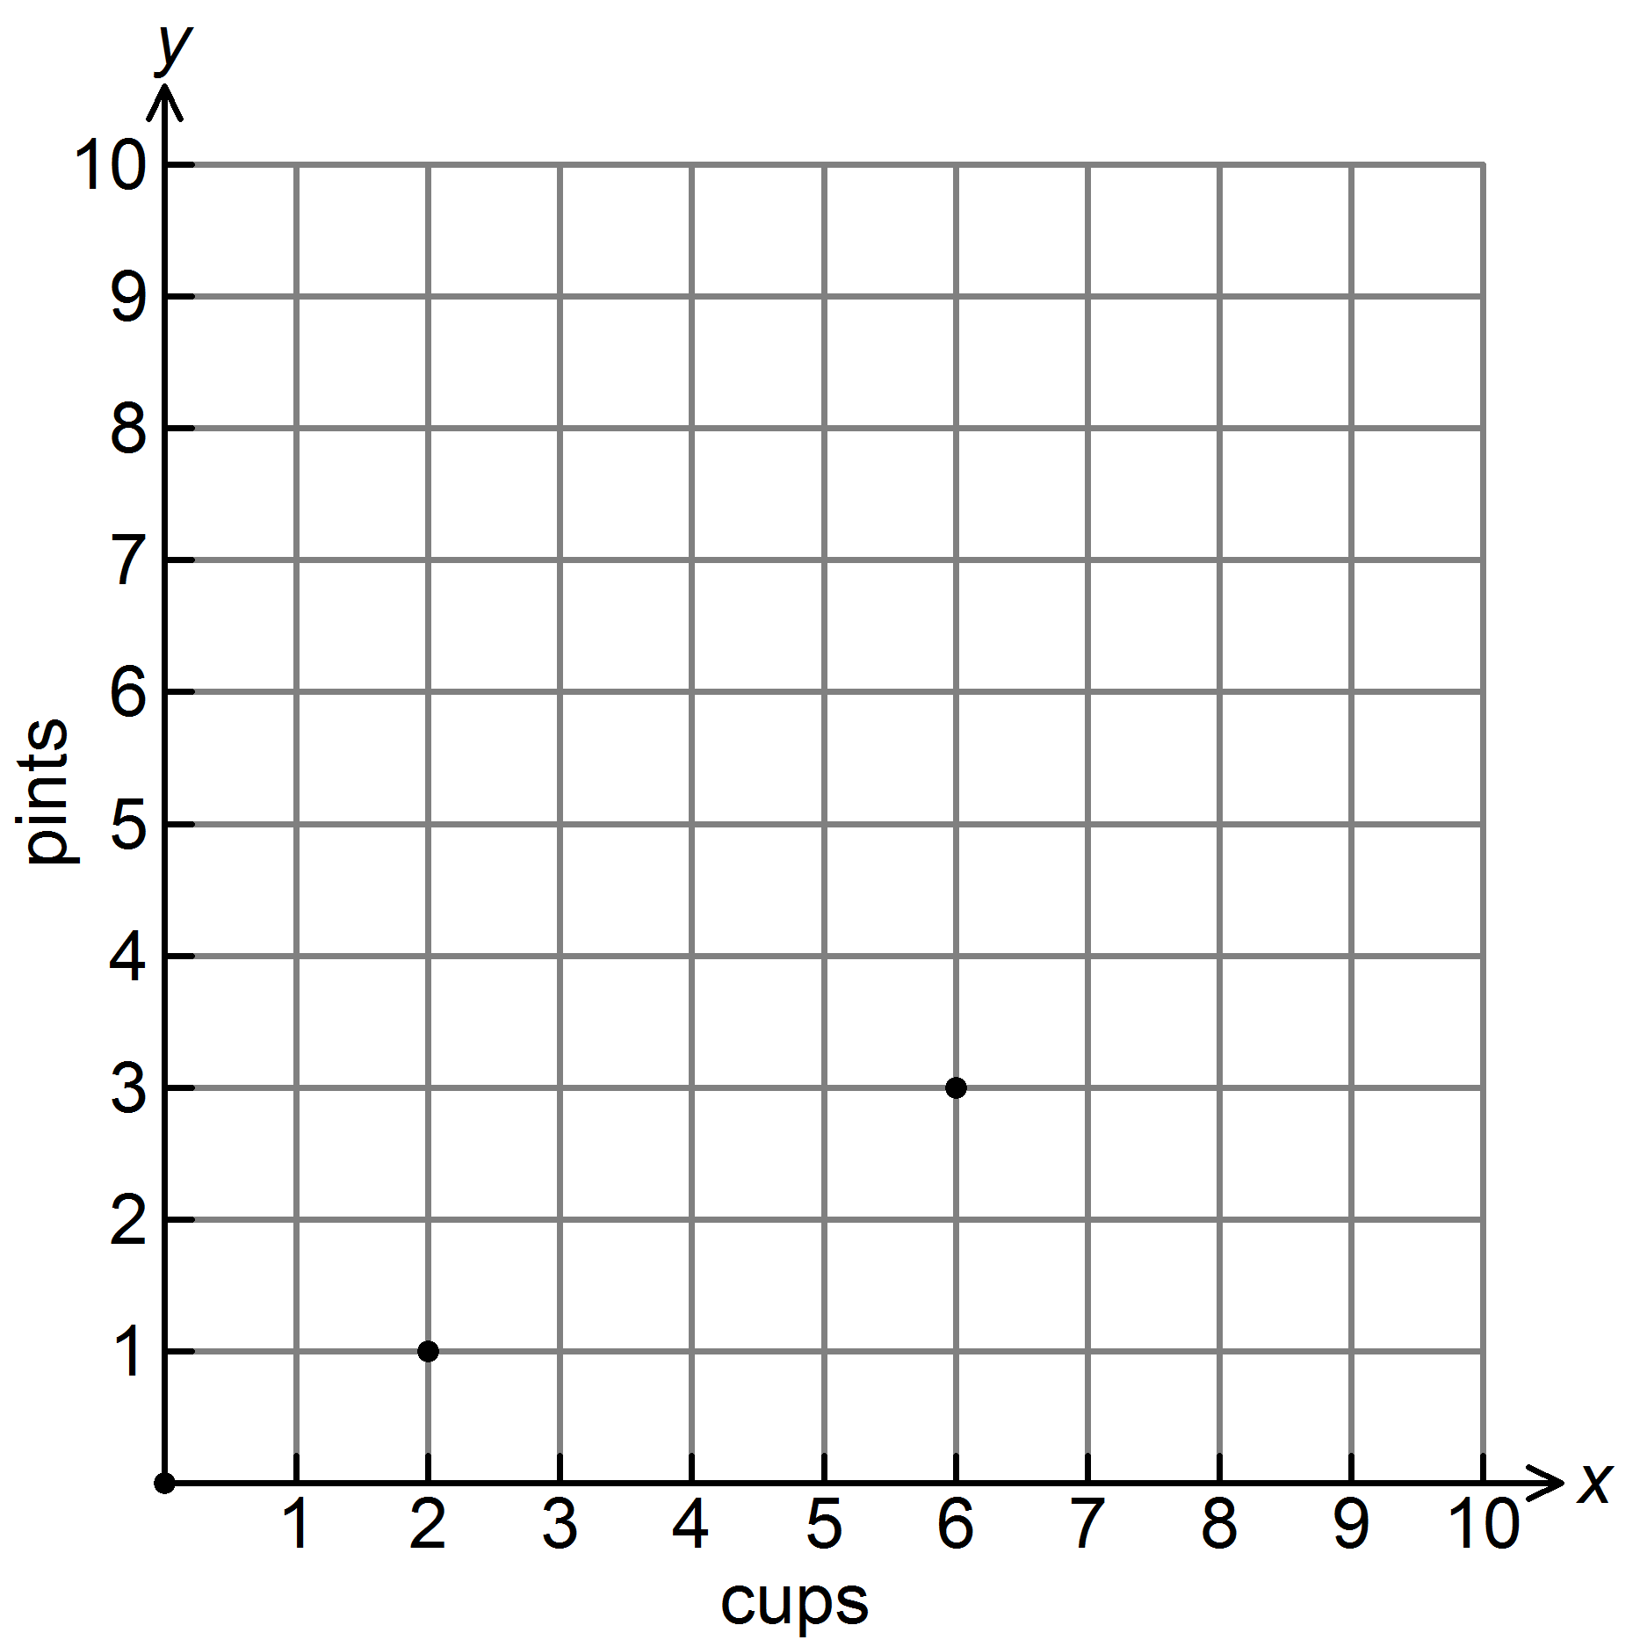

|  |  |  |  |  |  |  |  |
| --- | --- | --- | --- | --- | --- | --- | --- |
| A. | (1, 2) | B. | (2, 4) | C. | (2, 0) | D. | (4, 2) |

1. Michael’s paycheck last week was $146.50. He would like to put 20% of his earnings in his savings account. How much money should he put in his savings account?

|  |  |  |  |  |  |  |  |
| --- | --- | --- | --- | --- | --- | --- | --- |
| 1. $5.02 |  | 1. $15.22 |  | 1. $29.30 |  | 1. $88.27 |  |

1. The prices of 4 different bottles of lotion are given in the table. Which size bottle is the BEST value?

|  |  |
| --- | --- |
| Size | Price |
| 25 ounces | $4.50 |
| 15 ounces | $1.80 |

1. The 25-oz bottle
2. The 15-oz bottle
3. They both have the same unit price
4. Neither
5. Driving at a constant speed, Daisy drove 240 miles in 6 hours. How far would she drive in 1 hour? 15 hours?
6. Chompers is 76 cm long. How many mm is this?
7. .76 mm b. 7.6 mm c. 760 mm 7,600 mm

**Ratios**

A __________ is a comparison of two quantities by division.

The ratio of two red paper clips to six blue paperclips can be written in the following ways:

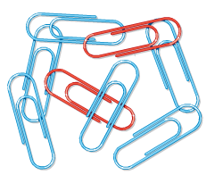 

Just like fractions, we usually represent a ratio in simplest form.

**ORDER MATTERS!**

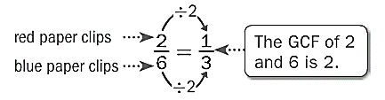

**Example:**

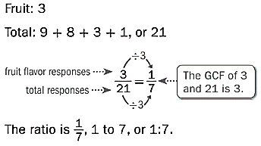Several students named their favorite flavor of gum. Write the ratio that compares the number of students who chose fruit to the total number of students.

|  |  |
| --- | --- |
| **Favorite Flavors of Gum** | |
| ***Flavor*** | ***# of Responses*** |
| Peppermint | 9 |
| Cinnamon | 8 |
| Fruit | 3 |
| Spearmint | 1 |

So, 1 out of every 7 students preferred fruit-flavored gum.

**You Try:**

*Use the stars to answer questions 1 and 2.*

1) Write the ratio of black stars to white stars in three different ways.

_______________ _______________ _______________

2) Write the ratio of white stars to black stars in three different ways.

_______________ _______________ _______________

*Use the table below to answer questions 3-6.*

Pleasssssssssse remember to sssssssssimplify!

|  |  |
| --- | --- |
| **Favorite Pets** | |
| Snake | 15 |
| Dog | 10 |
| Cat | 6 |
| Hamster | 8 |
| Fish | 1 |

3) What is the ratio of people who chose **snakes** as their favorite pet to those who chose **dogs**?

4) What is the ratio of people who chose **cats AND dogs** to those who chose **hamsters**?

5) What is the ratio of those who chose **snakes** as their favorite pet to **everyone** that was surveyed?

6) What is the ratio of those who chose **cats** to those who chose **fish**?

*Use the words,* ***“East Cobb Middle School”*** *to answer questions 7-11.*

7) What is the ratio of vowels to consonants?

8) What is the ratio of letters in ECMS to East Cobb Middle School?

9) What is the ratio of the letters in “East Cobb” to the letters in “Middle School”?

10) What is the ratio of the letters in “Middle School” to the letters in “East Cobb”?

11) Crain says the ratio of letters in “East” to “Cobb” is 4:4. Hailey says that ratio is 1:1. Who is correct? Explain your answer.

*The table below shows the number of balloons purchased in each color at Party City. Using this information, answer questions 12-15.*

|  |  |  |  |  |
| --- | --- | --- | --- | --- |
| Color | Red | Yellow | Blue | Green |
| Quantity Sold | 10 | 20 | 15 | 25 |

12) Which two items does the ratio 10:20 represent?

13) Which two items does the ratio 3:5 represent?

14) Which two items does the ratio 5 to 3 represent?

15) Which two items does the ratio $\frac{3}{2}$ represent?

16) Which two items does the ratio 4:3 represent?

Different Types of Ratios

**Part to __________** ratios are ratios that relate one part of a whole to another part of a whole.

**Example:**

There are 4 boys for every 6 girls. The ratio of boys (a part of the group of kids) to girls (another part of the group of kids) is 4:6 (*simplified to 2:3*).

**You Try:**

|  |  |  |  |  |  |  |  |  |  |
| --- | --- | --- | --- | --- | --- | --- | --- | --- | --- |
| Boys: | Image result for boy | Image result for boy | Image result for boy |  |  |  |  |  |  |
| Girls: | Image result for girl | Image result for girl | Image result for girl | Image result for girl | Image result for girl | Image result for girl | Image result for girl | Image result for girl | Image result for girl |

The ratio of boys to girls is: __________ to __________

The ratio of girls to boys is: __________ : __________

**Part to __________** ratios are ratios that relate one part of the whole to the whole.

**Example:**

There are 4 boys (a part of the group of children) for every 10 children (the whole group of children), written as 4:10 *(simplified to 2:5)*. On the other hand, 6 girls for every 10 children is written as 6:10 *(simplified to 3:5).*

**You Try:**

|  |  |  |  |  |  |  |  |
| --- | --- | --- | --- | --- | --- | --- | --- |
| Boys: | Image result for boy | Image result for boy | Image result for boy | Image result for boy | Image result for boy |  |  |
| Girls: | Image result for girl | Image result for girl | Image result for girl | Image result for girl | Image result for girl | Image result for girl | Image result for girl |

The ratio of boys to children is: __________ to __________

The ratio of girls to children is: __________ : __________

More Practice with Ratios

*Use the table to answer the following questions.*

|  |  |
| --- | --- |
| ***Favorite Snacks of the 6th Graders*** | |
| Ice Cream | 12 |
| Takis | 6 |
| Candy | 9 |
| Fruit | 4 |
| Sunflower Seeds | 2 |
| Seaweed | 5 |
| Cookies | 7 |

*Find the following ratios. Don’t forget to simplify if necessary.*

1) candy to seaweed __________ to __________

2) sunflower seeds to cookies __________ to __________

3) Takis to ice cream __________ to __________

4) candy to cookies and fruit __________ to __________

5) cookies to Takis __________ to __________

6) fruit to candy __________ to __________

7) Takis and fruit to seaweed __________ to __________

8) ice cream to sunflower seeds __________ to __________

9) candy to total __________ to __________

10) cookies and ice cream to total __________ to __________

Ratio Tables

A __________ __________ is a table of values that displays equivalent ratios.

**Example:**

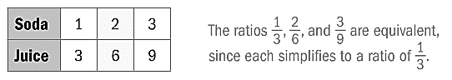

Equivalent ratios express the same relationship between quantities. In the example above, for every 1 soda, there are 3 juices.

**Examples:**

1) To make yellow icing, you mix 6 drops of yellow food coloring with 1 cup of white icing. How much yellow food coloring should you mix with 5 cups of white icing to get the same shade?

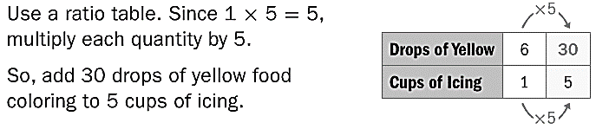

2) In a recent year, Joey Chestnut won a hot dog eating contest by eating nearly 66 hot dogs in 12 minutes. If he ate at a constant rate, determine about how many hot dogs he ate every two minutes.

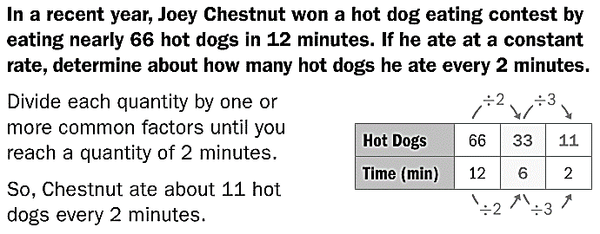

More Practice with Ratio Tables

*Find the missing values to complete the ratio tables.*

|  |  |  |  |
| --- | --- | --- | --- |
| **2** |  | **6** | **10** |
| **4** | **8** |  |  |

1)

|  |  |  |  |
| --- | --- | --- | --- |
|  |  | **3** |  |
| **7** | **14** | **21** | **28** |

2)

|  |  |  |  |
| --- | --- | --- | --- |
| **8** | **16** |  | **48** |
| **5** | **10** | **25** | **30** |

3)

|  |  |  |  |
| --- | --- | --- | --- |
| **2** | **6** | **8** | **10** |
| **5** |  |  |  |

4)

|  |  |  |  |
| --- | --- | --- | --- |
| **3** | **9** | **21** | **27** |
|  |  |  | **36** |

5)

|  |  |  |  |
| --- | --- | --- | --- |
| **4** |  | **12** | **16** |
| **6** | **12** |  |  |

6)

|  |  |  |  |
| --- | --- | --- | --- |
| **11** |  | **33** | **44** |
| **15** | **30** |  |  |

7)

|  |  |  |  |
| --- | --- | --- | --- |
| **5** |  | **15** |  |
| **12** | **24** |  | **48** |

8)

More Practice with Ratio Tables

*Find the missing values to complete the ratio tables.*

|  |  |  |  |
| --- | --- | --- | --- |
| **1** | **2** | **3** | **4** |
| **2** |  |  |  |

9)

|  |  |  |  |
| --- | --- | --- | --- |
| **2** | **4** | **6** | **8** |
| **3** |  |  |  |

10)

|  |  |  |  |
| --- | --- | --- | --- |
| **1** |  | **3** | **6** |
| **7** | **14** |  |  |

11)

|  |  |  |  |
| --- | --- | --- | --- |
|  |  | **3** |  |
| **9** | **18** | **27** | **36** |

12)

|  |  |  |  |
| --- | --- | --- | --- |
| **10** |  | **30** | **40** |
| **15** | **30** |  |  |

13)

|  |  |  |  |
| --- | --- | --- | --- |
| **3** |  | **9** |  |
| **12** | **24** |  | **48** |

14)

|  |  |  |  |
| --- | --- | --- | --- |
| **8** | **16** | **24** | **32** |
|  |  |  | **36** |

15)

|  |  |  |  |
| --- | --- | --- | --- |
| **15** |  | **45** | **60** |
| **16** | **32** |  |  |

16)

Unit Rates

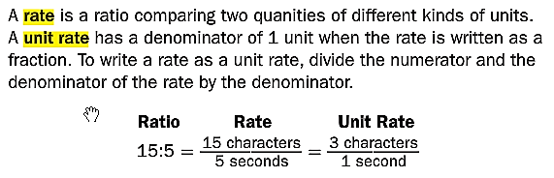

**Examples:**

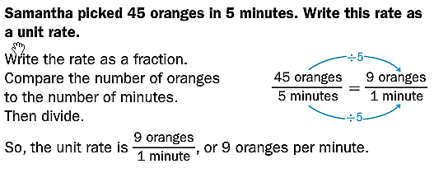

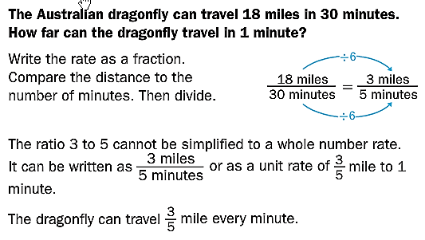

Unit Rates Practice

|  |  |  |
| --- | --- | --- |
| http://t1.gstatic.com/images?q=tbn:ANd9GcRrMdogky0rw6B7zXWkClAGv_JYdRxxsgffHGRtMFYNIx5Zaq0-  Jay drove 360 miles on 24 gallons of gas. | What is the rate? | Find the unit rate. Show your work! |
| http://www.rosiepiter.com/clipart_illustrations/a_young_red_haired_girl_waving_and_driving_a_green_car_0071-1006-2115-2550_SMU.jpg  Maya drove 540 miles on 30 gallons of gas. | What is the rate? | Find the unit rate. Show your work! |
| 1452 calories in a 12-slice cake. | What is the rate? | Find the unit rate. Show your work! |
| 880 calories in an 8-slice pie | What is the rate? | Find the unit rate. Show your work! |
| http://upload.wikimedia.org/wikipedia/en/thumb/6/65/Wiki_cheerios.jpg/250px-Wiki_cheerios.jpghttp://www.extension.org/mediawiki/files/2/2f/15oz_cheerios.jpg  15-oz Cheerios for $3.95 | What is the rate? | Find the unit rate. Show your work! |
| http://upload.wikimedia.org/wikipedia/en/thumb/6/65/Wiki_cheerios.jpg/250px-Wiki_cheerios.jpg10oz Cheerios Grocery Store Label  10-oz Cheerios for $2.85 | What is the rate? | Find the unit rate. Show your work! |

Equivalent Ratios and Unit Rate

You can find a unit rate by setting up an equation of equivalent ratios. This equation is called a proportion.

**Example:**

1) There are 21 water bottles to 7 forks. Find the unit rate for 1 fork.

$$÷7$$

First, set up a proportion: $\frac{Water Bottles}{Forks}=\frac{21}{7}=\frac{}{1}$

$$÷7$$

You can look at the relationship that is created for the forks. The 7 was divided by 7 to make 1. Then apply that same relationship to the top. 21 divided by 7 is 3.

*So, there are 3 water bottles for every 1 fork.*

**You Try:**

1) Megan paid $12.00 for 3 lip gloss flavors. What is the unit rate?

2) Erin paid $12.00 for 5 lip gloss flavors. What is the unit rate?Equivalent Ratios

You can find equivalent ratios in two different ways, using a table or a graph.

**Tables**

1. Fill in the information already given to you.
2. Find the pattern by writing the numbers as a fraction.
3. Fill in the rest of the table based on the pattern. (Multiply the top and bottom number by a common factor.)

**Example:**

1) Find the missing value by finding equivalent ratios.

$$×5$$

$$×5$$

|  |  |  |  |  |  |
| --- | --- | --- | --- | --- | --- |
| Green Beads | 2 | 4 | 6 | 8 | 10 |
| Blue Beads | 5 | 10 | 15 | 20 | ? |

$$\frac{2}{5}=\frac{4}{10}=\frac{6}{15}=\frac{9}{20}=\frac{10}{?}$$

Since the pattern shows that we are multiplying the numerator and denominator of our original fraction by the same factor, you can see that we multiplied 2 times 5 to get 10. That means we will multiply 5 by 5, so the ? must be equal to 25.

**You Try:**

1) Find the missing value by finding equivalent ratios.

|  |  |  |  |  |  |
| --- | --- | --- | --- | --- | --- |
| Green Beads | 2 | 4 | 6 | 8 | 10 |
| Blue Beads | 5 | 10 | 15 | 20 | ? |

$\frac{2}{5}=\frac{4}{10}=\frac{6}{15}=\frac{9}{20}=\frac{10}{?}$? = ______

**Graphs**

1. Plot the points that are already given to you.
2. Draw a line to connect the points.
3. Plot the rest of the points based on the pattern you see.

**Example:**

1) To make rice, you need 1 cups of rice and 2 cups of water. Use the graph below to find out how many cups of water you would need to make 3 cups of rice.

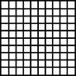

Ordered Pairs:

**( 1 , 2 )**

**( 2 , 4 )**

**( 3 , _____)**

What pattern do you see? As you increase the rice by 1 cups, you must increase the water by 2 cups.

Using the graph above, can you tell how many cups of water you would need for 5 cups of rice?

**You Try**

1) Every 3 days, students in a fitness class run 2 miles. Use the graph below to determine how many miles they run in total over 9 days.

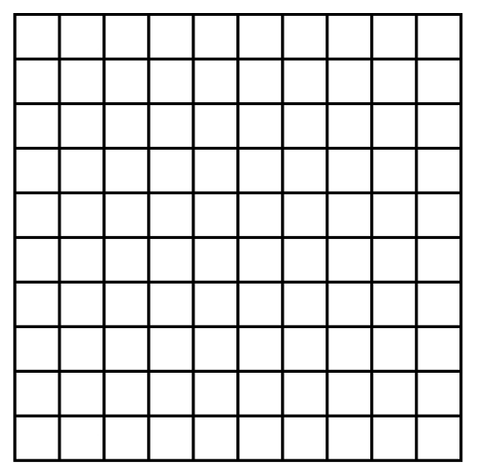

Ordered Pairs:

**( 3 , 2 )**

**( _____ , _____ )**

**( _____ , _____ )**

What pattern do you see?

They would run __________ miles total in 9 days.

2) Use either method you have learned to answer the following question: There are 3 people in each row of seats on an airplane. How many people can be seated in 4 rows?

Proportions

A ___________________ is an equation that relates two equivalent ratios. Ratios are said to be in proportion if they can both be reduced to the same ratio.

$\frac{1}{2}=\frac{5}{10}$ $\frac{1}{2}=\frac{5}{8}$

This **is** a proportion.This is **NOT** a proportion

You can check to see if two ratios are in proportion by cross-multiplying. The cross-products must be equal.

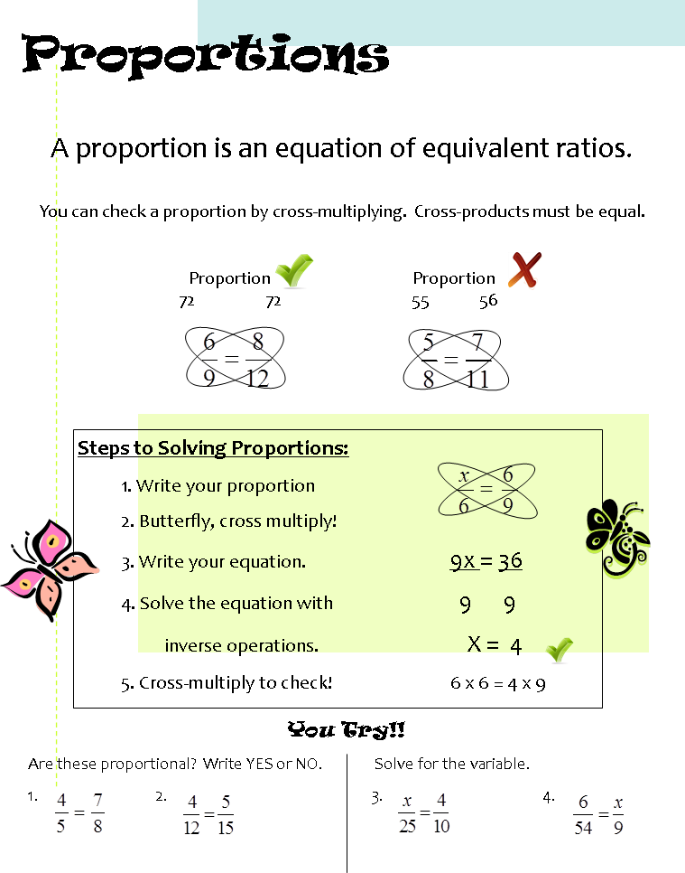

**Example:**

*State whether the ratios are proportional. If they aren’t proportional, change one of the numbers to make them proportional. Circle .*

1) They are in proportion.

**You Try:**

1) 2) 3)

4) 5) 6)

Solving Proportions

One way to solve proportions is to cross multiply and see what factor you need to make the cross-products equal.

**Example:**



Another way that you can solve a proportion is to find the factor that is shared across the numerator or denominator and use that same relationship to complete the proportion.

**Example:**

1) 2)

**You Try:**

Finding the missing number in the proportion:

1) 2) 3)

4) 5) 6)

You can set up proportions to solve word problems as well.

**Example:**

1) Jazmine won a pie-eating contest, eating 6 pies in 10 minutes. At that rate, how many pies can she eat in two hours?

There are 120 minutes in two hours. So, $\frac{6}{10}=\frac{p}{120}$. Since 10 times 12 equals 120, 6 times 12 is 72. She would eat 72 pies in two hours.

**You Try:**

1) Matthew hiked 10 miles in 4 hours. At that rate, how far can he hike in 18 hours?

2) A recipe calls for 2.5 cups of sugar to make 12 cookies. How much sugar is needed to make 36 cookies?

3) If 16 necklaces can be bought for $40, how much will 12 necklaces cost?

4) Sebastian can correctly solve 120 multiplication problems in 2 minutes. At this rate, how long would it take him to solve 300 problems?

5) Alexandra types at a speed of 45 words per minute. How many words can she type in 10 minutes?

6) Daisy needs 1.5 cups of sugar to make 12 cupcakes. How much sugar does she need to make 48 cupcakes?

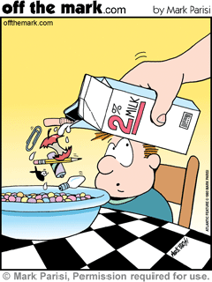Finding the “Percent of” a Number

Percent means

In math ***“of”*** means

To find the “percent of” a number:

1. Change the percent to a ____________________ and then ____________________.
2. Turn the percent into a ____________________ and then ____________________.

100% means 1 whole. Therefore 100% of 85 is 85. That’s just like changing 100% to its equivalent decimal, 1, and multiplying by 85. If you have less than 100% of a number, the solution is less than the original number.

**Example:**

Find 75% of 36.

|  |  |
| --- | --- |
| **OPTION 1**  (Change the percent to a decimal)  .75  x 36  450  2250  27.00 | **OPTION 2**  (Change the percent to a fraction)  9  1 $$\frac{75}{100}•\frac{36}{1}=\frac{3}{4}•\frac{36}{1}=27$$ |
| Therefore, 75% of 36 is 27. | |

**TIP:** Always, always, always check your answer to see if it is reasonable. (Does it make sense?) 75% is less than 100% so 27 should be less than 36. 75% is greater than 50% so 27 should be greater than half of 36, which is 18. If those things are true, you are probably on the right track!

**You Try:**

For each problem below, circle the ONLY reasonable answer based on what you know.

|  |  |
| --- | --- |
| **Problem** | **Circle the ONLY reasonable answer** |
| 90% of 40 | 9 36 17 57 |
| 25% of 72 | 18 54 2.5 70 |
| 50% of 1600 | 56 16 1650 800 |
| 110% of 55 | 1.5 115 60.5 25 |
| 5% of 80 | 58 4 804 85 |

*Find the “percent of” for each of the problems below.*

1) 50% of 12 2) 20% of 45 3) 15% of 100

4) 5% of 40 5) 150% of 92 6) 25% of 90

7) 100% of 183 8) Eddie’s mystery number is 45% of 200.

What is his mystery number?

9) “Arachibutyrophobia” is the fear of peanut butter getting stuck to the roof of your mouth. In a survey of 150 people, 2% of them have arachibutyrophobia. How many people surveyed have this fear?

10) When making peanut butter and jelly sandwiches, 20% of people put the peanut butter on first. Out of 75 people, how many people would NOT put peanut butter on first?

11) At ECMS, about 25% of the 6th graders made an A in math. If there are 416 6th graders, how many made an A?

12) Last year, ECMS had 1280 students. If we have 110% of that amount this year, how many students are at ECMS this year?

Finding the “Whole” when Given the Percent

**Example:**

There are 14 candies in a bag that is 20% full. How many candies are in a full bag?

**USE A TAPE DIAGRAM**

Whole: Unknown (# of candies in full bag)

Part: 14 candies

Percent: 20%

0%

20%

100%

|  |  |  |  |  |
| --- | --- | --- | --- | --- |
|  |  | ? |  |  |
|  |  |  |  |  |
|  |  | | | |

If there are 14 candies in 20%, then there are 14 candies in each of the other 20% sections of the diagram. The total number of candies in the bag is the sum of all the quantities:

14 + 14 + 14 + 14 + 14 = 70 or 14(5) = 70.

100%

80%

60%

40%

0%

20%

|  |  |  |  |  |
| --- | --- | --- | --- | --- |
|  |  | ? |  |  |
|  |  |  |  |  |
| 14 | 14 | 14 | 14 | 14 |

Thus, there are 70 candies in a full bag.

**USE A TABLE**

There are 14 candies in a bag that is 20% full. How many candies are in a full bag?

|  |  |  |  |  |  |  |
| --- | --- | --- | --- | --- | --- | --- |
| **Percentage** | 0% | 20% | 40% | 60% | 80% | 100% |
| **Part** | 0 | 14 | 28 | 42 | 56 | 70 |

**You Try:**

***Use a table to solve the percent problems below.***

1) 16 is 80% of what number?

|  |  |  |  |
| --- | --- | --- | --- |
| **Percentage** |  | 16 |  |
| **Part** | 20% | 80% | 100% |

2) Peyton made a 90% on her math test. If she got 27 questions correct, how many total questions were on the test?

|  |  |  |  |
| --- | --- | --- | --- |
| **Percentage** |  |  |  |
| **Part** |  |  |  |

3) 64% of the students in a classroom are girls. If there are 16 girls, how many total students are in the class?

|  |  |  |  |
| --- | --- | --- | --- |
| **Percentage** |  |  |  |
| **Part** |  |  |  |

The Percent Proportion

You can use a percent proportion to solve for any one piece when given the other 3.

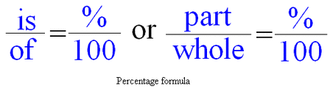

**Example:**

|  |  |
| --- | --- |
| Finding a percent (part) of a number (whole):  What is 20% of 240?  First, set up your proportion: $$\frac{x}{240}=\frac{20}{100}$$ Then solve by cross multiplying: $$\frac{x}{240}=\frac{20}{100}$$ $$x•100=240•20$$ $$x•100=4800$$ $$x=\frac{4800}{100}$$ $$x=48$$ 48 is 20% of 240. | Finding the whole given the percent (part):  60 is 75% of what number?  First, set up your proportion: $$\frac{60}{x}=\frac{75}{100}$$ Then solve by cross multiplying: $$\frac{60}{x}=\frac{75}{100}$$ $$60•100=x•75$$ $$6000=x•75$$ $$x=\frac{6000}{75}$$ $$x=80$$ 60 is 75% of 80. |

**You Try:**

Use one of the methods you have learned to solve the following problems.

1) What is 5% of 200? 2) 8 is 40% of what number?

3) What is 15% of 80? 4) 18 is 25% of what number?

5) What is 25% of 60? 6) 62 is 50% of what number?

Problem Solving with Percents

1) Martha put 20% of her paycheck in the bank. If her paycheck was $150, how much did she put in the bank?

a) Should your answer be MORE or LESS than $150?

b) Solution =

c) Write your answer in a complete sentence:

2) Ethan got 90% of the problems correct on a quiz. If he got 27 problems correct, how many problems were on the quiz?

a) Should your answer be MORE or LESS than 27?

b) Solution =

c) Write your answer in a complete sentence:

3) Whitney bought a pair of jeans that cost $25. If tax is 5%, how much tax will she pay?

a) Should your answer be MORE or LESS than $25?

b) Solution =

c) Write your answer in a complete sentence:

4) Ellis’ bill at Red Lobster was $18.50. If he gives his server a 20% tip, how much tip will he leave?

a) Should your answer be MORE or LESS than $18.50?

b) Solution =

c) Write your answer in a complete sentence:

Tips, Taxes and Discounts

|  |  |  |
| --- | --- | --- |
| Tips: If my bill is $25, how much should I tip and what is my total?  EQ: What is 20% of $25?  Step 1: Find key words!  Step 2: Change all percents to decimals or fractions!  Step 3: Substitute key words in your question:  What is 20% of $25 means  y =.2025 *OR* y = 1/5  25  Y (tip) = $5  Step 4: Add your tip to your total!  $25 + $5 tip= $30 total | | BTW: You thank your server by giving him a *tip*! This tip will be…  Added Subtracted  … to your bill. |
| BTW: Anytime we buy something, we pay sales tax to the government. Thus, tax is…  Added Subtracted  … to your total. | Taxes: A shirt costs $25. If taxes are 5%, what will my total be?  EQ: What is 5% of $25?  Step 1: Find key words to tell you what to do!  Step 2: Change all percents into decimals or fractions!  Step 3: Substitute key words into your essential question:  Y = .05$25 *OR* y = 5/100  25  Y (tax) = $1.25  Step 4: Add your tax to your total!  $25 + $1.25 = $26.25 | |
| Discounts: If a $32 sweater is 25% off, what is the sale price?  EQ: What is 25% of $32?  Step 1: Find key words to tell you what to do!  Step 2: Change all percents into decimals or fractions!  Step 3: Substitute key words into your essential question:  Y = .25  32 *OR* Y = 25/100 • 32  Y (discount) = $8  Step 4: Subtract your discount from your original price!  $32 - $8= $24 | | BTW: When something is on sale, the discounted amount is…  Added Subtracted  … from the original price. |

Selecting Appropriate Units of Measurement

When measuring something, you need to first figure out what the APPROPRIATE measure would be. The “benchmarks” below can give you a good idea of what each measurement looks like.

**METRICS (Base 10) CUSTOMARY (USA)**

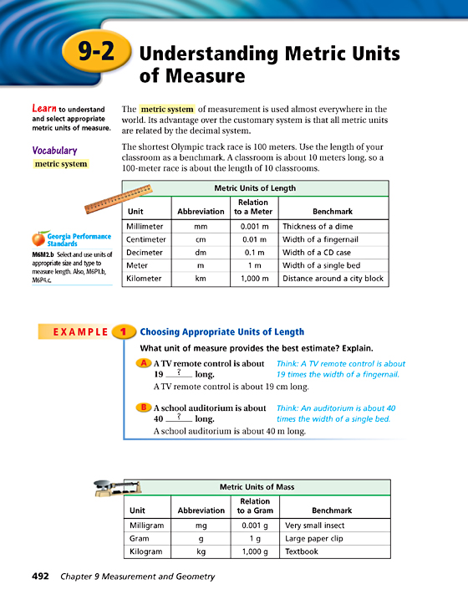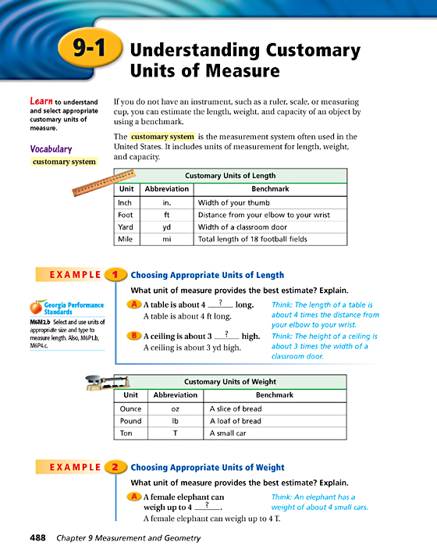

**length**



**Weight**

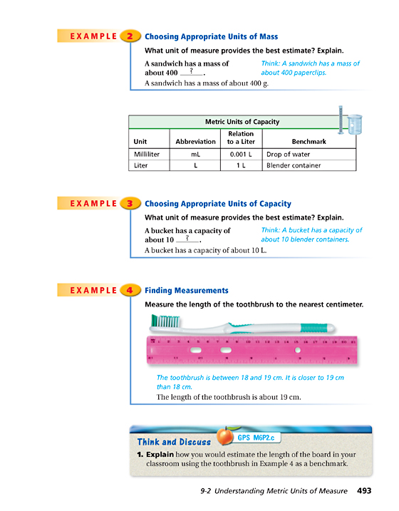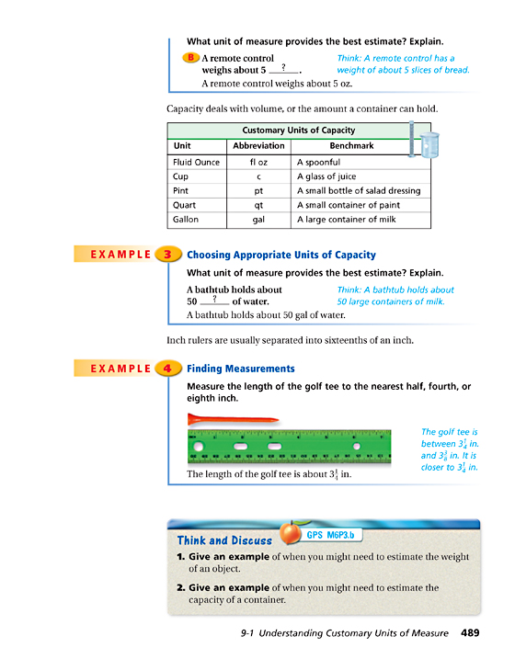

**Liquid CAPACITY**

To find the APPROPRIATE measure,

**FIRST**, decide whether you are using metric or customary units.

**SECOND**, decide whether you are measuring, length, weight or liquid capacity. Then use your brain to decide which unit of measure makes the most sense!

*Choose the APPROPRIATE measurement.*

In **METRIC UNITS**, what would you use to measure…

1. distance to the moon
2. weight of a person
3. the capacity of soup on a spoon
4. the length of your textbook
5. the weight of a Post-It note

In **CUSTOMARY UNITS**, what would you use to measure…

1. the weight of an elephant
2. water in a swimming pool
3. the width of your eye
4. the distance across the hall

the weight of a flea

Converting Customary (Standard) Units of Measurement

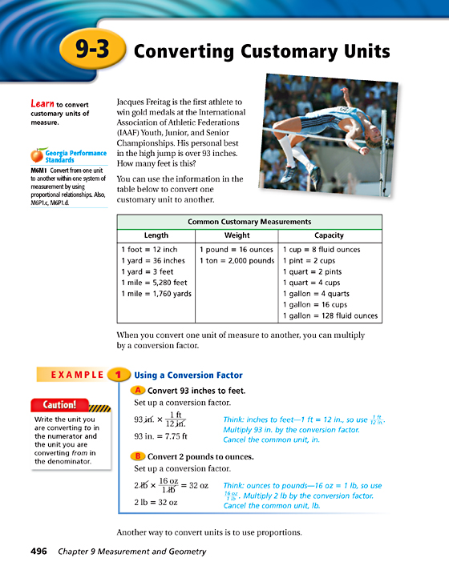

**You can use ratios and proportions to calculate measurement conversions quickly.**

**Example:**

Jacob is 66 inches tall. How many feet tall is he?

**MODELING THE PROBLEM**

Feet

0

1

5

2

3

4

6

0

12

60

24

36

48

Inches

72

6

$$\frac{1}{2}$$

66

$$5\frac{1}{2}$$

***This picture shows that 66 inches = 5 ½ feet.***

**USING PROPORTIONS**

66 in = _____ ft $\frac{12 in}{1 ft}=\frac{66 in}{x ft}$

$12x=66$

So, 66 in. = 5.5 ft $x=5.5$

Remember: A proportion shows that two ratios are equivalent.

Use a conversion factor for one of the ratios.

**You Try:**

1) 6 tons = _______________ lbs.

Always think about looking for patterns…

How many inches are in 2 feet? 

2) 21 ft = _______________ yds.

3) _______________ cups = 28 fl. oz.

4) 3 mi = _______________ yds.

Customary Practice

|  |  |
| --- | --- |
| **Length**  1) 1 yard = __________ feet  2) 1 foot = __________ inches  3) 1 mile = __________ feet  **Weight**  1) 1 ton = __________ pounds  2) 1 pound = __________ oz. | **Capacity**  1) 1 pint = __________ cups  2) 1 gallon = __________ quarts  3) 1 quart = __________ pints  4) 1 cup = __________ fl. oz.  5) 1 gallon = __________ cups |
| 1) 60 inches = __________ feet  2) 5 yards = __________ feet  3) 8 cups= __________ pints  4) 5 pounds = __________ oz.  5) 6 feet = __________ inches | 6) 4 miles = __________ feet  7) 4 tons = __________ pounds  8) 3 quarts = __________ cups  9) 4 pints = __________ cups  10) 3 gallons = __________ qts |

Metric Practice

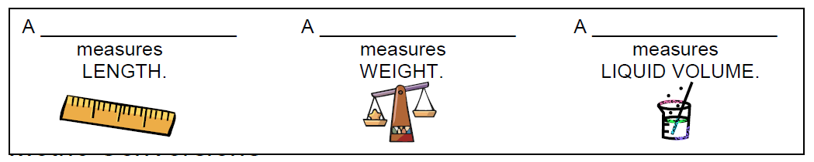

***Use a proportion to convert the following measurements.***

|  |  |
| --- | --- |
| 1) A large thermos holds about 1.5 liters. How many milliliters does it hold? $$\frac{1.5L}{mL}=\frac{1L}{1000mL}$$   Answer: __________ | 2) A computer screen is about 30.75 cm wide. How many millimeters wide is it? $$\frac{30.75cm}{mm}=\frac{1cm}{10mm}$$ Answer: __________ |
| 3) A beetle weighs about .68 grams. How many milligrams does it weigh?  *There are 1000 mg in one g*  Answer: __________ | 4) The distance from Dallas to Denver is 1260 km. What is this distance in meters?  *There are 1000 m in one km*  Answer: __________ |
| 5) 50cm = ______ mm  *There are 10 mm in one cm*  Answer: __________ | 6) 3.16L = ______ mL  *There are 1000 mL in one L*  Answer: __________ |

***Compare, Write <, > or =.***

|  |  |
| --- | --- |
| 7) 500 mm ❑ 50cm  *There are 10 mm in one cm* | 8) 6.2 L ❑ 620 mL  *There are 1000 mL in one L* |
| 9) 8.3 kg ❑ 8300 g  *There are 1000 g in one kg* | 10) 2.6 m ❑ 26000 cm  *There are 100 cm in one m* |