Rectangular Prism: | Surface Area  (Show work and circle your answer.)  (It may help to draw a net!) | Volume  (Show work and circle your answer.)  V = lwh OR V = Bh
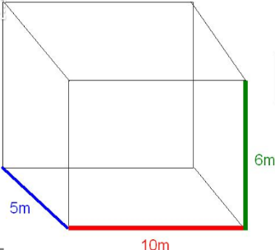 | 1) SA = ________________________ | 2) V = _________________________
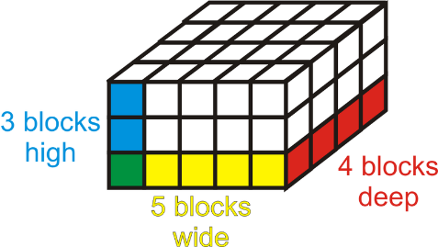 | 3) SA = ________________________ | 4) V = _________________________
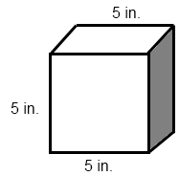 | 5) SA = ________________________ | 6) V = _________________________
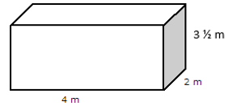 | 7) SA = ________________________ | 8) V = _________________________

9) Circle the choices that relate to volume. Underline the choices that relate to surface area.
Filling a pool with water Wrapping a present The amount of cereal in a box Painting a doghouse

10) How are surface area and volume alike? _____________________________________________________________
11) Name 2 ways surface area and volume are different.
a.________________________________________________________________________________________________
b.________________________________________________________________________________________________

