Solving Two-Step Equations
Identify each part of the equations. Circle any coefficient, underline any constant, and box any variable.
90x – 15 = -465 -12 + 3y = 21 -75 = 3(x + 30) 2y + 5 = -3y + 40

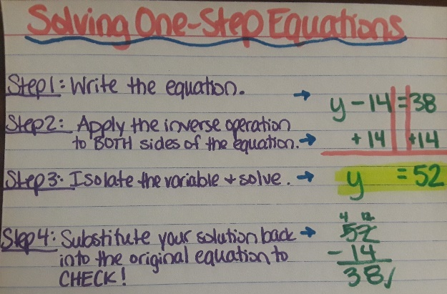
Throwback: One-Step Equations Your Turn to solve and show all steps:
n | - 27 | = | -39
 | +27 | = | +27
n |  | = | -12
Check:
-12 | - 27 | = | -39
-6p | = |  | 93
÷ (-6) | = |  | ÷ (-6)
p | = |  | -15.5
Check:
-6 | • (-15.5) | = | 93

m | + 83 | = | 61
 |  | =
 |  | =
Check:
 |  | =
h | + (-5) | = | 23
 |  | =
 |  | =
Check:
 |  | =
8f | = |  | 240
 | =
 | =
Check:
 |  | =
$$\frac{r}{1.2}$$ | = |  | -0.5
 | =
 | =
Check:
 |  | =

Solving Two-Step or Multi-Step Equations
The point of solving an equation is to find the value of the _________________. To do this, we must _______________
the variable on one side of the equation. To keep the equation ______________________, every action must be taken to _________________ sides of the __________________ sign.
Your first step is to “undo” the operation that is _________________ from the variable. Perform that ______________ operation to both sides. Continue this process for every value in the equation until the variable is isolated (solved).
Lastly, ___________________ your solution into the original equation to check your answer.
Example: Your Turn to solve and show all steps:
7n | - 2 | = | -44
 | + 2 | = | + 2
7n |  | = | -42
÷ 7 |  | = | ÷ 7
n |  | = | -6
Check:
7(-6) | - 2 | = | -44
-42 | + (-2) | = | -44
$$\frac{x}{12}$$ | + 4 | = | 1
 | - 4 | = | - 4
$$\frac{x}{12}$$ |  | =
x 12 |  | =
 |  | =
Check:
 |  | =
 |  | =
47 | - 12r | = | 76
- 47 |  | = | - 47
 |  | =
 |  | =
 |  | =
Check:
 |  | =
 |  | =
25y | + 75 | = | -25
 |  | =
 |  | =
 |  | =
 |  | =
Check:
 |  | =
 |  | =
Practice:
11x | + 15 | = | 48
 |  | =
 |  | =
 |  | =
 |  | =
Check:
 |  | =
 |  | =
-3y | - 22 | = | -7
 |  | =
 |  | =
 |  | =
 |  | =
Check:
 |  | =
 |  | =
-64 | + $\frac{m}{10}$ | = | -24
 |  | =
 |  | =
 |  | =
 |  | =
Check:
 |  | =
 |  | =
$$\frac{p}{-35}$$ | + 0.8 | = | 0.6
 |  | =
 |  | =
 |  | =
 |  | =
Check:
 |  | =
 |  | =

6n + 14 = 62 -32 + (-2x) = -46 $\frac{g}{-1.5}$ – 3 = 5 $\frac{c}{30}$ + 4 = -1

-4(s + 5) = -24 $\frac{k-14}{-8}$ = 15 $\frac{22 +z }{11}$ = 6 9(t – 11) = 81

-3y – 18 = 6y + 9 3(-x – 2) = -4x + 8 10d + (-19d) = 4d +13

