Shoot Your Shot - Equations!
- You must attempt at least 18 points.
- You must do at least ONE problem of each operation (+ - x and ÷)
- Write the number of each problem you solve and show all your work balancing equations or you will not receive full credit!
- See back for 3 point shots!
Free Throws (1pt) | Jump Shots (2pts)
1. a + 81 = 153 | 9. a + 9.8 = 14.1
2. b – 12 = 104 | 10. b - 2.7 = 8.9
3. 8t = 96 | 11. 1.5n = 9.6
4. y / 5 = 32 | 12. j / 4.5 = 2.1
5. e + 26 = 1004 | 13. c + ½ = 3/4
6. h - 14 = 52 | 14. p - 2 ½ = 8 ¾
7. 3g = 225 | 15. 4f = 44.32
8. d / 5 = 17 | 16. r / 6 = 5.2

3 Point Shots:
Must Write Equation & Solve

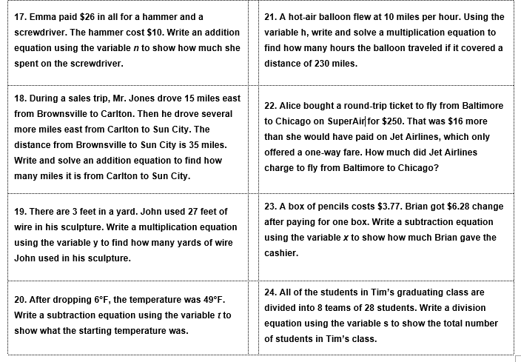

Name:________________________ Date:________________
Shoot Your Shot - Equations! Answer Sheet & Work

Name:_______________________________ Class Period: 1 2 3 4

Free Throws (1pt) | Jump Shots (2pts) | Three-Point Shots (3pts)
Free Throws (1pt) | Jump Shots (2pts) | Three-Point Shots (3pts)

