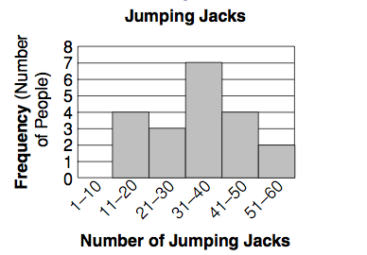

**Use Jumping Jacks histogram for questions 1-3.**

1. How many people participated in the surveyed?
2. How many people did fewer than 41 jumping jacks (JJ)?
3. How many people were able to do 21-30 JJ?

**Use Number of Pets histogram for 4-6**



1. True or False: Most families have more than 9 pets.
2. What is the shape of the distribution?
3. Skewed Right B. Skewed Left C. Symmetrical
4. Most families have how many pets?

**7-10 Write S for statistical N for non-statistical**

1. *What year was the voting age reduced to 18?*
2. *How many moons does Jupiter have?*
3. *How much time does your family spend on technology during the week?*
4. *What were the ages of voters in the last election?*



Use donation histogram above for 11-14

1. How many people donated $50 or more?
2. Do you think people are more likely to donate large or small amounts of money?
3. For which interval did people donate the most?
4. How many more people donated 20-29 than 30-39?

**Create a histogram using the following information in the frequency chart:**



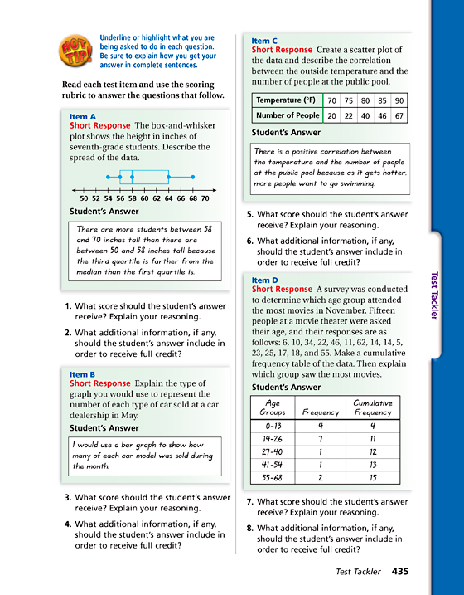

The box plot represents heights of **16** 7th grade students

**Use box plot above for 1-4**

1. What is the **interquartile range**? ____________
2. What is the median height? ________________
3. What **percent** of students are shorter than 56 inches? ___________
4. **How many** students are between 56 and 64 inches? ___________

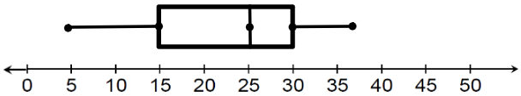

**Use the box plot above for question 5**

1. Complete the **five number summary** for the box plot.

**Minimum** = ______________

**First or Lower quartile**: ____________

**Median** = __________

Third or Upper quartile: ___________

**Maximum** = _____________

**Use the box plot below to answer questions 6-8**



1. What is the range of ages in years for the participants in the survey? ___________
2. 25% of the participants are younger than what age? _____________
3. Between what ages represents 50% of the data? ____________
4. Circle the correct answer

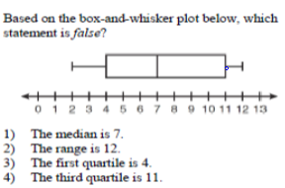

1. Circle the correct answer

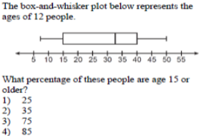

1. Circle the correct answer

