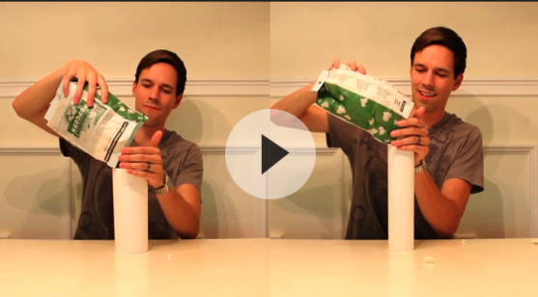
“Popcorn Picker” 3-Act Task
Adapted from http://threeacts.mrmeyer.com/popcornpicker/

Name: ______________________________________

Act 1: Brainstorm!
What question are you going to solve? | What do YOU predict?
Act 2: Gather Info
What information do you need to know to solve the problem?
Act 3: Solve your problem!
Show your work! You may use a calculator, but work out the problems below. Clearly label your answers.
Sequel: Choose one of the following extensions!
Circle one of the following choices. Be sure to show your work and use strong math vocabulary!
1) Clearly justify your reasoning to the “Popcorn Picker” task. Explain how you solved the problem and why you included certain steps. | 2) A cube that is 4 inches long is also being tested on its popcorn-holding ability. How will it compare with the other two containers? Show your work! | 3) A new rectangular popcorn container holds 1,500 cm³ of popcorn. The length of the container is 12 cm, and the width is 10 cm. What is the height of the container? Show your work!
Here’s how I answered #19: | Mastered | Partially Met | Did Not Meet
I used at least 2 math vocabulary words. | 2 | 1 | 0
I justified my reasoning in sentences, gave support for my answer, and clearly explained steps when necessary. | 4 | 2 | 0
I solved the problem correctly. | 4 | 2 | 0

