Directions: Write the equation for each problem. Show ALL steps to solve the
equations. Write the letter above the solution to answer the riddle. ALL STEPS
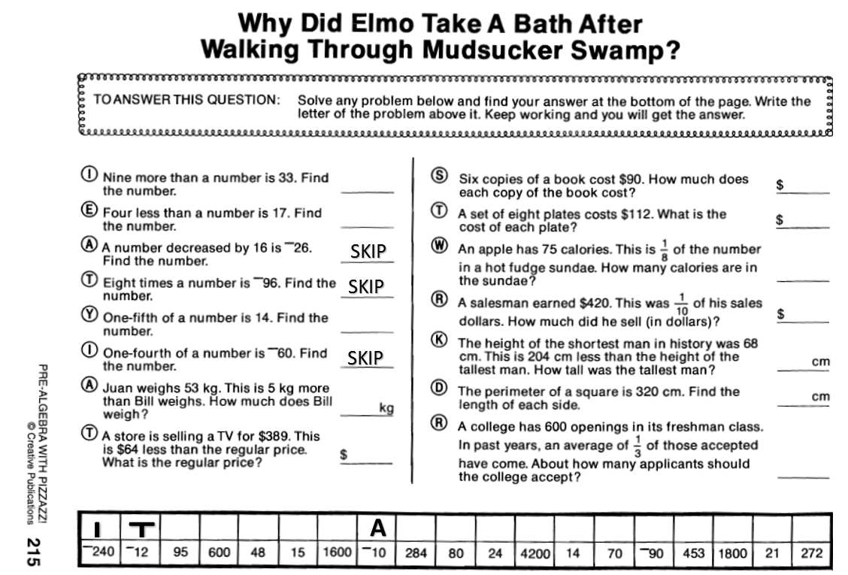
MUST BE SHOWN TO RECEIVE CREDIT!

