Name _______

Mystery Shapes

1. Graph and connect the following ordered pairs in order on the coordinate plane. Connect the last ordered pair to the first ordered pair. What shape was created?
(-3, -5), (-3, 6), (2, 6), (2, -5)
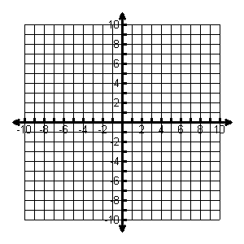
Find the perimeter of the shape: units
Find the area of the shape: square units
Which axis(es) does the shape cross? In which quadrant(s) is the shape?

2. Graph and connect the following ordered pairs in order on the coordinate plane. Connect the last ordered pair to the first ordered pair. What shape was created?
(-8, -3), (-8, 2), (-3, 2), (-3, -3)
Find the perimeter of the shape: units
Find the area of the shape: square units
Which axis(es) does the shape cross? In which quadrant(s) is the shape?

3. Graph and connect the following ordered pairs on the coordinate plane. Connect the last ordered pair to the first ordered pair. What shape was created?
(2, -3), (2, -9), (8, -9)
Find the area of the shape: square units
In which quadrant(s) is the shape?

4. Graph a rectangle with an area of 42 square units.
Name the coordinates you used: , , , Find the perimeter of the shape: units

