Percent Proportion Word Problem Practice Name:____________________

(is) Part = % Date:___________Pd:____
(of) Whole 100
Multiple Choice #1-4 Before you solve each problem, determine if you are solving for the Part or Whole
1. Tax is ___________ to the original cost.  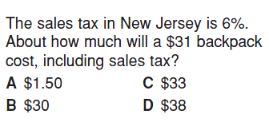 | 2.  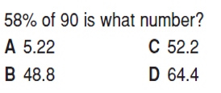
3. Discounts are _______________ from the cost.  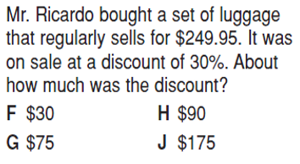 | 4.  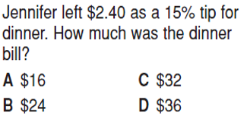

Short Answer #5-12: Before you solve each problem, circle if you are solving for the PART or the WHOLE
5. The price of a new laptop is $2, 275. If the sales tax rate is 7%, what is the total cost of the computer, including sales tax?
PART or WHOLE

6. At the natural history museum, 40% of visitors are children. There are 36 children at the museum. How many visitors altogether are at the museum?
PART or WHOLE

7. Deanna’s family ordered sandwiches to be delivered. The bill was $21.85. They gave the delivery person a 20% tip. How much did they tip the delivery person?
PART or WHOLE

8. 15% of the number of people who attended a concert arrived late. If 30 people arrived late, find the number of people who attended the concert.
PART OR WHOLE
9. There are 4950 students in the freshman class at the University of Georgia. 12% of the students were on the Dean's List. How many students were on the Dean's List?
PART or WHOLE

10. Haylee ’s dog, Lala, ate 80% of a bag of dog food. If she ate 16 pounds of dog food, how many pounds of food were in the entire bag?
PART or WHOLE

11. Tyler’s cat sleeps 75% of a 24 hour day. How many hours does Tyler’s cat spend sleeping?
PART or WHOLE

12. Allessia spent 25% of her savings on a tap dancing class. If the class cost $20, how much total money did she have?
PART or WHOLE

13. The discount is __________________ from the original price.

