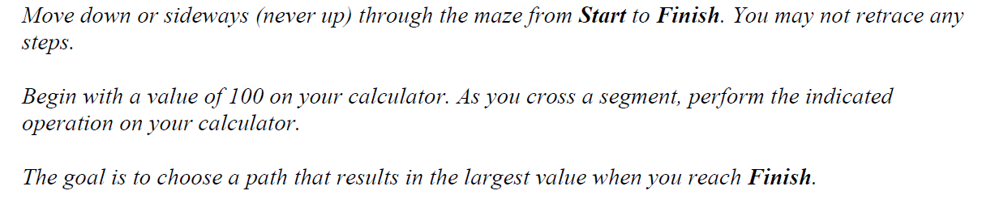

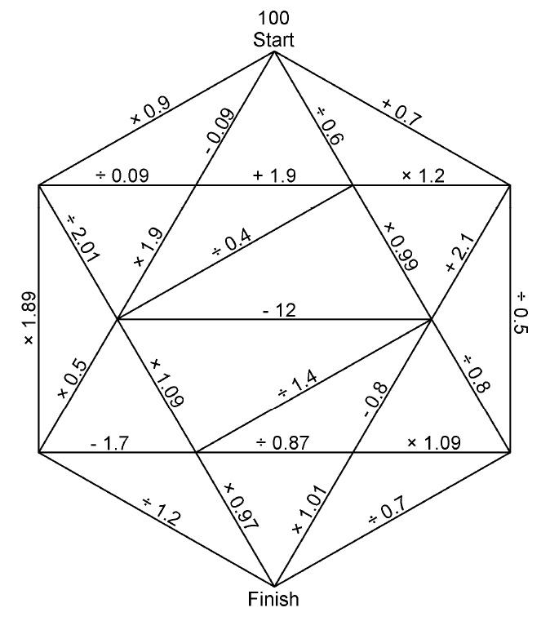

Did you have any strategies for getting the greatest solution possible? Thoroughly explain your processes and reasoning.

__________________________________________________________________________________________________
__________________________________________________________________________________________________
__________________________________________________________________________________________________
__________________________________________________________________________________________________
__________________________________________________________________________________________________
__________________________________________________________________________________________________

