Math 6 Name ___________________________________
Unit 2: Rate, Ratio, Proportional Reasoning Date _______________
Sample Post Test
Knowledge and Understanding
- What are percentages?

- What kinds of problems can you solve by using ratios?

Proficiency of Skills
- Write an equivalent ratio to 4:5.

- Fourteen is 20% of what number?

- Find 7% of 85.

- Determine the missing value.

- Write the ratio as a unit rate: $48 for 4 tickets

Application
- Jerrod drove 217 miles in 3.5 hours. Martin drove 244 miles in 4 hours. Who drove at the fastest rate of speed?

- If 1 inch is approximately 2.54 centimeters, how many centimeters are equal in length to 3.5 inches?

- The table below shows the number of each item sold at the concession stand.
Item | Quantity Sold
Popcorn | 20
Nachos | 15
Hot Dog | 25
Candy Bar | 30
What might the ratio 2:1 represent?

- The table below shows the cost for varying number of books. If the relationship stays the same, determine the value of n.
Number of Books | Cost
3 | $18
5 | $30
12 | $72
20 | n

- The ratio of boys to girls in a class is 6:4. If there are 30 students in the class, how many are boys?

- In a class of 40 students, 75% returned their permission slips for the school field trip. How many students returned their permission slips?

- Crosby Middle School held a car wash as a fundraiser. Out of the 25 vehicles that were washed, 20 were cars. What percent of the vehicles were cars?

- The graph below compares cups to pints. Using the graphed coordinates, which of the ordered pairs would also satisfy this relationship?
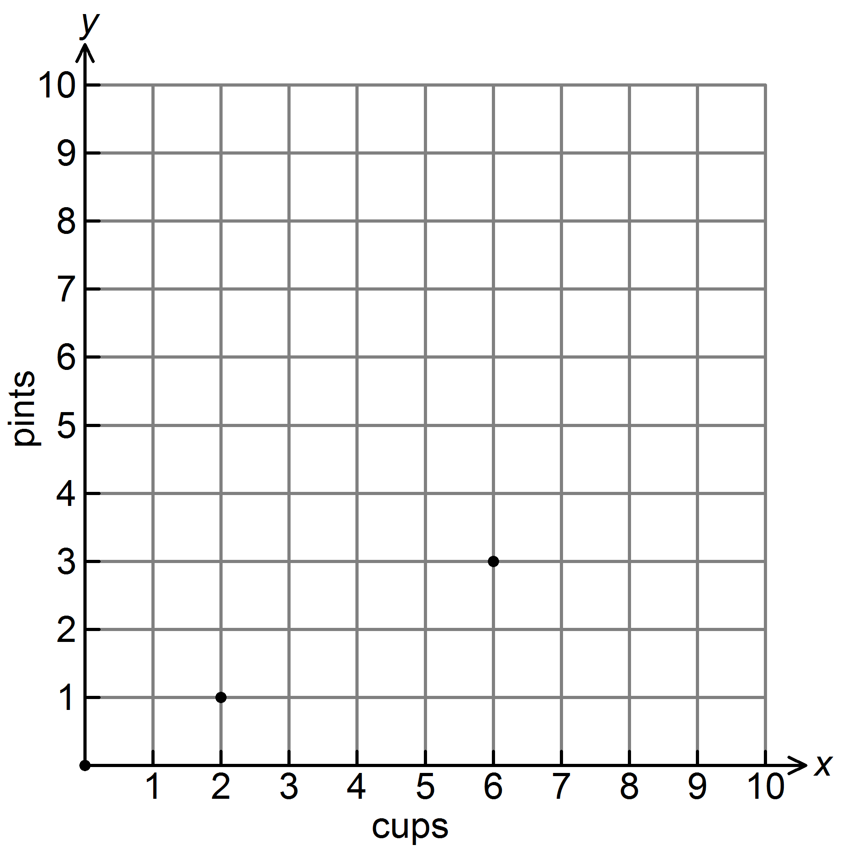
A. | (4, 2) | B. | (2, 4) | C. | (2, 0) | D. | (1, 2)

- Melissa’s paycheck last week was $125.52. She would like to put 20% of her earnings in her savings account. How much money should she put in her savings account?
A. | $20.00 | B. | $25.10 | C. | $100.42 | D. | $105.52

- The prices of 4 different bottles of lotion are given in the table.
Size | Price
25 ounces | $4.68
15 ounces | $2.40
10 ounces | $1.62
5 ounces | $0.82

Which size bottle is the best value?

A. | The 25-ounce bottle
B. | The 15-ounce bottle
C. | The 10-ounce bottle
D. | The 5-ounce bottle

- Rusty drives his race car at a constant speed of 175 miles per hour. Which method can be used as the first step to find the number of hours it will take him to drive 500 miles?

A. | Divide 500 by 175.
B. | Multiply 500 by 175.
C. | Subtract 500 from 175.
D. | Add 500 to 175.

- Mr. Evans surveyed his students to determine their favorite summer sport. The results are shown in the table below.

Sport | Boys | Girls
Swimming | 70 | 60
Tennis | 30 | 40

What percent of the students surveyed chose swimming?
A. | 130% | B. | 70% | C. | 65% | D. | 60%

Performance Task
- At the amusement park, there is a ride through the Haunted Mansion. Each boat holds 4 people, and there are
6 boats. The ride takes 10 minutes. There are still 150 people in the line, and the ride closes in exactly one hour. Will all the people be able to ride through the Haunted Mansion? Justify your answer.

Math 6
Unit 2: Rate, Ratio, Proportional Reasoning
Post Test Answer Key
Problem | Standard | Answer
1. | MGSE6.RP.3 | Answers may vary. Possible answer: Percentages are ratios that compare a number to 100.
2. | MGSE6. RP.1 | Answers may vary. Possible answer: Unit rate, measurement conversions, etc.
3. | MGSE6. RP.1 | Answers may vary. Possible answer: 8:10
4. | MGSE6.RP.3c | 70
5. | MGSE6.RP.3c | 5.95
6. | MGSE6.RP.3 | 400
7. | MGSE6.RP.3b | $12 for 1 ticket
8. | MGSE6.RP.3b | Jerrod
9. | MGSE6.RP.3d | 8.89 cm
10. | MGSE6.RP.1 | The sales of candy bars to nachos
11. | MGSE6.RP.3a | $120
12. | MGSE6.RP.3 | 18 boys
13. | MGSE6.RP.3c | 30 students
14. | MGSE6.RP.3c | 80%
15. | MGSE6.RP.3a | A
16. | MGSE6.RP.3c | B
17. | MGSE6.RP.3b | B
18. | MGSE6.RP.2 | A
19. | MGSE6.RP.3c | C
20. | MGSE6.RP.3 | Answers may vary. Possible answer:  Every 10 minutes, 24 people can ride the ride.  Elapsed Time (minutes) Total number of passengers  10 24  20 48  30 72  40 96  50 120  60 144  Not all people will get to ride the ride as there are still 6 people left.

