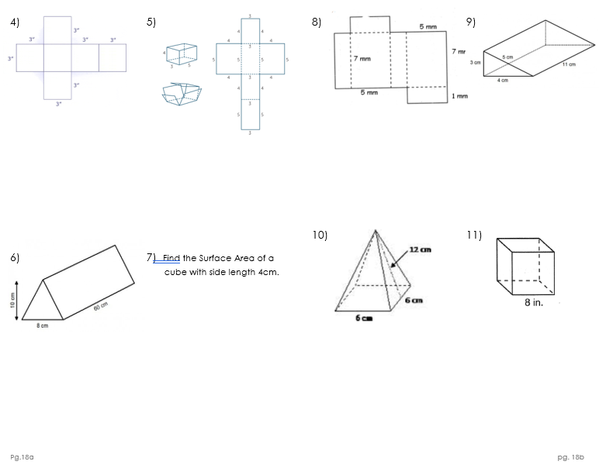

54 square inches 94 square units 94 square mm

96 square cm 384 square inches

