Fruit Loop Activity…Yum! Name:____________________________________
Date:__________________ Period: 1 2 3 4
COLORS | Red | Orange | Yellow | Green | Blue | Purple | TOTAL
AMOUNT
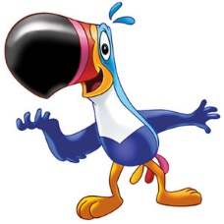
1) | Write the ratio of Yellow to Green:  ___________________  If possible, simplify the ratio:  ___________________ | Write the ratio 3 ways: | What type of ratio is this (circle one)?  part-to-part  part-to-whole | Write 2 more equivalent ratios: | Write the ratio using “ratio language.”
2) | Write the ratio of Red to Total:  ___________________  If possible, simplify the ratio:  ___________________ | Write the ratio 3 ways: | What type of ratio is this (circle one)?  part-to-part  part-to-whole | Write 2 more equivalent ratios:
3) | Write the ratio of Orange to Blue and Purple:  ___________________  If possible, simplify the ratio:  ___________________ | Write the ratio 3 ways: | What type of ratio is this (circle one)?  part-to-part  part-to-whole | Write 2 more equivalent ratios:
4) | Write the ratio of Purple to All Other Colors:  ___________________  If possible, simplify the ratio:  ___________________ | Write the ratio 3 ways: | What type of ratio is this (circle one)?  part-to-part  part-to-whole | Write 2 more equivalent ratios:

